

Microsoft Azure

Machine Learning

Lab

Table of Contents

Executive Overview 3

First Time Set-up Instructions 3

Uploading a Dataset to Azure ML 5

Creating a new experiment 5

Data Exploration 7

Training and Testing a Binary Classification Model 9

Model Tuning 14

Performance Evaluation 16

Executing R Scripts 19

Creating a Web Service for Binary Classification Model 22

Azure ML Web service call from Excel 25

Optional: Clustering 28

Optional: Jupyter Notebooks 30

Optional: Visualizations for classification using Power View 33

Optional: Visualizations for clustering using Power View 35

Optional: Reading data from Azure SQL database 39

Optional: Writing predictions to Azure SQL database 44

Optional: Azure ML Web service call from RStudio 44

Optional: Publishing R models as Web services from RStudio 46

Summary 47

# Executive Overview

The purpose of this lab is to introduce you to hosting machine learning models in Microsoft Azure cloud, including basic design, experimentation and development tasks. In the lab, we will cover Microsoft Azure Machine Learning (Azure ML), a fully managed machine learning platform that allows you to perform predictive analytics. Azure ML Studio is a user facing service that empowers data scientists and domain specialists to offer customers, end-to-end solutions by significantly reducing the complexity to build predictive models. Azure ML provides an interactive and easy to use web-based interface with a drag-and-drop authoring model and a catalogue of modules that encapsulate functionality for the end-to-end model construction workflow.

As a part of the lab, you will be creating two different models based on the dataset called **Churn**. The dataset consists of records belonging to 4667 customers of a fictitious telecom service provider. The columns of the dataset hold information such as the length of customer account, total day, and night, evening and international minutes used.

The first model you will create is called churn analysis known as customer attrition which is the problem of identifying the customers who are likely to leave a service or a business. The goal of the analysis is to contact these high risk individuals and take necessary actions such as providing special offers and discounts to prevent them from leaving the business. You will model the problem using the binary classification technique.

The second model you will create is a segmentation model where the objective is to find natural clusters of customers within the data sets who have similar characteristics. This is also extremely beneficial to understand the customer base for targeted marketing applications where the goal is to target the right individuals in order to grow the business.

Additionally, many optional sections are provided to demonstrate the full functionality of Azure ML. The optional parts are not meant to be finished within the time allocated for this lab and should be completed as follow up exercises.

# First Time Set-up Instructions

You will need an Azure subscription for this lab. Here are the first time instructions to provision a workspace for Azure Machine Learning:

**Step-by-step**

1. Go to <http://azure.microsoft.com/en-us/> . Click on **PORTAL** link on top of the page. Login to your portal using the trial Azure credentials provided at the top of the content tab of the lab VM. If you like your work to stay in your own Azure subscription and be available after the lab is over, please use your own azure subscription. You can also sign-up for a free trial account at <http://azure.microsoft.com/en-us/>.
2. Now, create a machine learning workspace by using **+New** button at the portal and select **Data + Analytics -> Machine Learning**. In **Quick Create**, provide the following information:
   1. Workspace Name: Pick a name for your workspace
   2. Location: South Central US
   3. Storage Account: Create new storage account
   4. New storage account name: Pick a name for your storage.

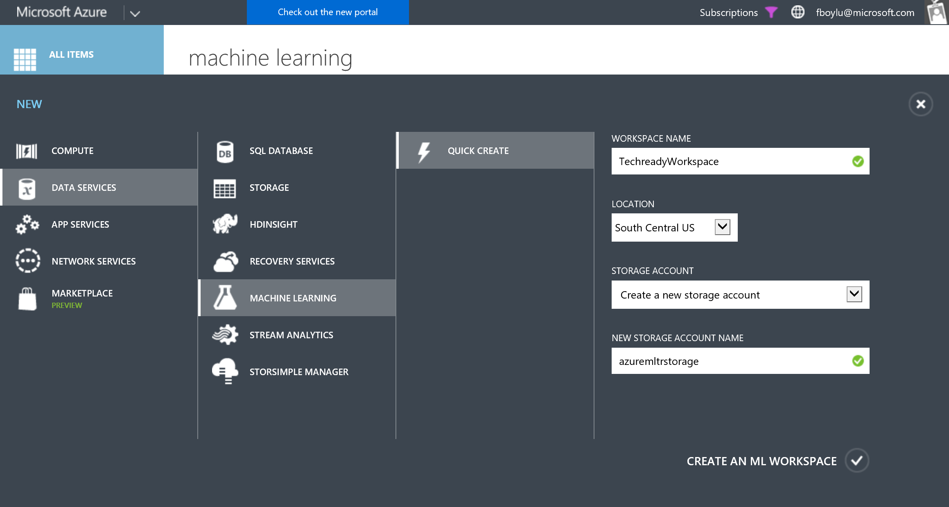

1. Once the workspace is created, click on the workspace name and in the next page, click on **Sign-in to ML Studio** link. Microsoft Azure Machine Learning Studio will open on your default browser. Azure ML Studio may ask you if you’d like to take a tour, click on “**Not Now**” and also close the next window that opens using the close button on the up right corner but you can walk through those steps later to understand the basics of the Studio. You should then have a workspace that looks similar to the screen below.

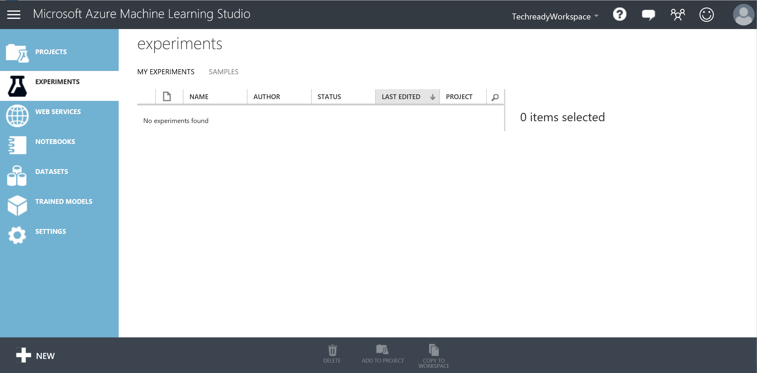

# Uploading a Dataset to Azure ML

In this exercise, you will upload a new data set stored on your virtual machine in the form of a .csv file. This step takes about 5 minutes to complete.

**Key Points**

1. The data set information about 4500 fictitious individuals that are subscribed to a mobile telecommunications service provider.
2. The information contained in the data set includes the length of the account, plan subscriptions, international minutes, etc…

**Step-by-step**

1. In the studio, click on **+New** link at the bottom left corner. Click **DATASET** on the left bar and then **FROM LOCAL FILE**. Browse to the location C:\Lab1 and select the file **ChurnData.csv**. Notice that the type of the data set is set to **Generic CSV File with a header (.csv)** and click the check mark at the bottom of the window.

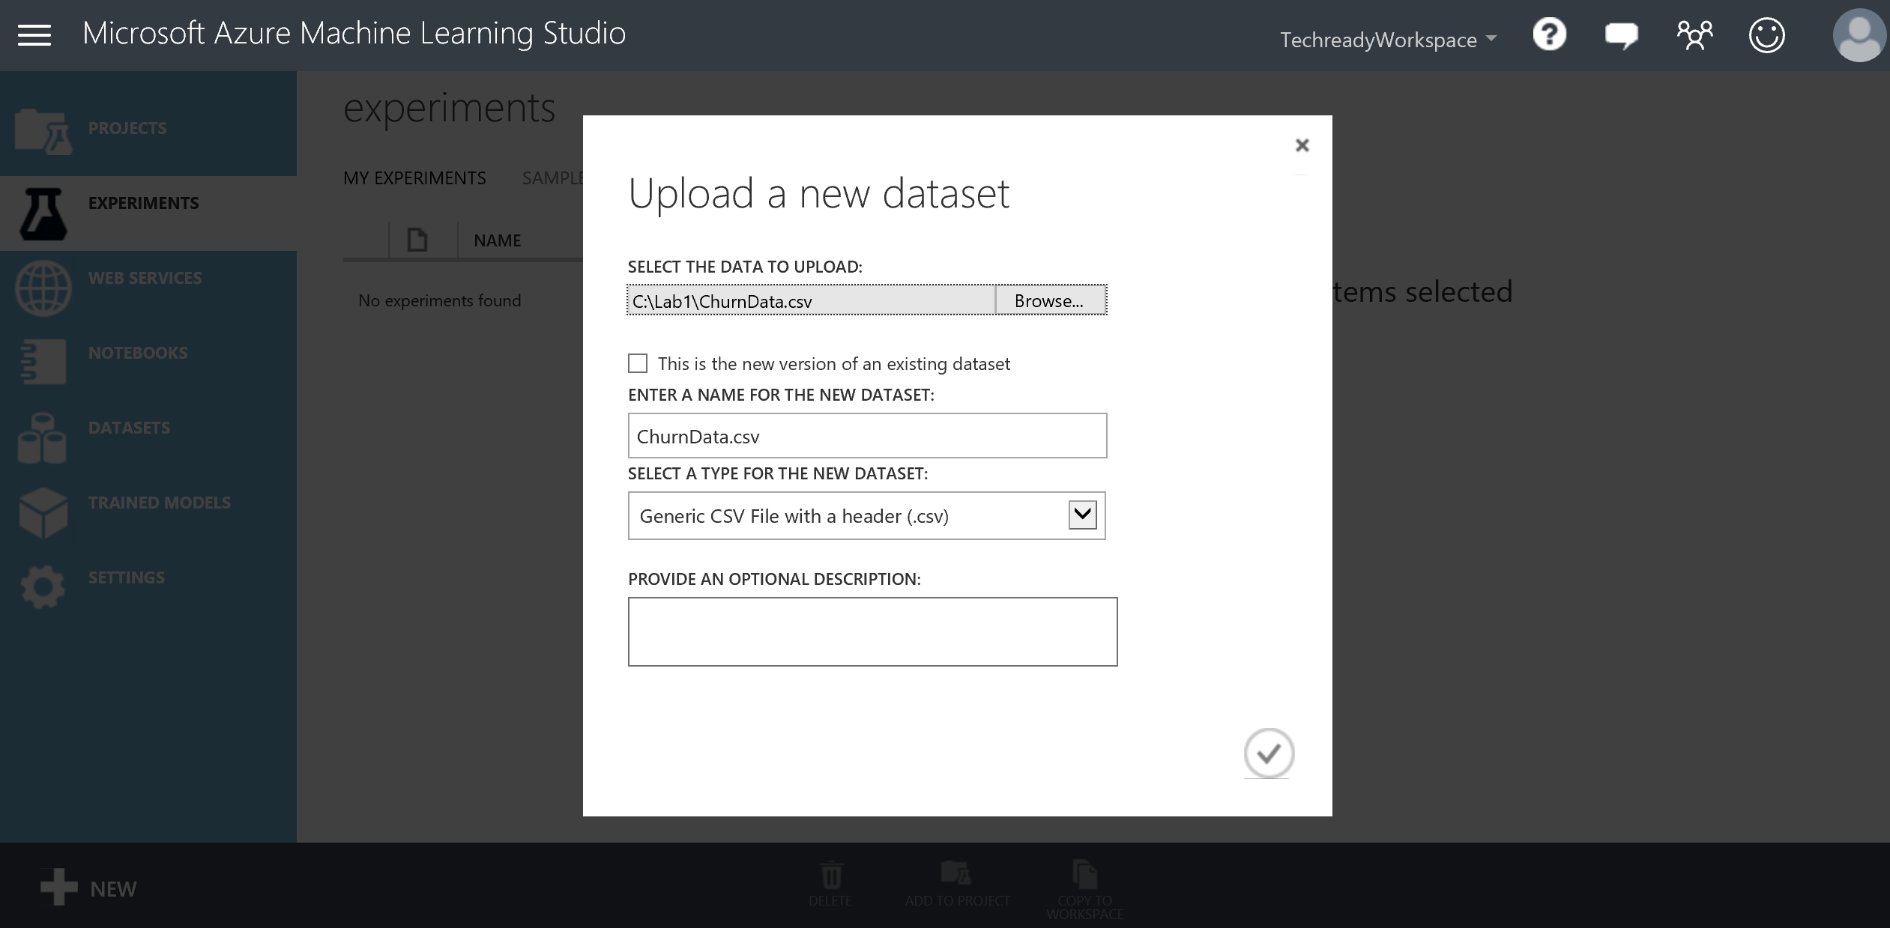

1. When the upload finishes, you will have a new dataset called ChurnData.csv which can be found under **DATASETS** tab.

# Creating a new experiment

In this section, you will create a new experiment and add the previously uploaded dataset to your experiment. You will then visualize some statistical properties of the data set along with some sample rows. This step takes about 5 minutes to complete.

**Key Points**

1. Experiments in Azure ML studio are based on modules that perform specific tasks. Module references can be found in the online help file which can be accessed any time by clicking the question mark at the upper-right corner of the page.
2. Online help file also provides guidance on topics such as getting data from various resources to visualizing results.

**Step-by-step**

1. Go to your workspace and select **+New** at the bottom left corner of the page, click on **EXPERIMENT** tab and notice the sample experiments provided which range from basic experiments to more advanced samples. You can find many more experiments by clicking the **VIEW MORE IN GALLERY** link which will take you to the **Cortana Intelligence Gallery** where you can search for experiments published by a large community of data scientists. Once you are done exploring, go back to the studio and click on the first box called **Blank** **Experiment**. Change the title of the experiment to **Churn** by deleting the default title (Experiment created on mm/dd/yyyy)**.** Expand the **Saved Datasets** list in the left navigation pane and under **My Datasets** drag/drop the **ChurnData.csv** to the experiment canvas. You can adjust the zooming level of your experiment by using the zooming scale at the bottom of the experiment canvas. You can also use your browser’s zooming to adjust to the zoom level you are comfortable with. You can use the 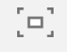 button to toggle the larger experiment view.

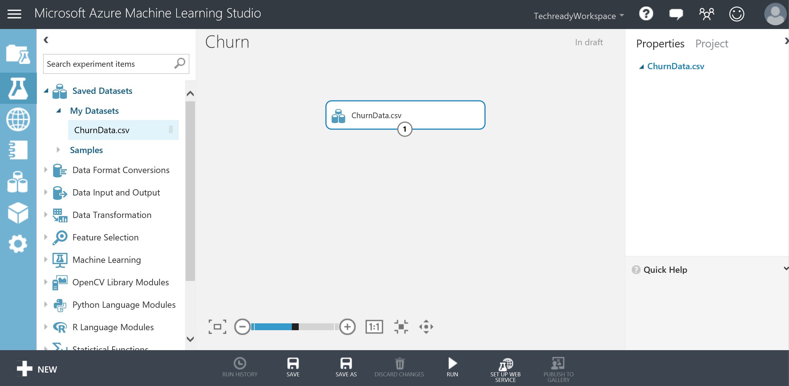

1. Right click on the small circle below the ChurnData.csv module and select **Visualize**.

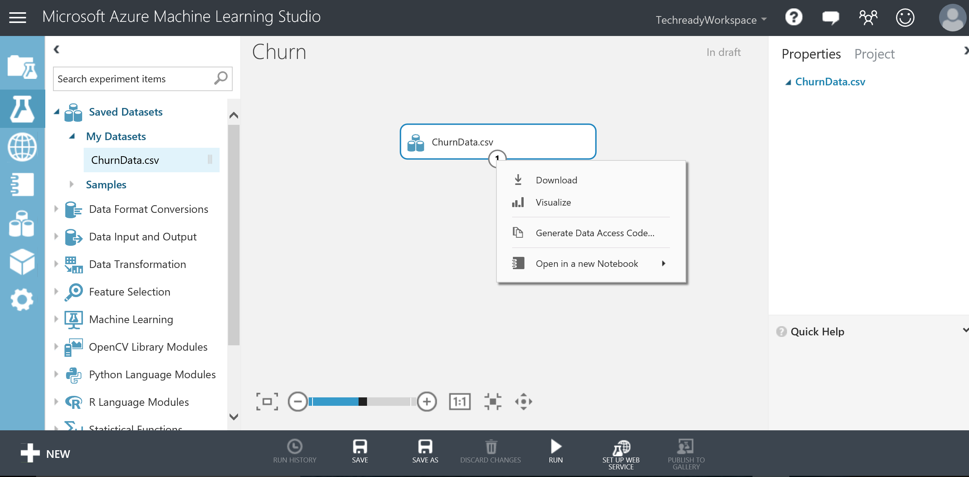

1. This will take you to a page with general statistics information on the columns of the dataset. Scroll to the right to see more column information and down for first 100 rows of the dataset. Click on the Account_Length column and observe the statistics and visualizations for the column on the right side of the screen. Scroll down for the histogram of the column. Close the window by clicking the close button on the top-right corner below the menu bar.

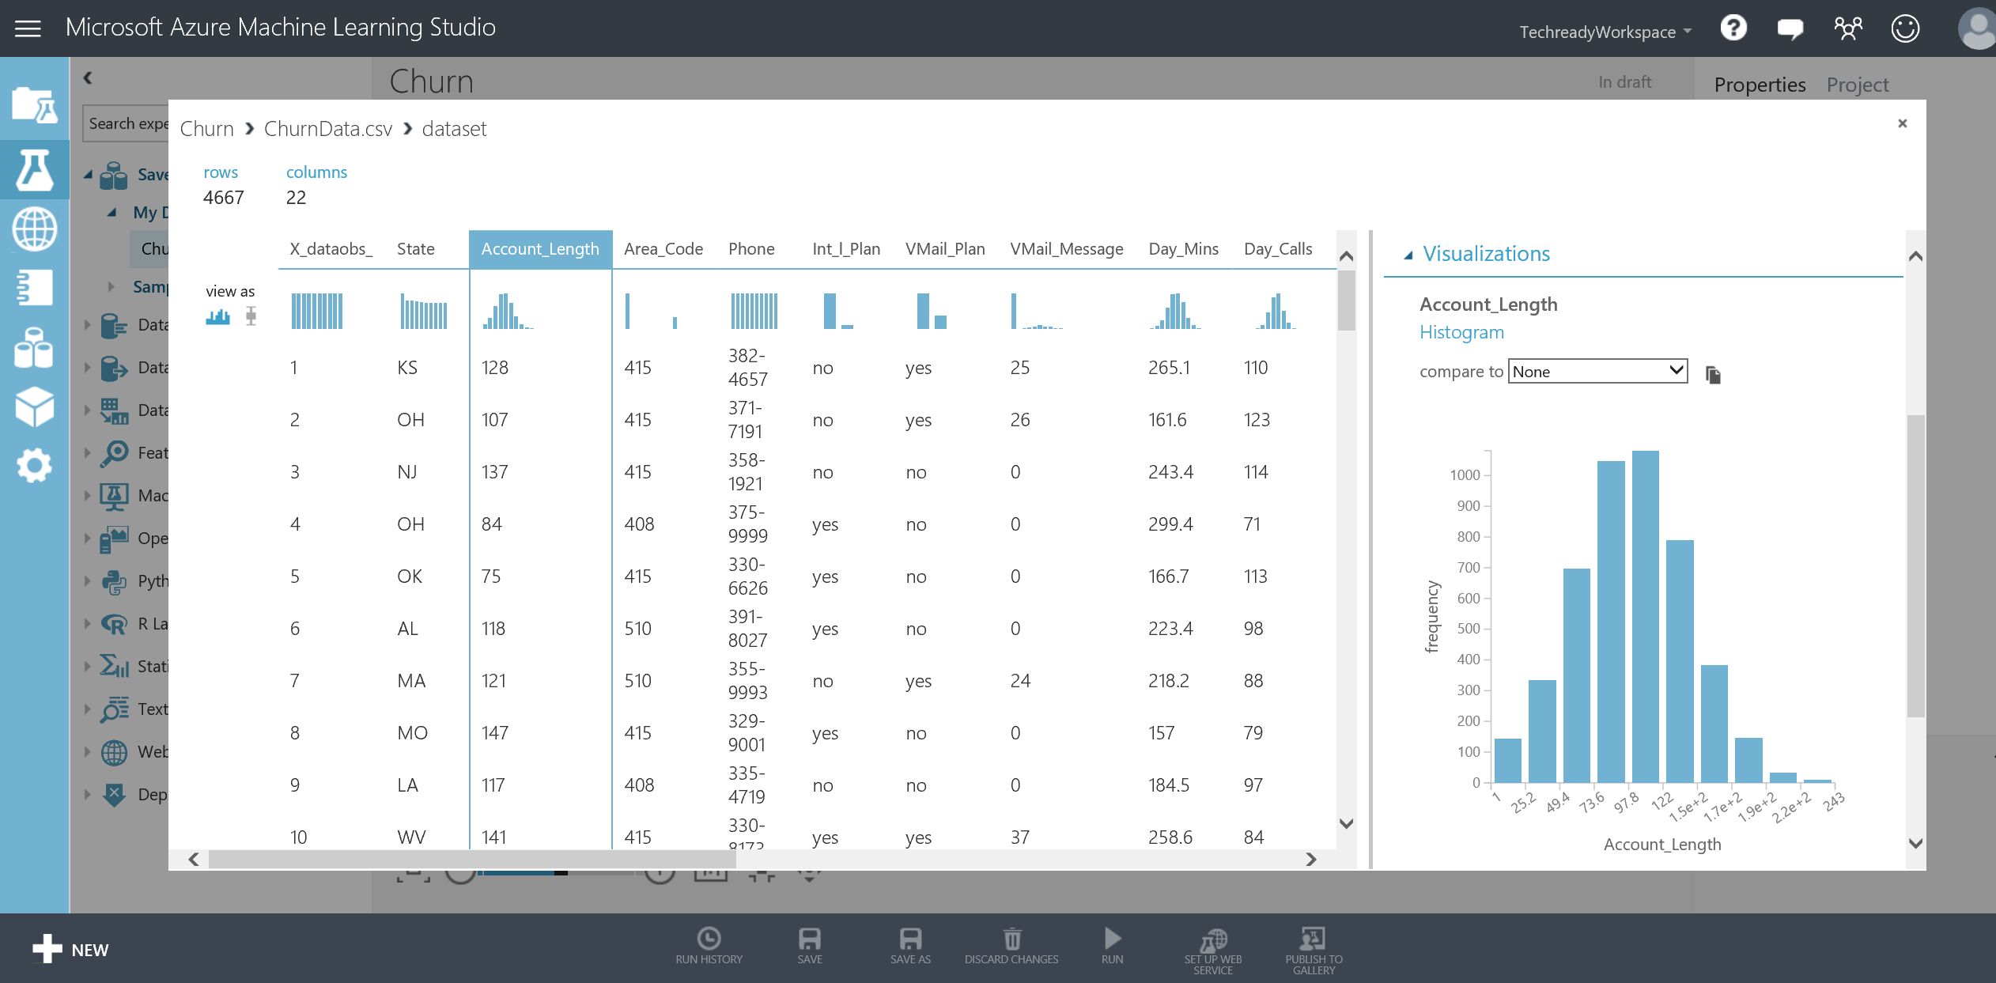

# Data Exploration

First step in any data science project is to explore and understand the data. This requires doing some statistical analysis and creating visualizations to get a better view about its properties which are important criteria when deciding which machine learning model fits well for the data. In this section, we will look into the correlations between columns of the data set for this purpose. This step takes about 10 minutes to complete.

**Key Points**

1. For now, we will use the visualization functionality provided for the data sets in this step. However, we will create better visualizations to check for correlations in the coming sections using Python language extensibility.

**Step-by-step**

1. Before we start, we will exclude the first feature X_dataobs_ from our dataset since it is the identification column with unique values and does not have any predictive power in our analysis.
2. In the search box on the left side navigation bar, type **Select Columns in Dataset** and drag/drop the module by placing it under the ChurnData.csv module. Next, connect the output port of ChurnData.csv to the input port of Project Columns. Hit the **Save** button on the bottom bar to save your draft.

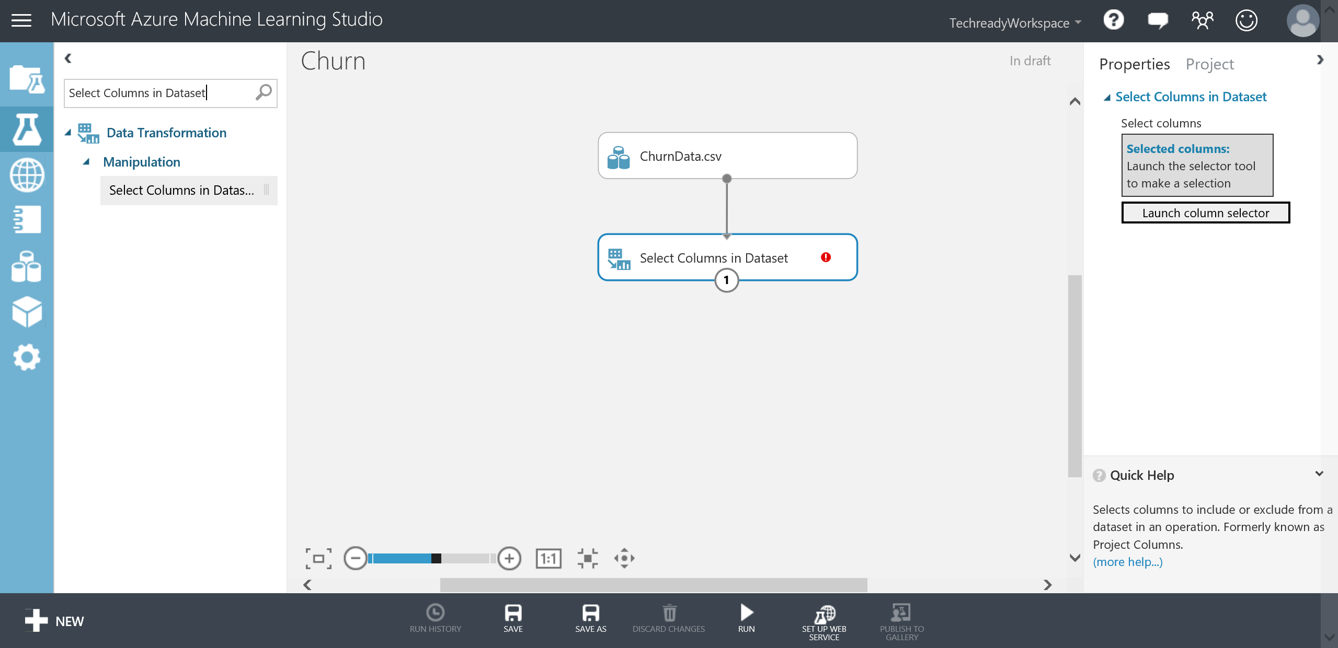

1. Notice the red **“Value required.”** sign on the top-right corner of the Select Columns in Dataset module. To provide the required value click on the Select Columns in Dataset module and then click **Launch column selector** on the **Properties** navigation pane on the right side (if the **Properties** navigation pane is collapsed click on the **<** on the top right corner of the page). On the **Select columns** window, select **WITH RULES** taband select **ALL COLUMNS** under **Begin With** and then then in the first two drop down menus, select **Exclude** and **column names** and click the text box next to them. You should see a list of available columns in the dataset. Select **X_dataobs_** and click the check mark to confirm your settings.

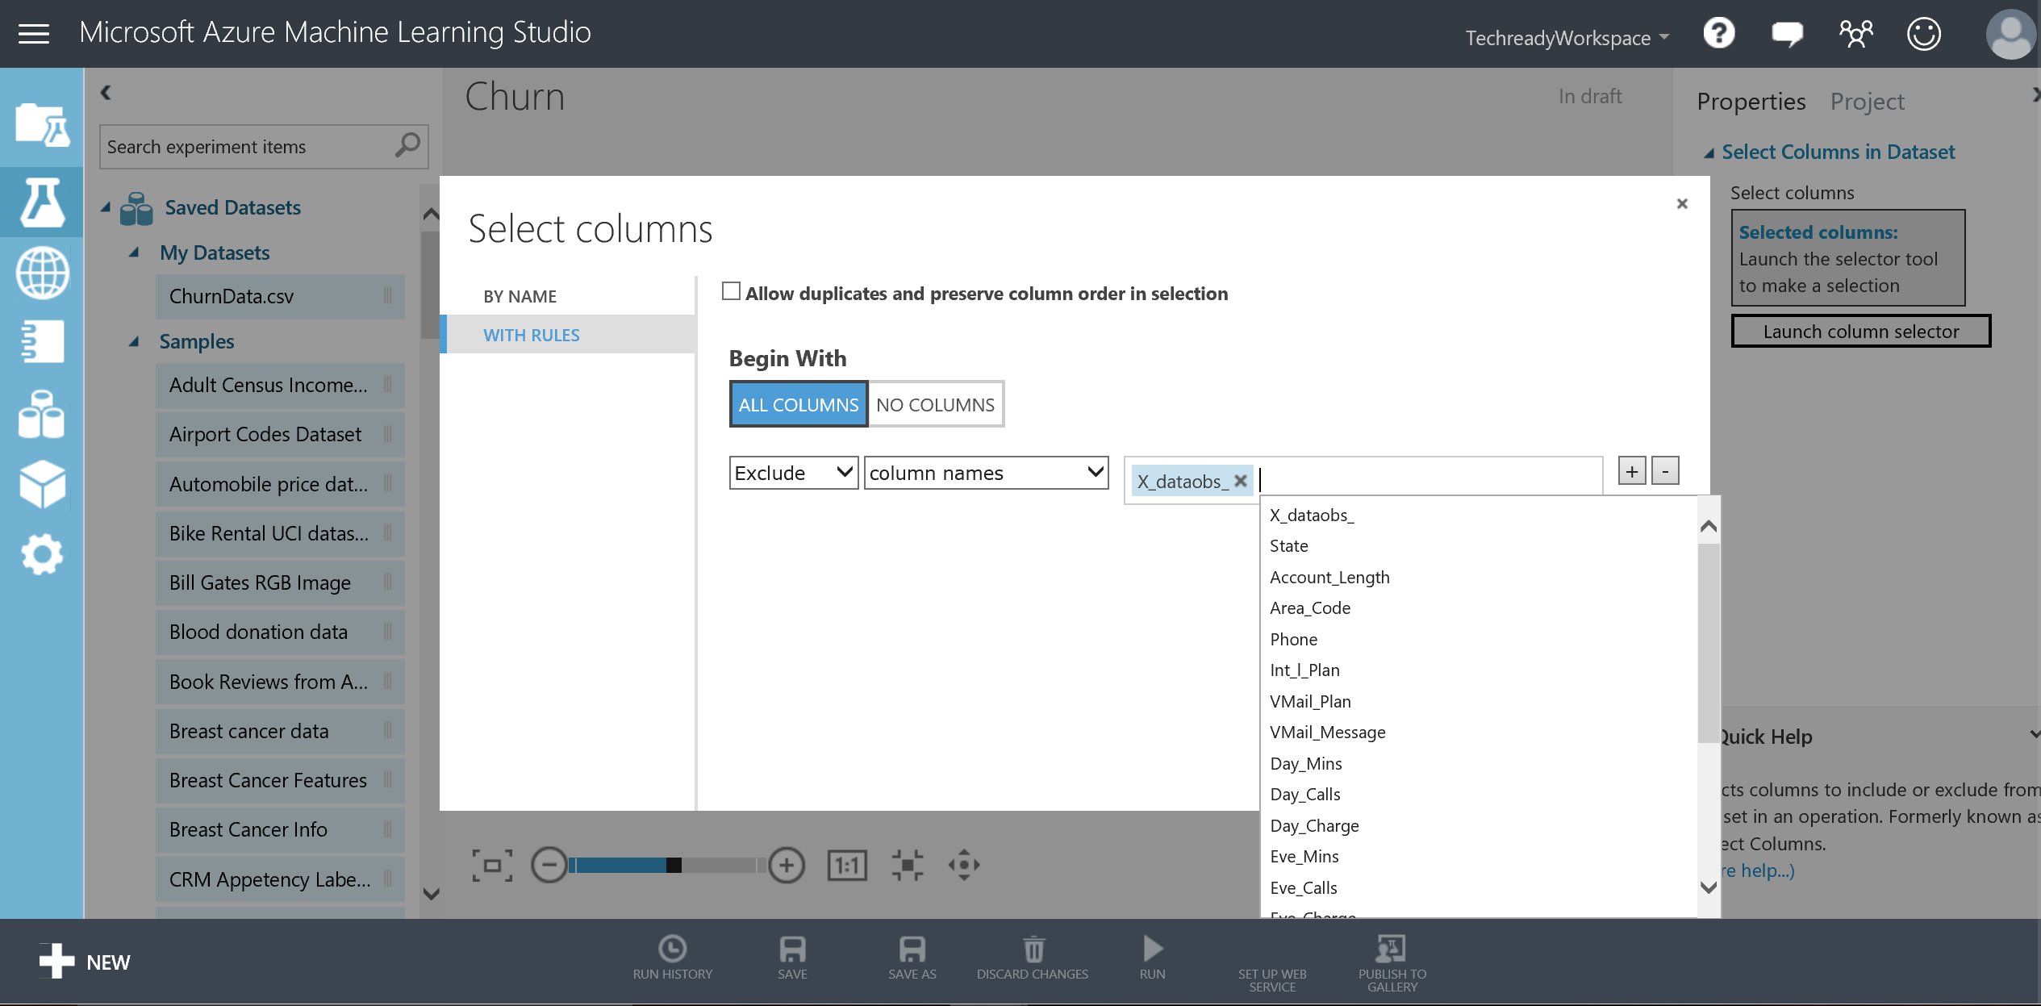

1. Click **Run** at the bottom menu bar. Once you have seen the green check mark on Select Columns in Dataset, right click the circle below the module and then select **Visualize** to visualize its results. You will notice that X_dataobs_ has been removed from the output.
2. Scroll to the right of the window to locate **Day_Mins** column and select it. Next, on the right side, scroll down to Visualizations, find the **compare to** drop down menu above the histogram and select **Day_Charge.** Select the **Day_Mins log scale** and **Day_Charge log scale** at the bottom of the chart to reduce the wide range of the column values to a smaller scale. This will display a scaled scatter plot of the two variables. Observe that the two variables have perfect correlation represented by the straight line. This is also true between **Eve_Mins** and **Eve_Charge**, **Night_Mins** and **Night_Charge**, **Intl_Mins** and **Intl_Charge** since charges are calculated from minutes by multiplying with cost per minute. In the next sections, we will exclude some of these highly correlated columns since they essentially carry the same information. Close the page by clicking the close button on the top-right corner.

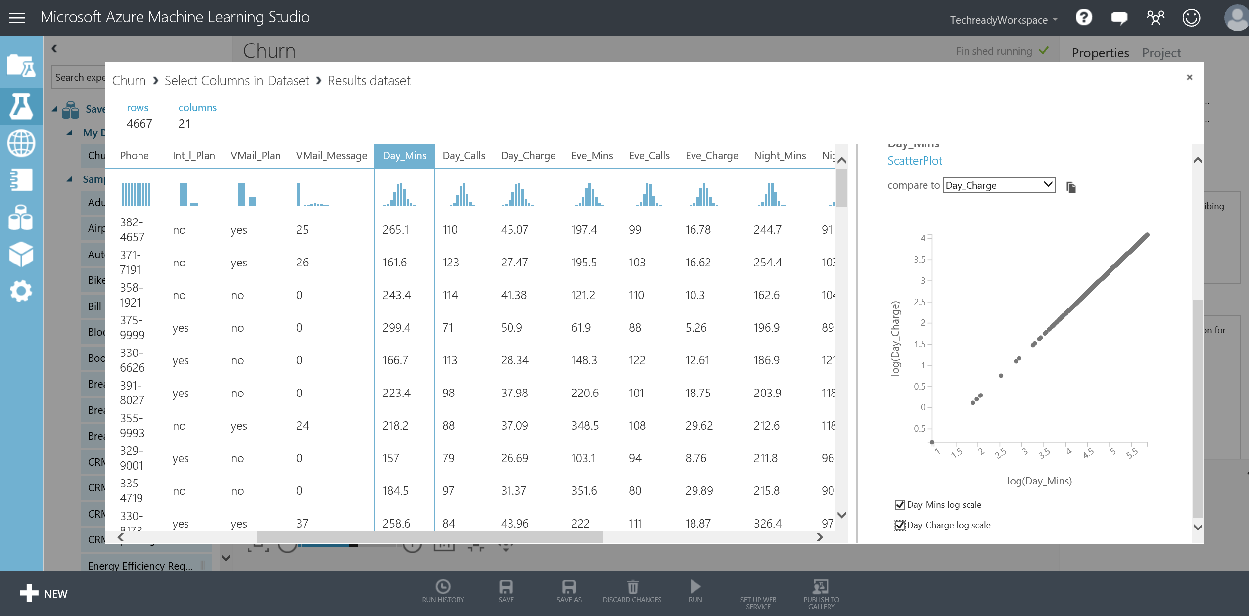

# Training and Testing a Binary Classification Model

There are many machine learning techniques you can perform using Azure ML Studio. Some of these are Classification, Clustering, Regression, Anomaly Detection and Recommender methods. In this section, we will focus on creating a Binary Classification Model.

**Key Points**

1. There is an extensive library of binary classification algorithms included in Azure ML Studio such as Boosted Decision Trees, Logistic Regression and Support Vector Machines. You are strongly encouraged to research about these algorithms to get a better understanding of the techniques.
2. Before, applying any machine learning model, an important step is the data cleaning and preparation. As an example, in this exercise, you will reduce down the dataset by eliminating highly correlated variables identified in the earlier steps.
3. In order to assess the quality of models, a common method in machine learning applications is to separate the data into **training** and **test** sets to measure the accuracy of predictions. In this part of the lab, you will first train the model with %70 of the total data points and test it with the remaining %30 of the data in order to assess the performance of the model.

**Step-by-step**

In this part, you will extend the experiment for training a binary classification to identify customers who are more likely to churn. This step takes about 20 minutes to complete.

1. First, you will use the same **Select** **Columns in Dataset** module already placed on your canvas in the earlier section to exclude **Day_Charge**, **Eve_Charge, Night_Charge** and **Intl_Charge** columns since these are highly correlated with **Day_Mins**, **Eve_Mins**, **Night_Mins** and **Intl_Mins**. You will also exclude **Area_Code** and **Phone** number.
2. Click on the **Select** **Columns in Dataset** module that you already placed on your experiment earlier and click **Launch column selector** in the properties menu bar on the right side. In the text box, next to X_dataobs_ feature, enter the following columns: **Area_Code**, **Phone**, **Day_Charge**, **Eve_Charge**, **Night_Charge** and **Intl_Charge** and click the check mark.

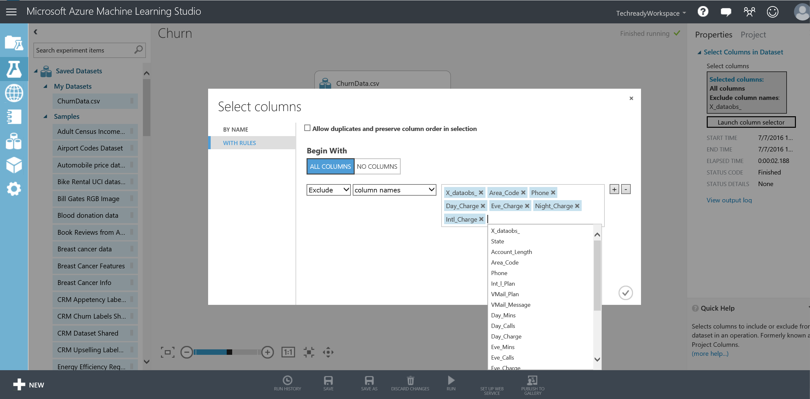

1. Next, on the left side navigation bar, type **Split Data**, drag/drop the module to the experiment and connect the output port of **Select Columns in Dataset** module to the **Dataset** input of **Split Data**. Next, click **Split Data** and on the **Properties** on the right side, type **0.7** in the textbox for **Fraction of rows in the first output dataset** and **1234** in **Random seed** textbox. Random seed is used to start the random process from the same seed every time the experiment is re-run.

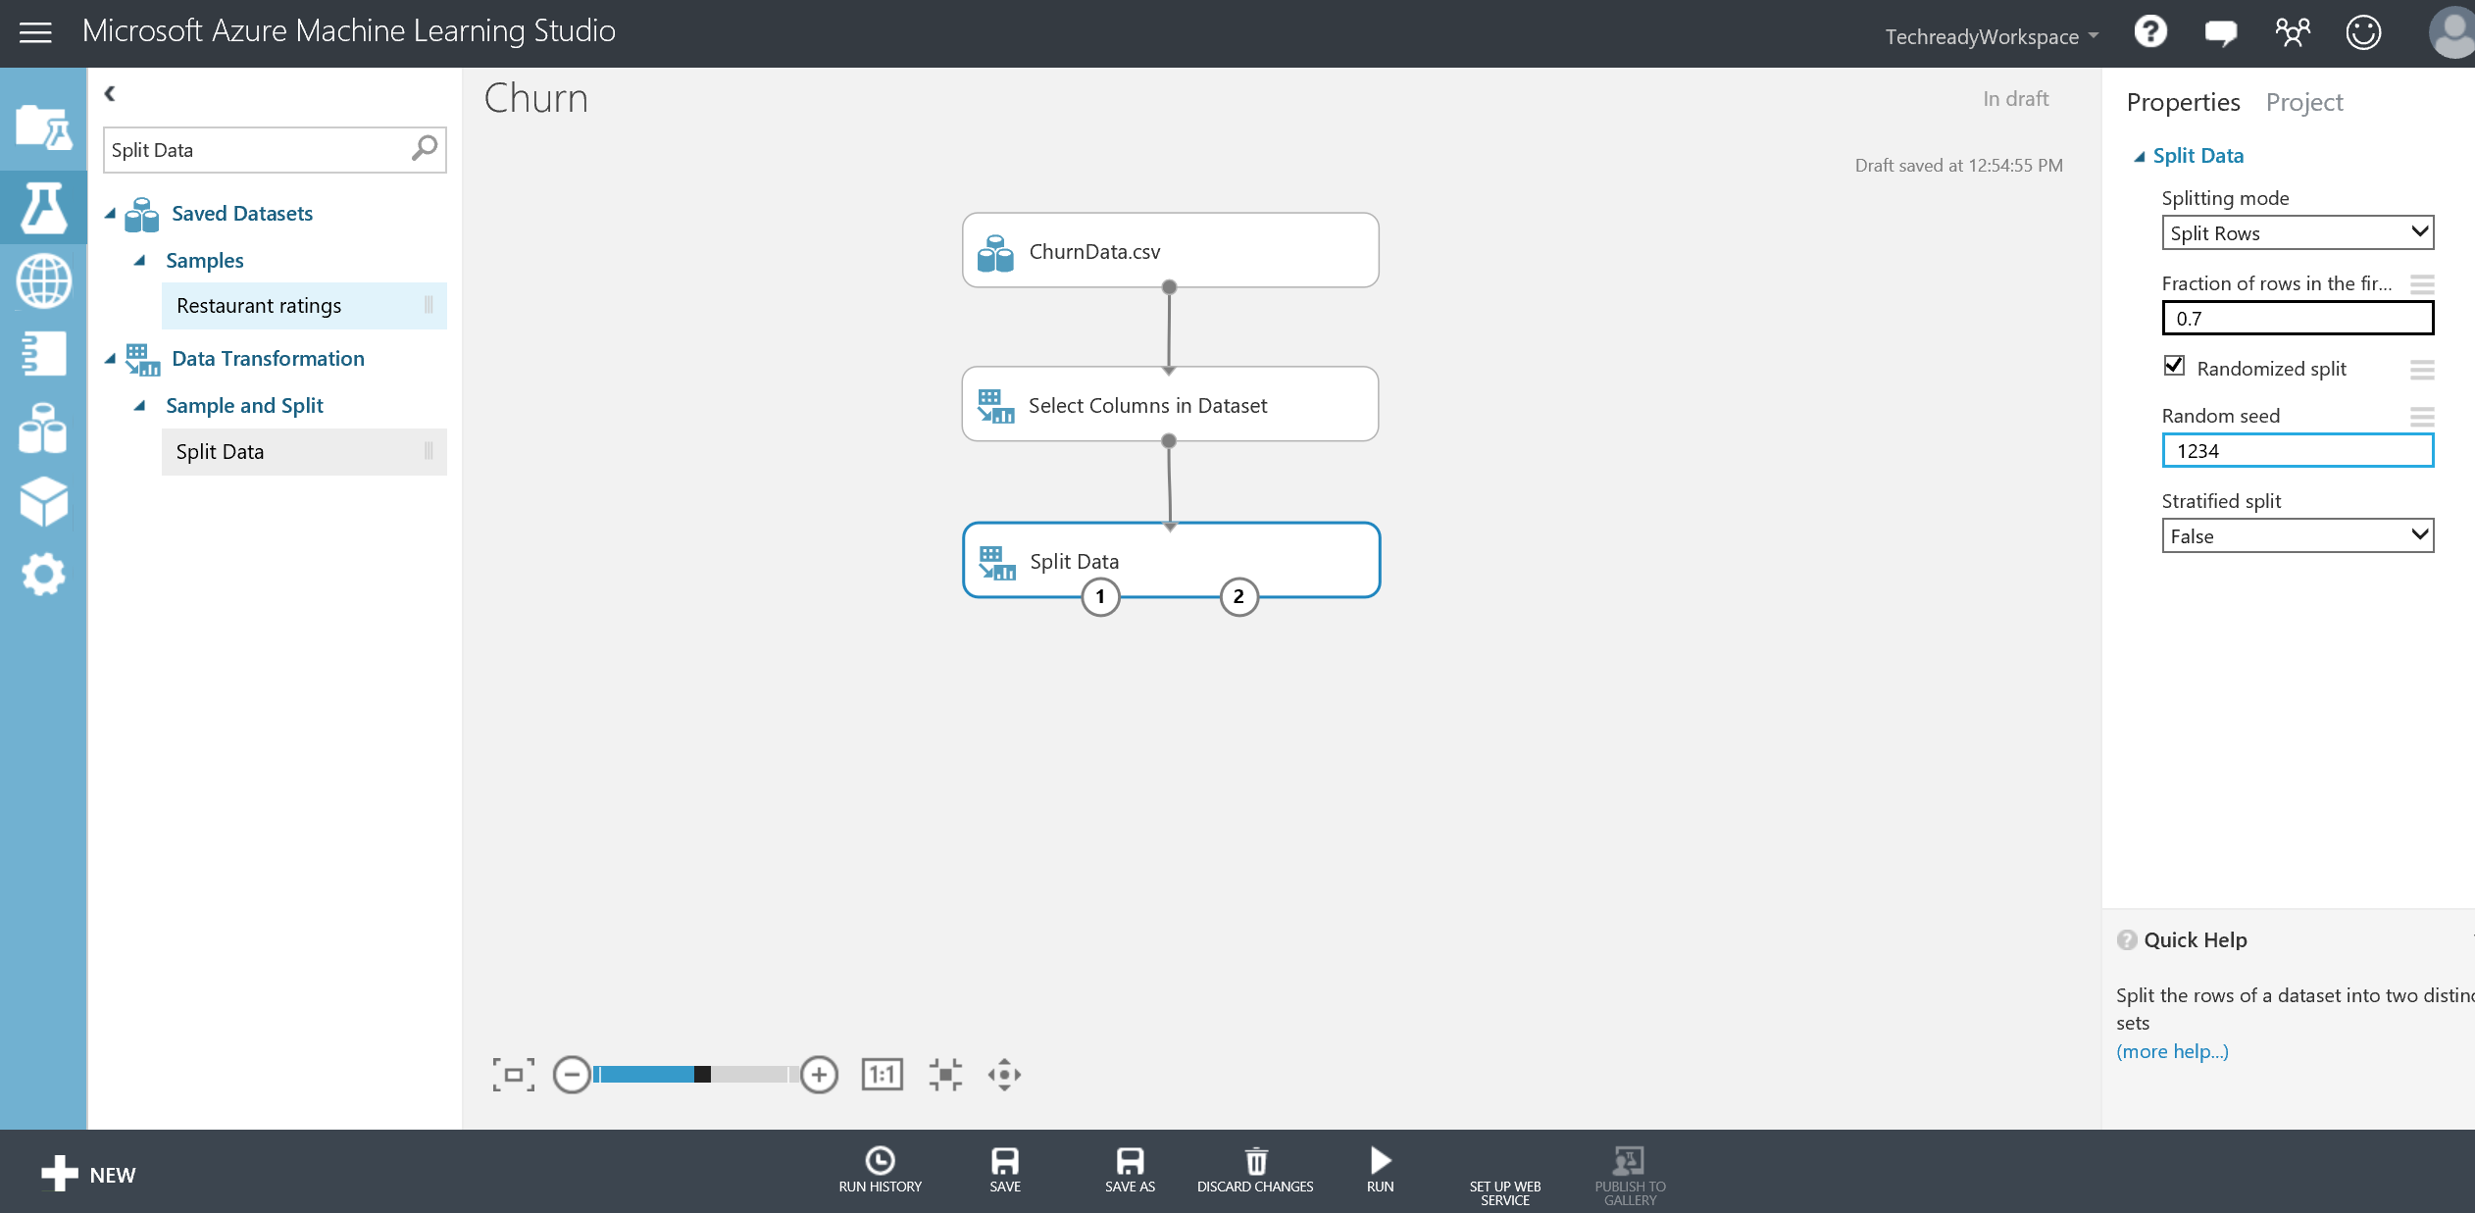

1. Now, on the left side navigation bar, type **Machine Learning** and under **Initialize Model, Classification** category**,** drag/drop **Two-Class Boosted Decision Tree** moduleon the experiment canvas. Next, under **Train** category, drag/drop **Train Model.** Connect **Results dataset1** output port of **Split** **Data** module to the **Dataset** input of **Train Model.** Also, connect **Untrained model** output port of **Two-Class Boosted Decision Tree** to the **Untrained model** input port of **Train Model.**

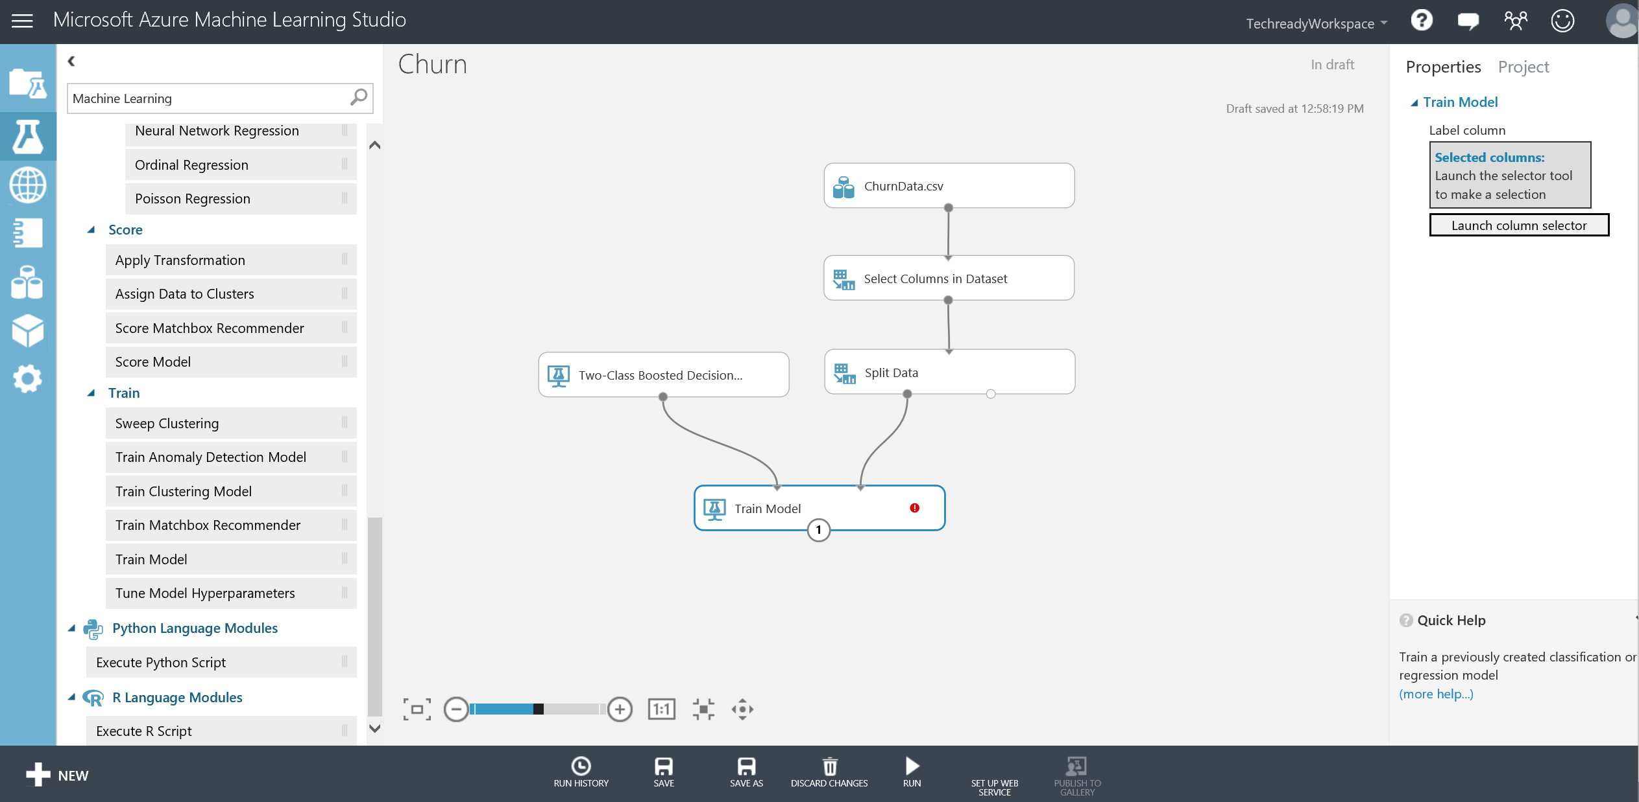

1. Click **Train Model** and on the Properties navigation bar on the right side, click **Launch column selector** and select **WITH RULES** tab. Next, select **Include** and **Column names** in the two drop downs and type or select **Churn_** in the textbox and click the check mark at the lower right corner.

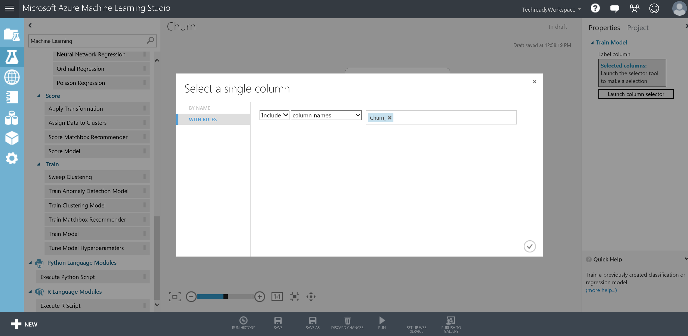

1. Type **Score Model** in the search box on the left navigation pane and drag/drop the module to the experiment canvas. Double click that module and type **Training** in the Label box (use the arrow to unhide the label). Connect **Trained model** output of **Train Model** module to the **Trained model** input of **Score Model** module. Next, connect **Results dataset1** output port from the **Split** module to **Dataset** input port of **Score Model** module and click **Run** at the bottom menu bar.

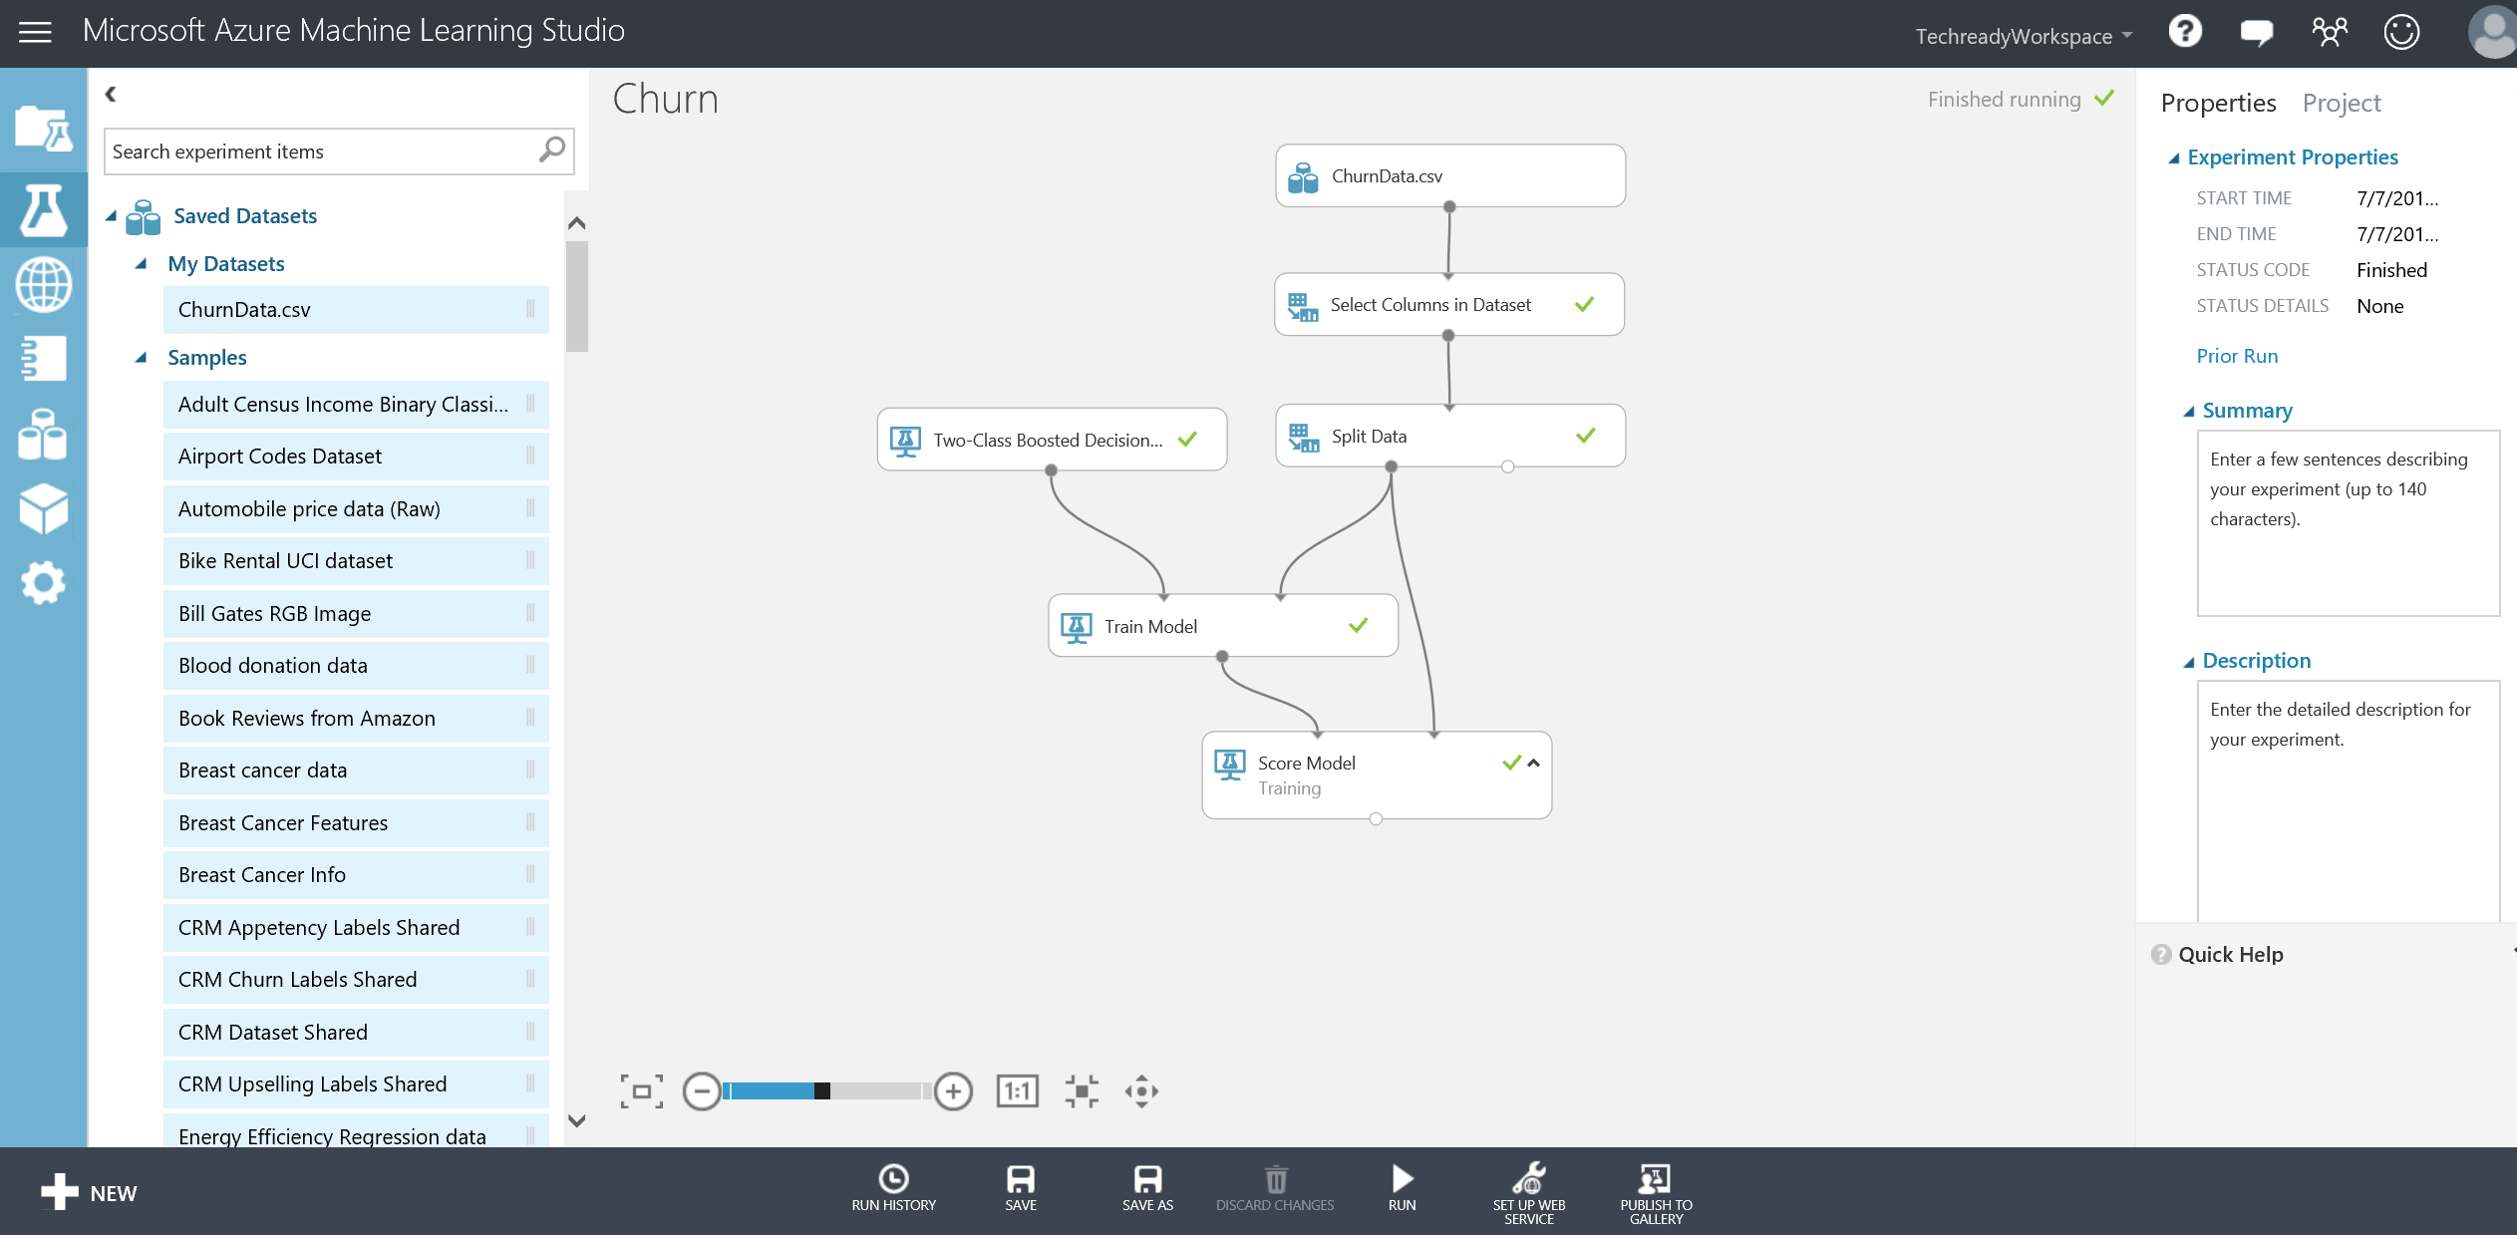

1. Make sure all modules have green check marks and experiment is finished. Right click **Scored dataset** output port of **Score Model / Training** and select **Visualize**. In the output page, scroll right to the end and observe the **Scored Labels** and **Scored Probabilities** columns. These are the predictions that the trained model has made on the top 100 training dataset rows. Scroll down and compare **Churn_** column with **Scored Labels** column to identify any false positives and false negatives. You will mostly find correct classifications where Churn_ and Scored Labels columns have the same value. We will look into the classification error (false positives and false negatives) in the Performance Evaluation section. Close the page using the close button on the upper right corner.

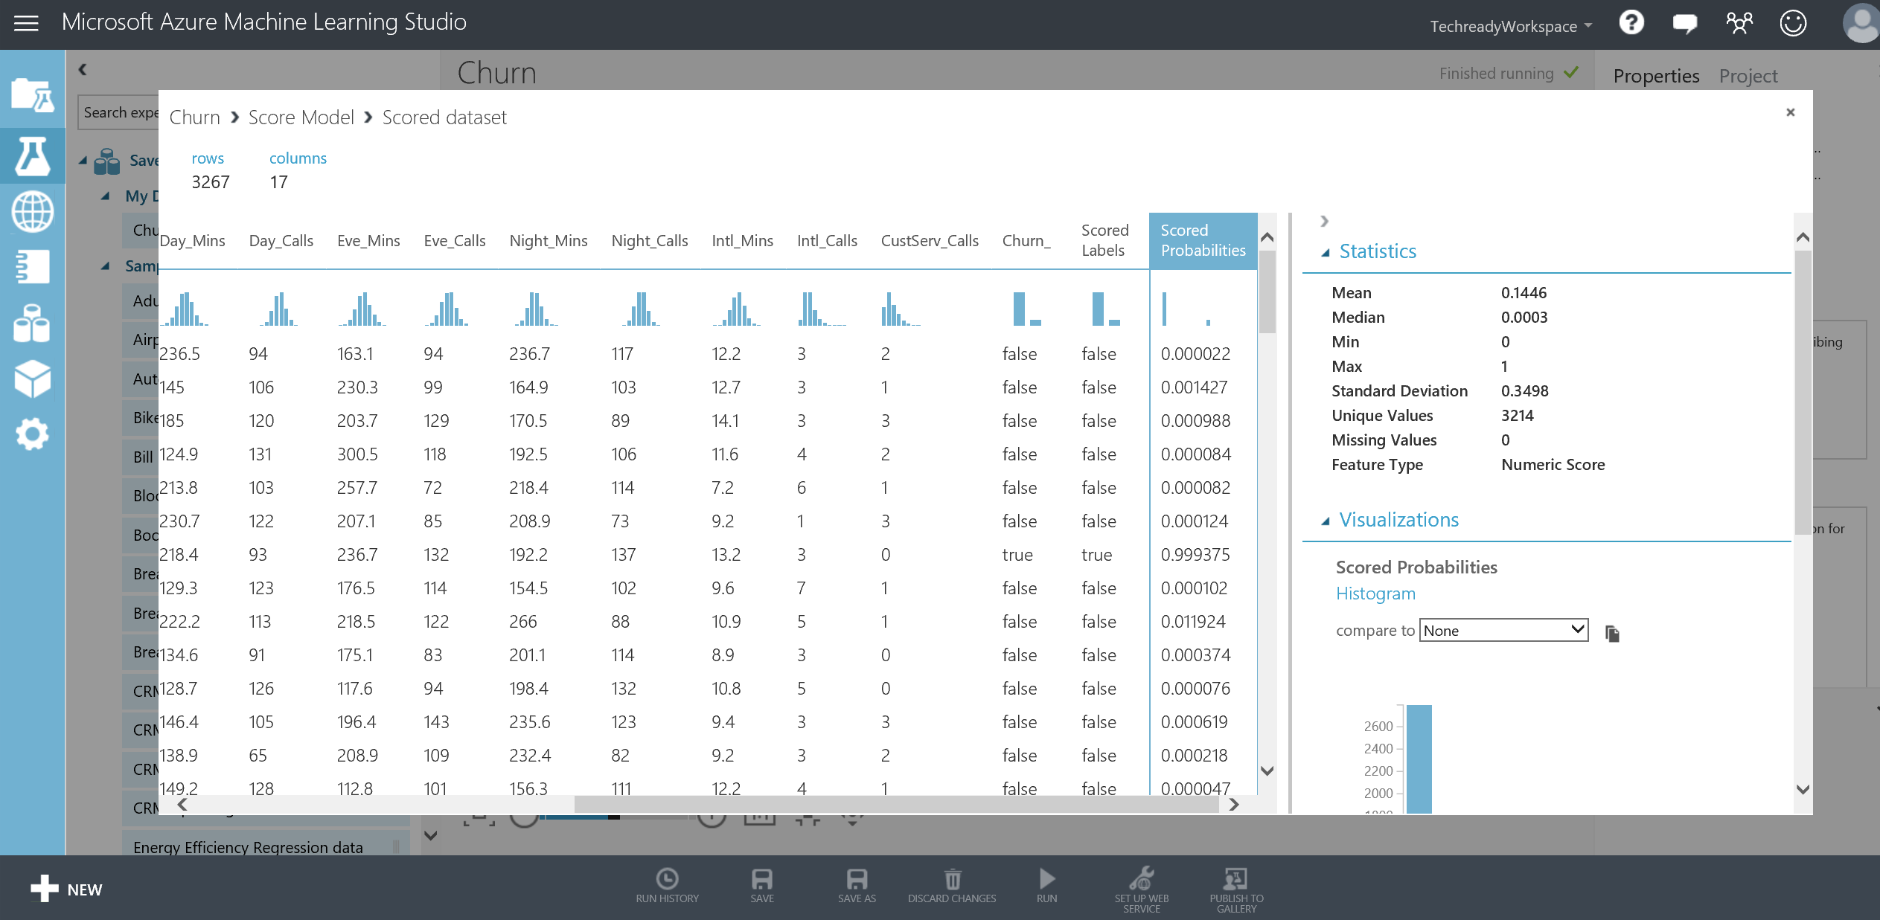

1. For testing, search for **Score Model** module again and drag/drop on the experiment. Double click the module and type **Testing** in the Label box. Connect the **Results dataset2** output of the **Split** moduleto **Dataset** input of **Score Model - Testing**. Now, connect the **Trained model** output of **Train Model** to **Trained model** input of **Score Model / Testing** and **Run** the experiment.

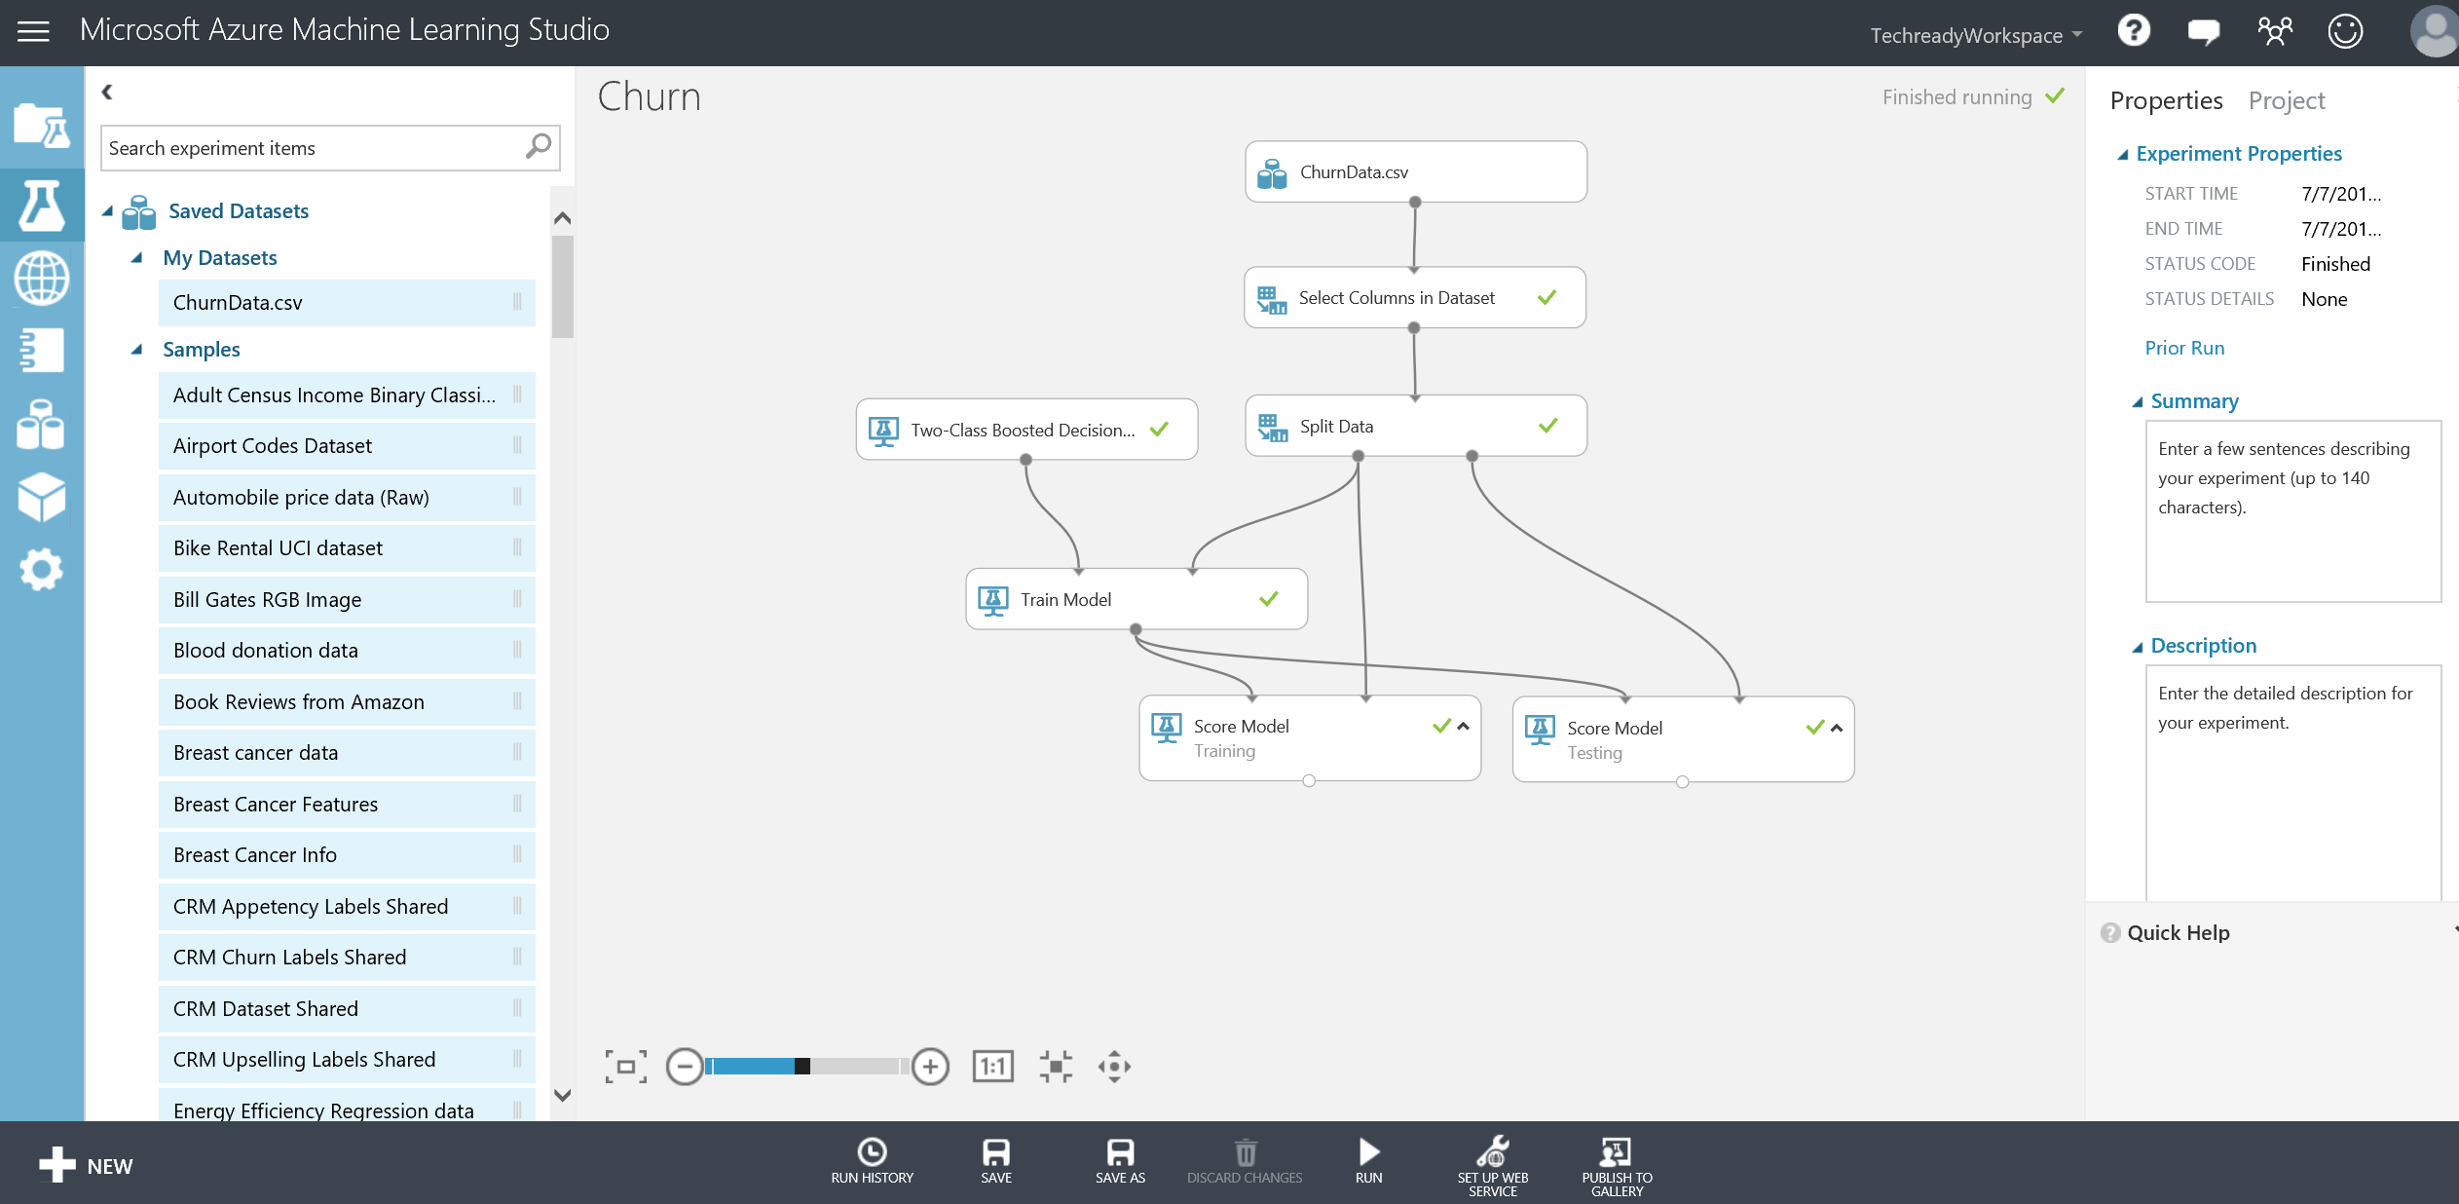

1. Right click **Scored dataset** output port of **Score Model – Testing** and select **Visualize**. In the output page, scroll right to the end of the page to observe the **Scored Labels** and **Scored Probabilities** columns. These are the predictions that the trained model has made on the test dataset. Scroll down and compare **Churn_** column with **Scored Labels** column to identify any false positives and false negatives. You will find that some rows are misclassified as **true** although the value for the **Churn_** column is **false.** These are called false positives. Close the page using the close button at the upper right corner.

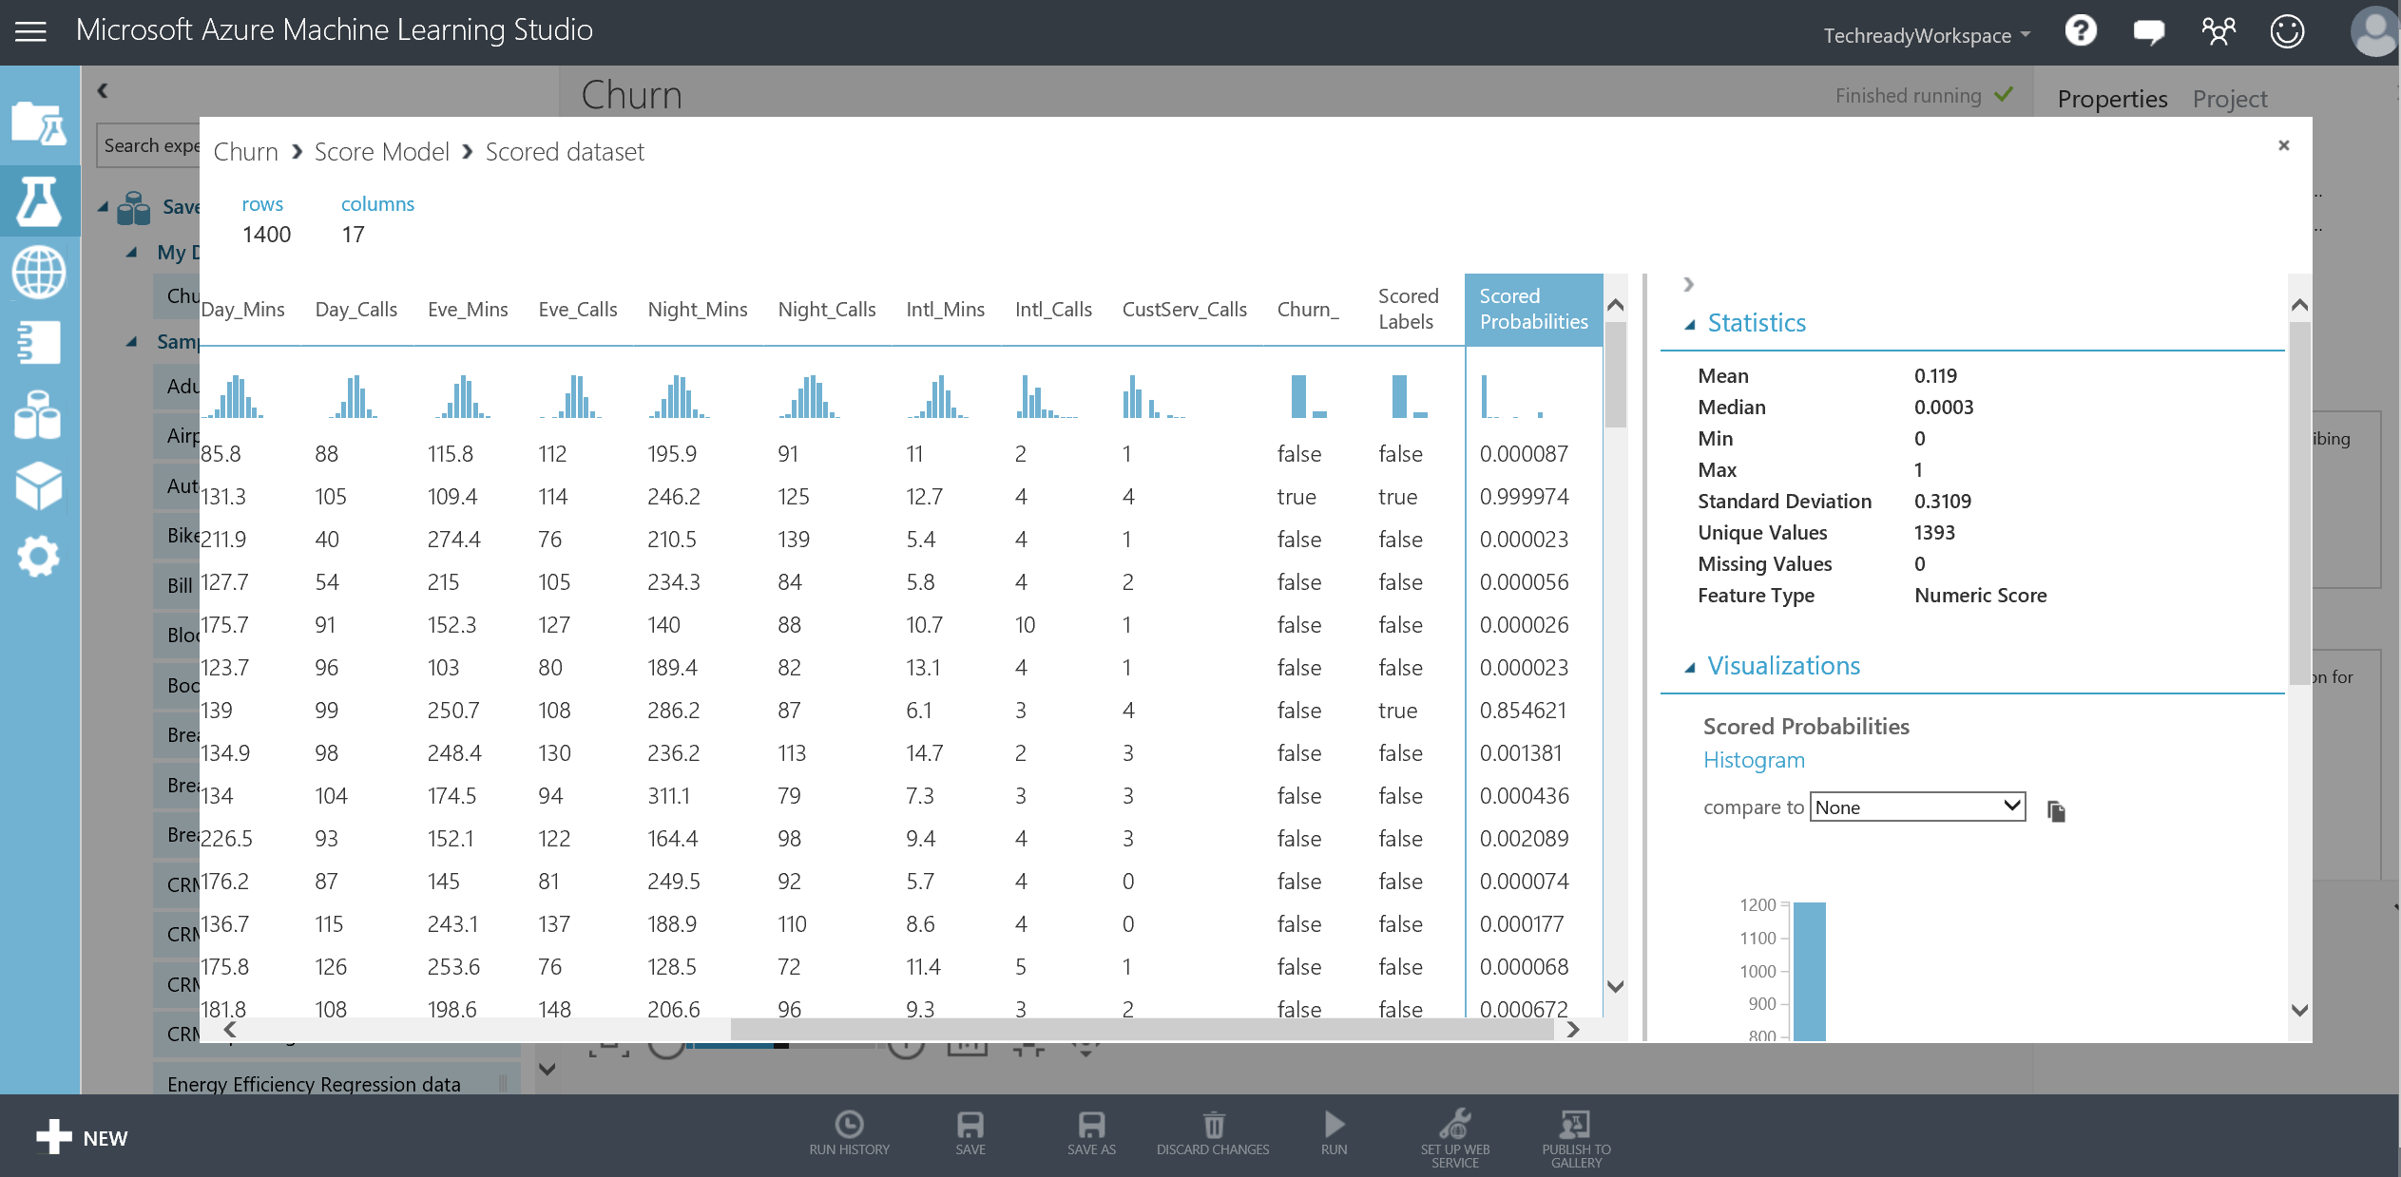

# Model Tuning

As a next step, you will use **Tune Model Hyperparameters** module to fine-tune your models.

**Key Points**

1. Machine Learning algorithms depend on hyperparameters that can change the model performance significantly. The best values for these hyperparameters are not computed while training the models so it is important to try different hyperparameters to find the best performing hyperparameter set.
2. As an example, some of the hyperparameters of Boosted Decision Trees algorithm are number of trees constructed and learning rate.

**Step-by-Step**

1. First, we will create a new experiment called **Churn Model Tuning**. Click on the **SAVE AS** button at the bottom bar**.** In the new window, change the experiment name to **Churn Model Tuning** and click the check mark. You will see that your experiment is renamed. You now have two experiments in your workspace. You can verify that by clicking the experiments tab on the leftmost navigation bar. Notice that a preview of the experiment is displayed on the right side.

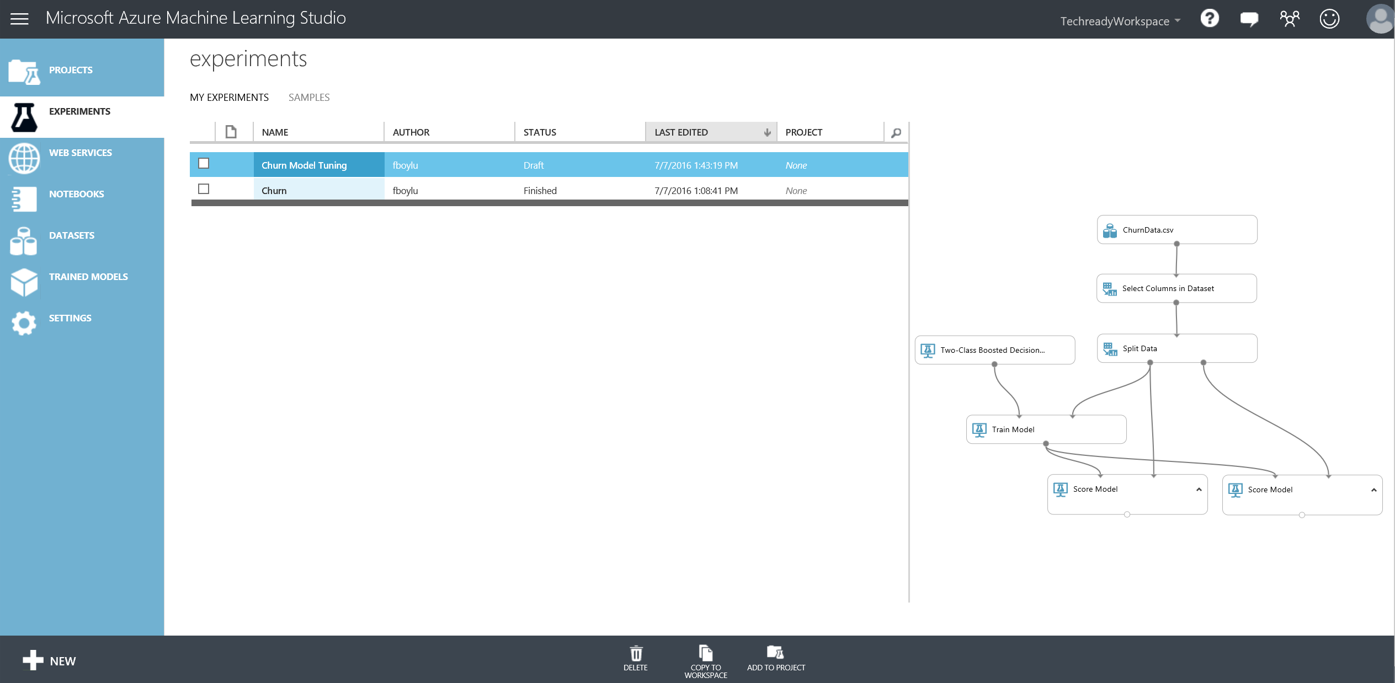

1. Go back to Churn Model Tuning experiment and in the search experiment items box, search for **Tune Model Hyperparameters** module and drop it on your experiment to replace Train Model module. Observe the Properties of Tune Model Hyperparameters module. It gives you the option to randomly sweep or sweep over a grid of the parameters of the training algorithm. Refer to the quick help page for more information on the module. In the properties pane, leave all options as default. However, you need to use column selector to select **Churn_** column as the label column.

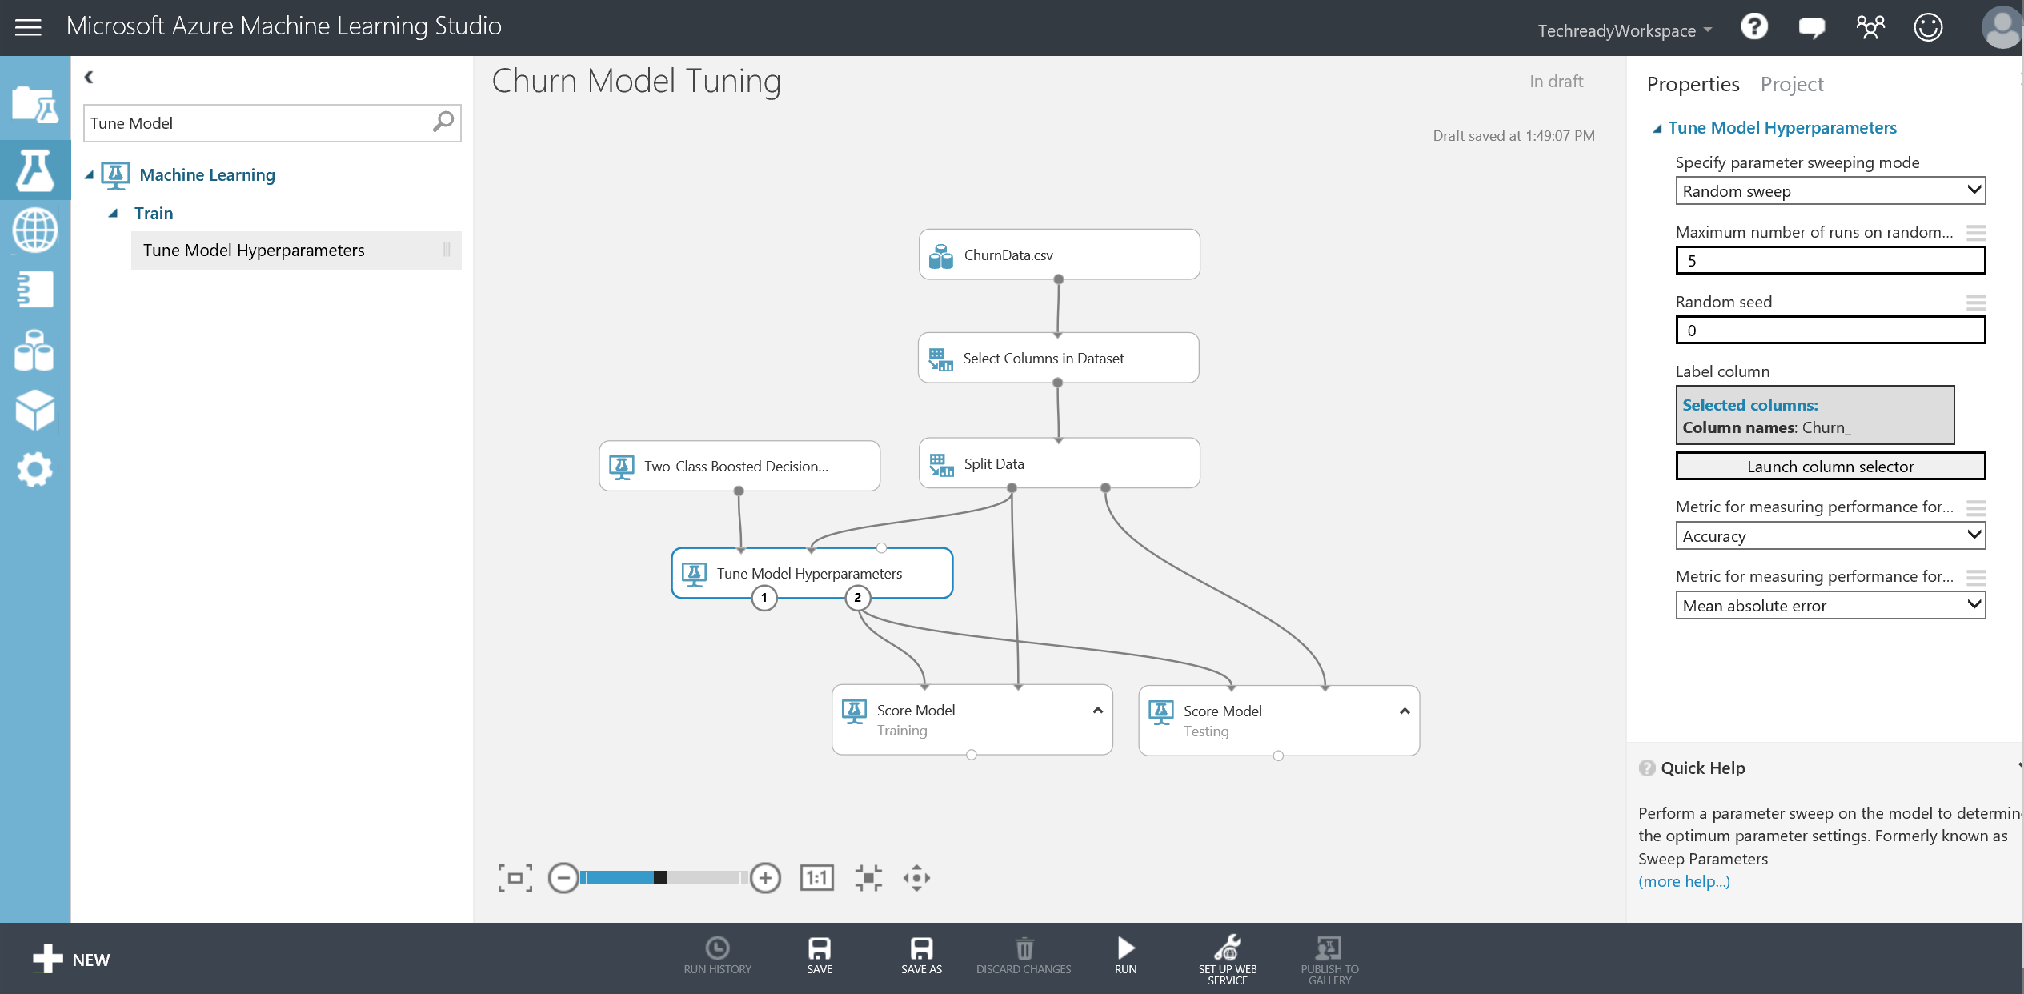

1. Now, select Two-Class Boosted Decision Tree module and on the parameters bar in the first drop down, chose **Parameter Range** and run your experiment.

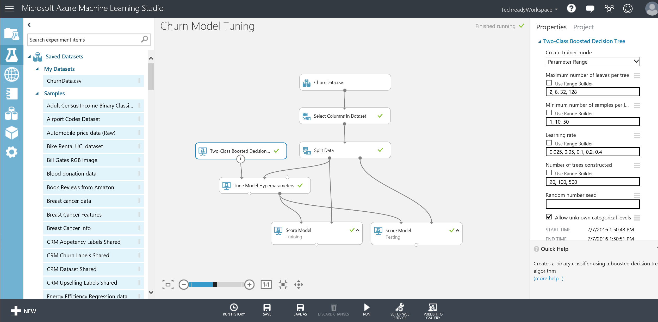

1. When finished, click on the left output port of Tune Model Hyperparameters and observe the random set of parameters that were used to run the experiment 5 times and their performance metrics. These will be discussed in the next sections.

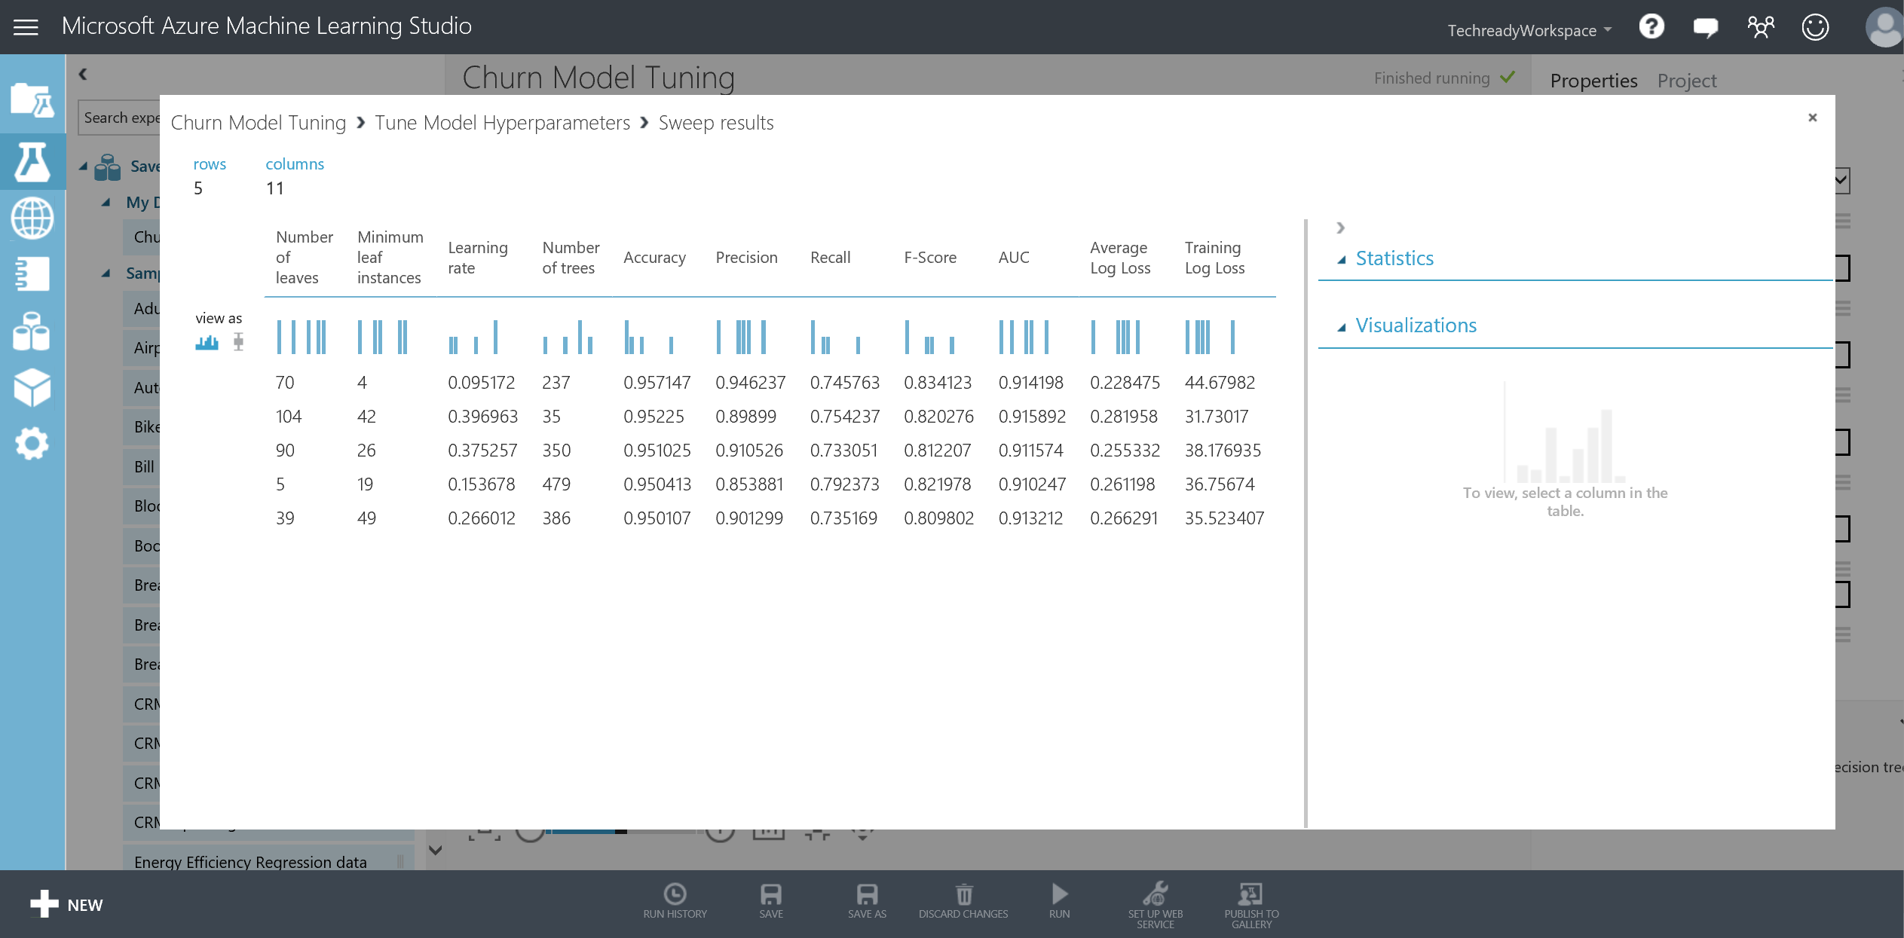

1. Close the window and click on the experiments tab on the left bar to return back to the Churn experiment.

# Performance Evaluation

In this exercise, you will assess the predictive power of the models you have built so far. You will observe the performance of the model on the training set and compare that to the test set to understand the trade-off between over fitting and generalization.

**Key Points**

1. To understand performance of a model, a few basic concepts must be introduced. For binary classification models, there are four possible outcomes:
   1. True Positive (TP) - a positive instance that is correctly classified as positive;
   2. False Positive (FP) - a negative instance that is incorrectly classified as positive;
   3. True Negative (TN) - a negative instance that is correctly classified as negative;
   4. False Negative (FN) - a positive instance that is incorrectly classified as negative).
2. There are three related metrics that are used to measure performance.
   1. Precision is calculated by TP/ (TP+FP)
   2. Recall is calculated by TP/ (TP+FN)
   3. Accuracy is calculated by TP+TN/ (TP+FP+TN+FN).
3. ROC curve is an important performance measure which will be explained in this section.

**Step-by-Step**

This exercise takes about 10 minutes to complete.

1. Go to your Churn experiment. Type **Evaluate Model** to the search box on the left and drag/drop it on the experiment. Connect the **Scored dataset** output port of **Score Model / Training** module to the left side **Scored dataset** input port of **Evaluate Model**.
2. Connect the **Scored dataset** output port of **Score Model / Testing** module to the right side **Scored dataset** input port of **Evaluate Model** and click **Run.**

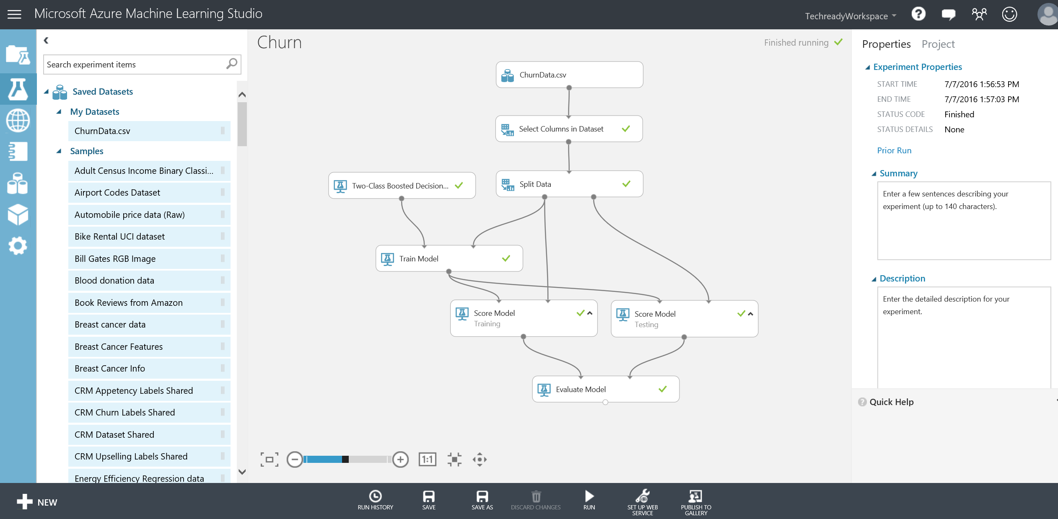

1. Right click the **Evaluation results** output port of **Evaluate Model** and select **Visualize.**

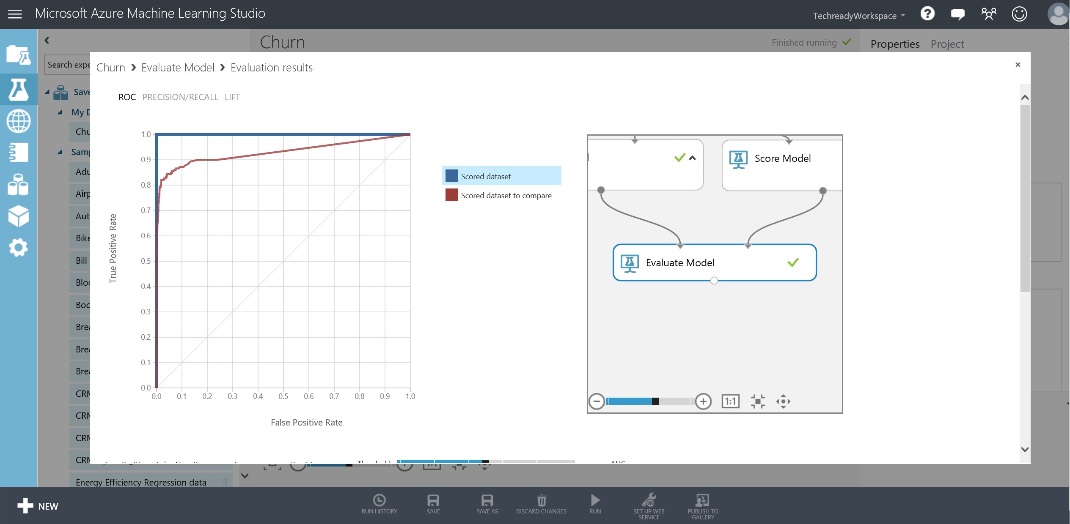

1. Notice that you are looking at **ROC** curves of both the training and test sets interlayered on top of each other for easy comparison. Also, when you scroll down the window, you will find the misclassification matrix. The blue curve (highlighted on the legend) belongs to the training set and shows that the classifier has perfect performance since the training dataset has no misclassifications (**False Positives** or **False Negatives). AUC** is calculated as the area under the **ROC** curve which maps performance into a single scalar. The ROC curve is a two-dimensional representation of a model's performance. A perfect model will score an AUC of 1, while random guessing (diagonal line stretching from (0,0) to (1,1)) will score an AUC of 0.5.
2. Now, highlight the red curve by clicking the legend to examine the test set performance. You can see that the test set AUC is lower than the training set meaning that the classifier made errors on the test data. Now observe the confusion matrix for TP, FP, TN and FN counts. 20 data points were misclassified as false positives and 36 as false negatives. Close the window to return to the experiment.

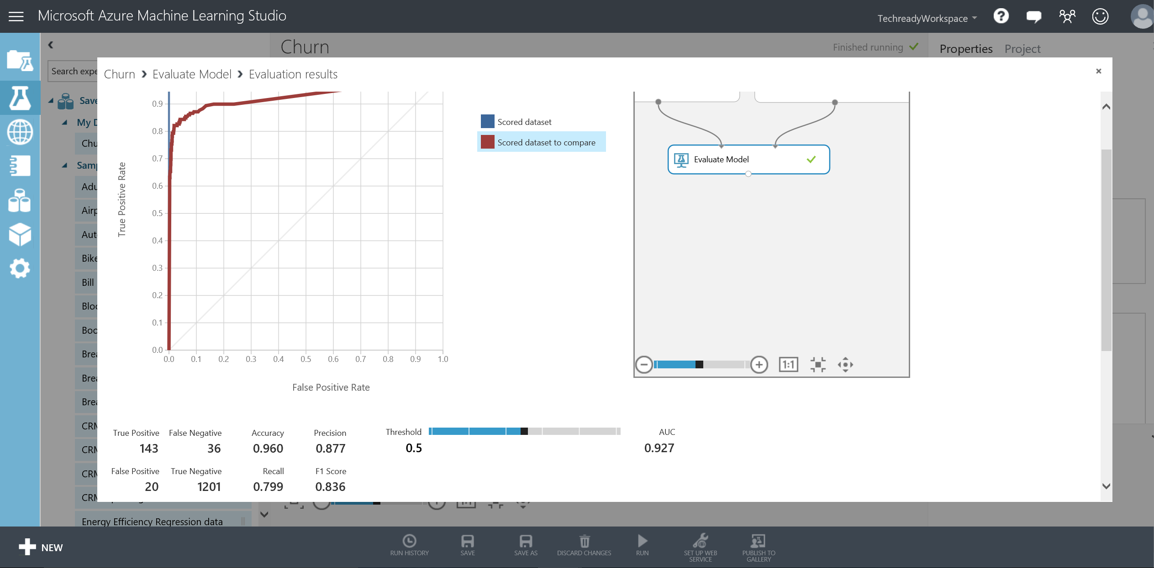

# Executing R Scripts

In this exercise, you will use the **Execute R Script** module to fit a decision tree algorithm to the churn data and visualize it by using the pre-installed R package called **party** within Azure ML. You will also use **ggplot2** package to create a visualization of the data. The purpose of this section is to get you introduced to the functionality in general and is not intended to dive into R scripting or to provide a detailed description of the package used.

**Key Points**

1. Azure ML can easily be extended with open source R packages and scripts to complement the existing modules.

**Step-by-Step**

This exercise takes about 10 minutes to complete.

1. First, we will create a new experiment called Churn Decision Tree. At the bottom bar, click on **SAVE AS,** type **Churn Decision Tree** for the experiment name and click the check mark. In the experiment, delete all the modules except **ChurnData.csv** and **Select Columns in Dataset.**
2. Next, type **Execute R Script** in the search box and drag the module and connect its first input port to the output port of **Select Columns in Dataset**.

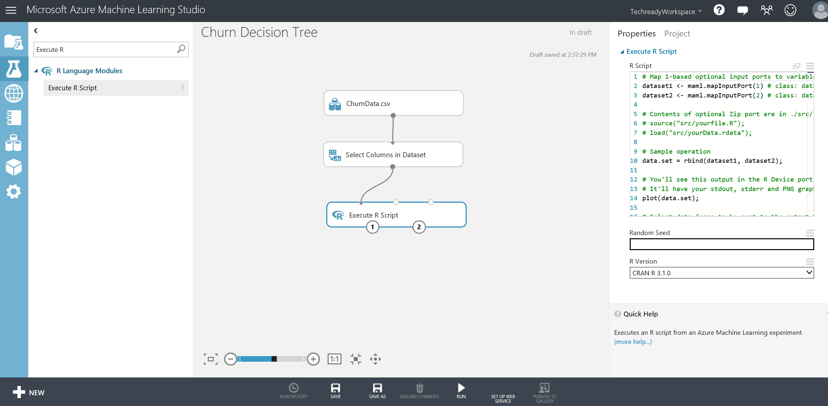

1. Replace the contents of the **R script text** box on the Properties panel with the following script below which you can find in the first part of the **R_Script.txt** file under C:\Lab1 folder (Copying and pasting from below may not work).

ChurnData <- maml.mapInputPort(1) # class: data.frame

library(party)

ChurnData[,c("State","Int_l_Plan","VMail_Plan")]<-lapply(ChurnData[,c("State","Int_l_Plan","VMail_Plan")], as.factor)

model<- ctree(Churn_~ . ,data= ChurnData,control = ctree_control(maxdepth=3))

plot(model, main = 'Churn Decision Tree', type = "simple")

print(model)

ChurnProb<- unlist(predict(model,ChurnData,type="prob"))

ChurnClass<- ChurnProb >= 0.5

ChurnPred <- data.frame(ChurnData$Churn_, ChurnClass,ChurnProb)

colnames(ChurnPred)<-c("Churn_","Scored Label","Scored Probability")

*# Select data.frame to be sent to the output Dataset port*

maml.mapOutputPort("ChurnPred");

1. Run the experiment. After it is finished, it should look like the screenshot below:

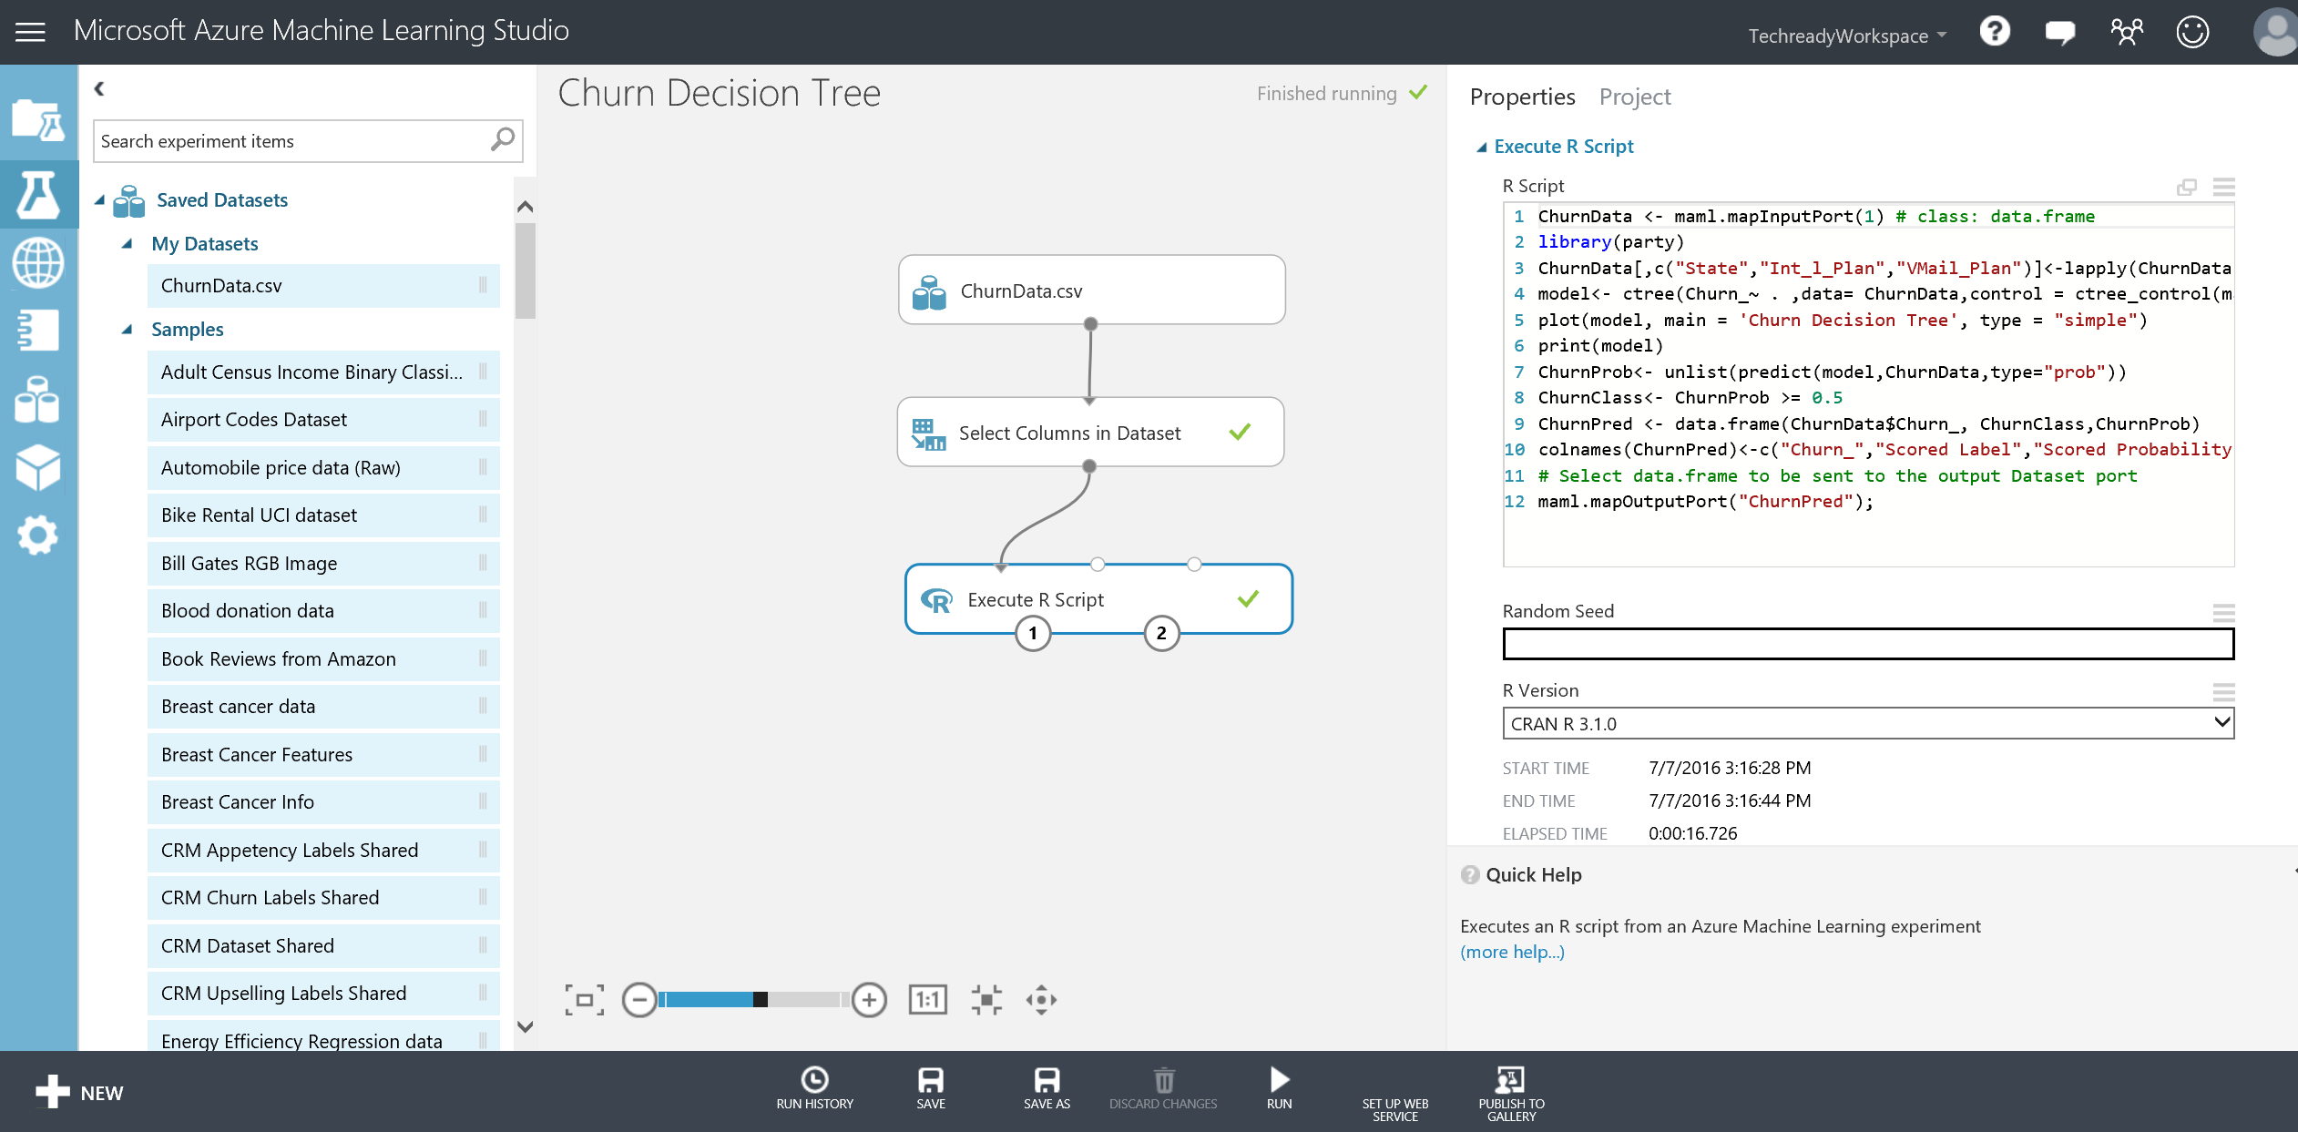

1. The above script calls the R package **Party (**[**http://cran.r-project.org/web/packages/party/index.html**](http://cran.r-project.org/web/packages/party/index.html)**)** and computes a small decision tree with 3 levels and also outputs the predicted labels and probabilities. Right click the left output port of Execute R module and **Visualize** to observe the predictions of the decision tree that was trained on the whole dataset.

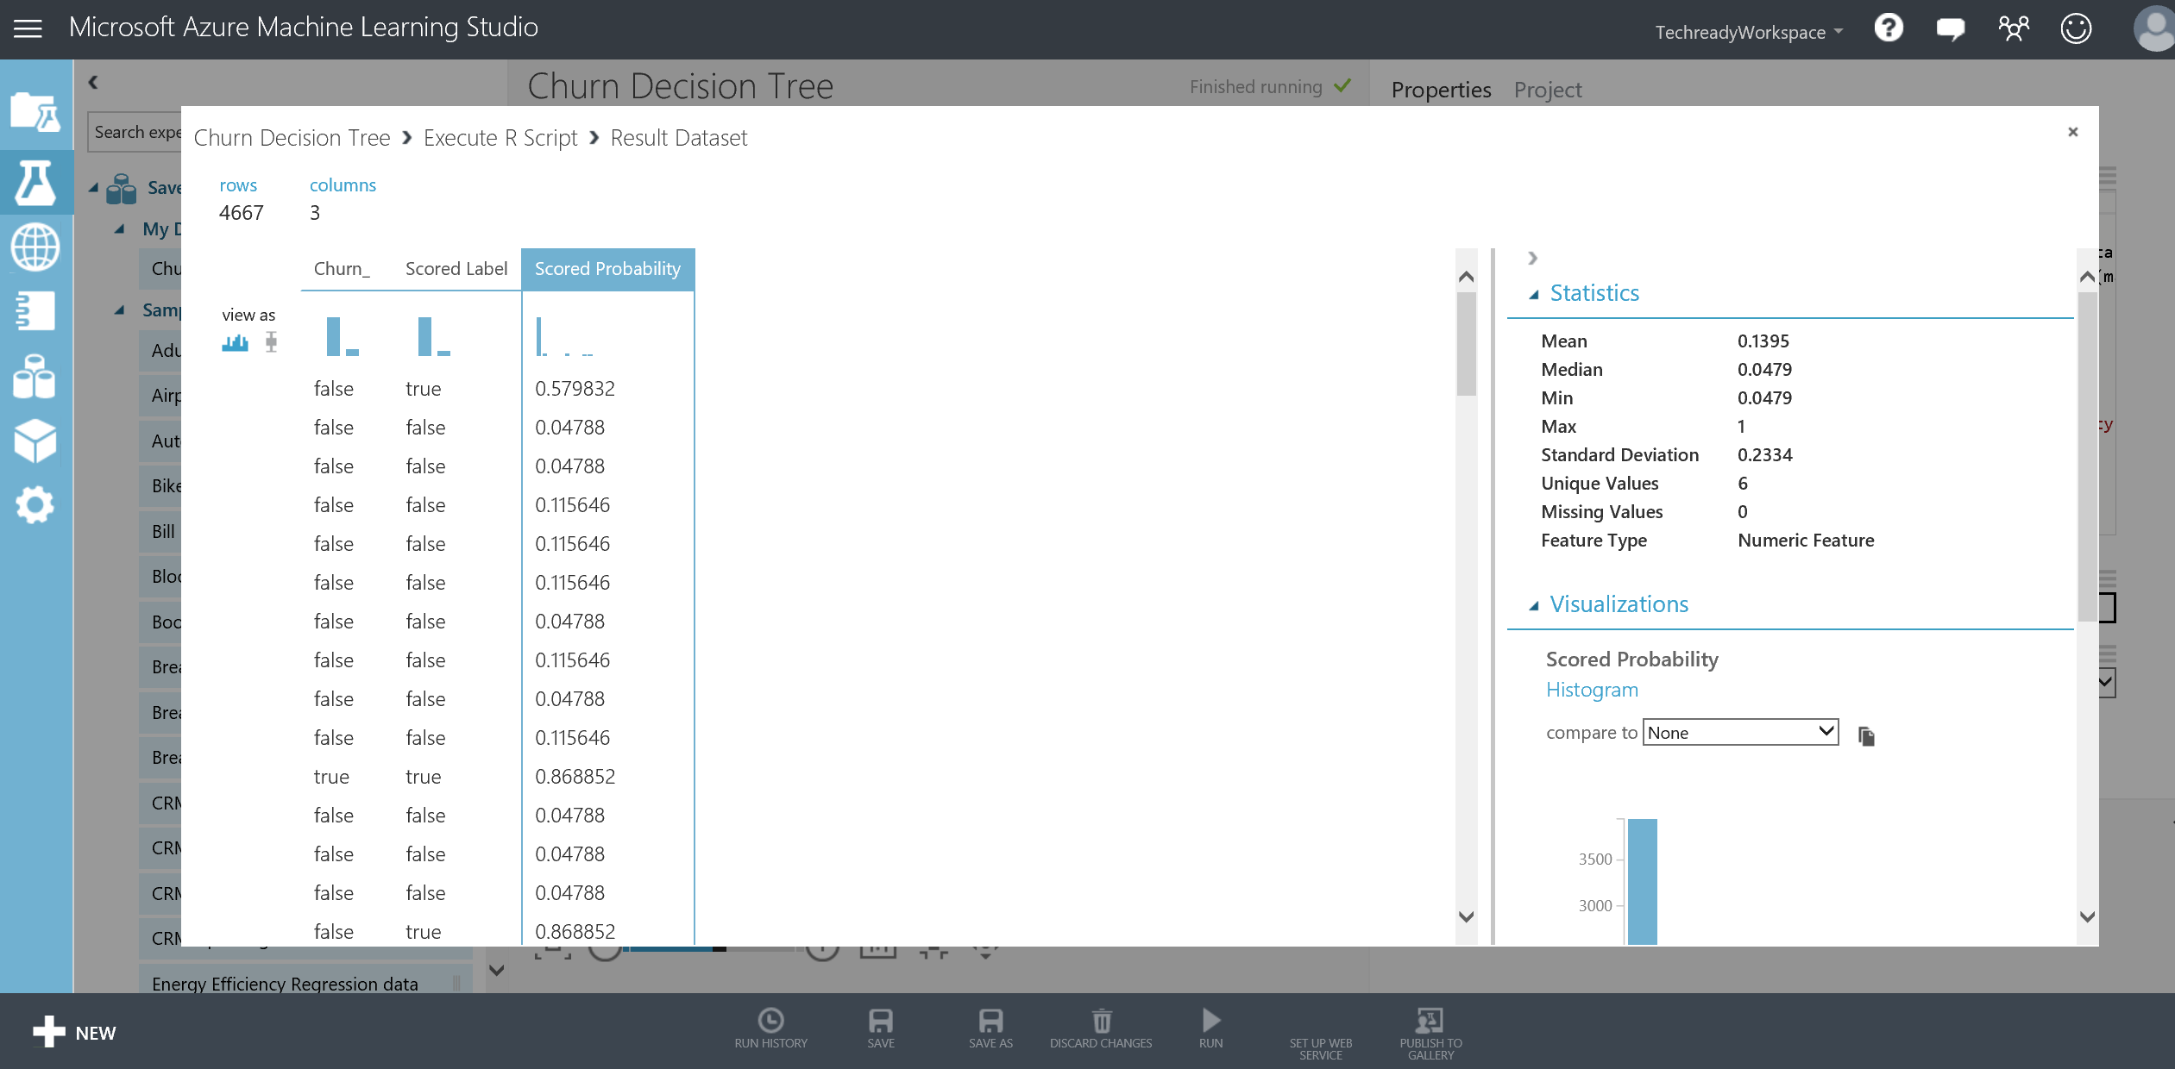

1. Close the window and this time right click the second output port of the Execute R script module and **Visualize.** You will find the plot of the decision tree that was just computed. Please refer to the package documentation provided at the link above for more details of the usage of the functions included in the package and their outputs.

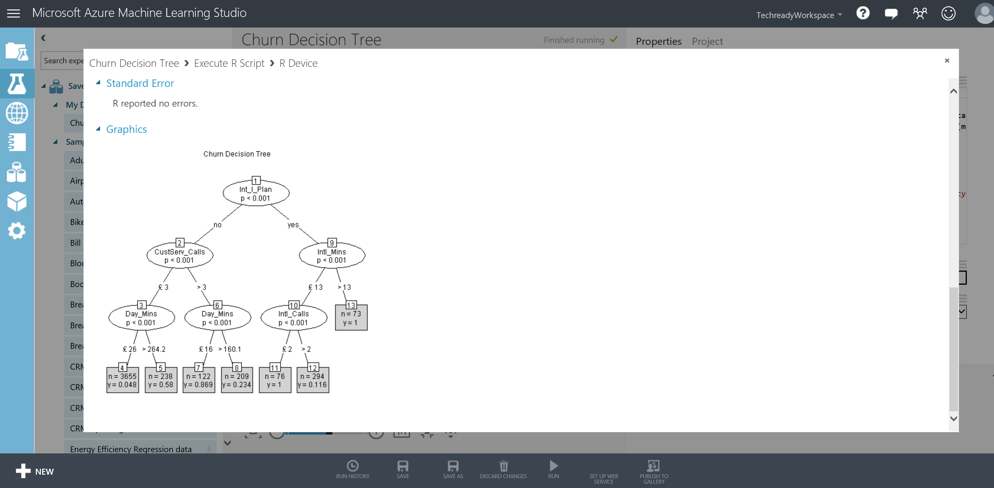

1. Next, place another **Execute R Script** on the experiment canvas and connect its first input port to the output port of **Project Columns**. Replace the contents of the **R script text** box on the Properties panel with the following (you can also find a copy of the script under C:\Lab1 folder):

ChurnData <- maml.mapInputPort(1) # class: data.frame

library(ggplot2)

# Scatter plot of Account_Lenght vs CustServ_Calls by churn

ggplot(ChurnData, aes(x=Account_Length, y=CustServ_Calls, color=Int_l_Plan))+ geom_jitter()+facet_wrap(~Churn_)

# Select data.frame to be sent to the output Dataset port

maml.mapOutputPort("ChurnData");

1. The above script calls the R package ggplot2 **(**[**https://cran.r-project.org/web/packages/ggplot2/index.html**](https://cran.r-project.org/web/packages/ggplot2/index.html)**)**

and creates scatter plots of Account_Lenght and CustServ_Calls by faceting according to Churn_ column. When finished your experiment should like the below:

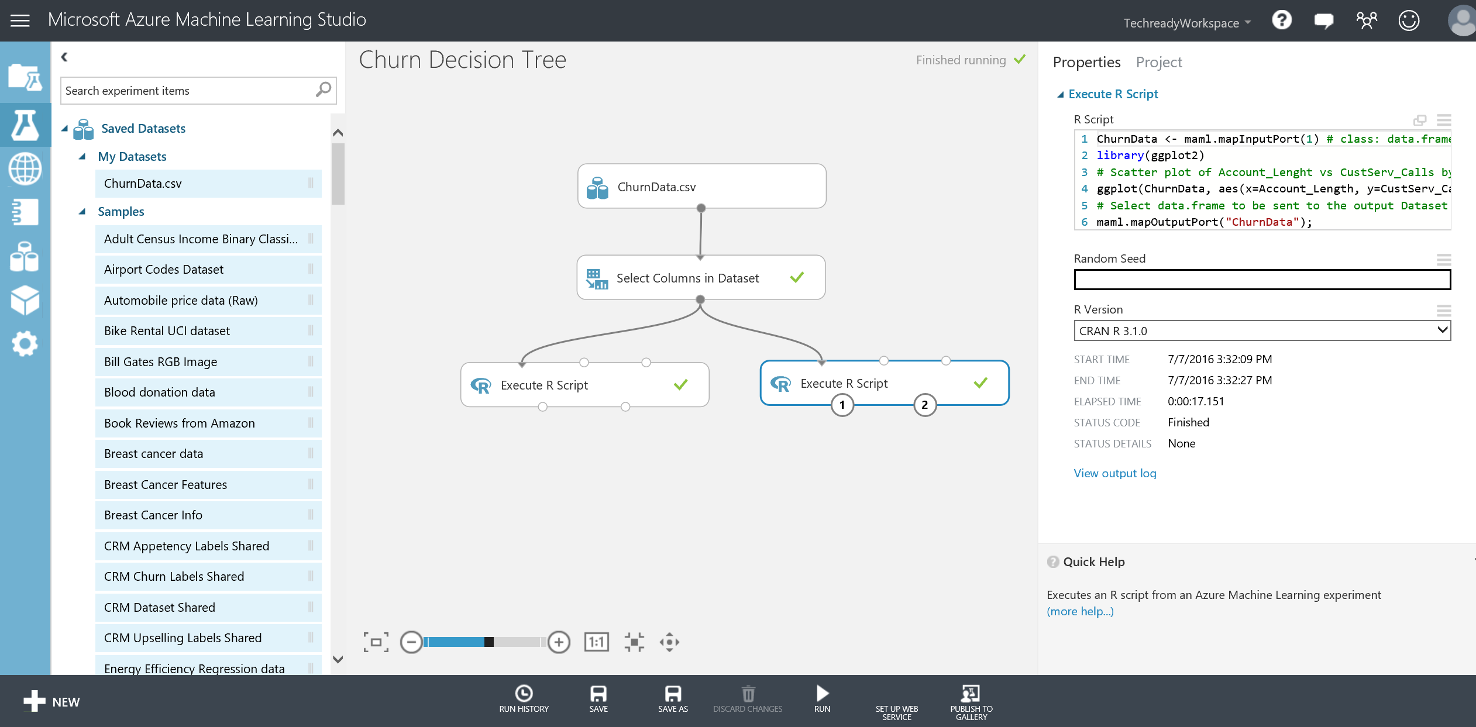

1. Right click the second output port of that Execute R module and **Visualize** to observe the plots generated by the script.

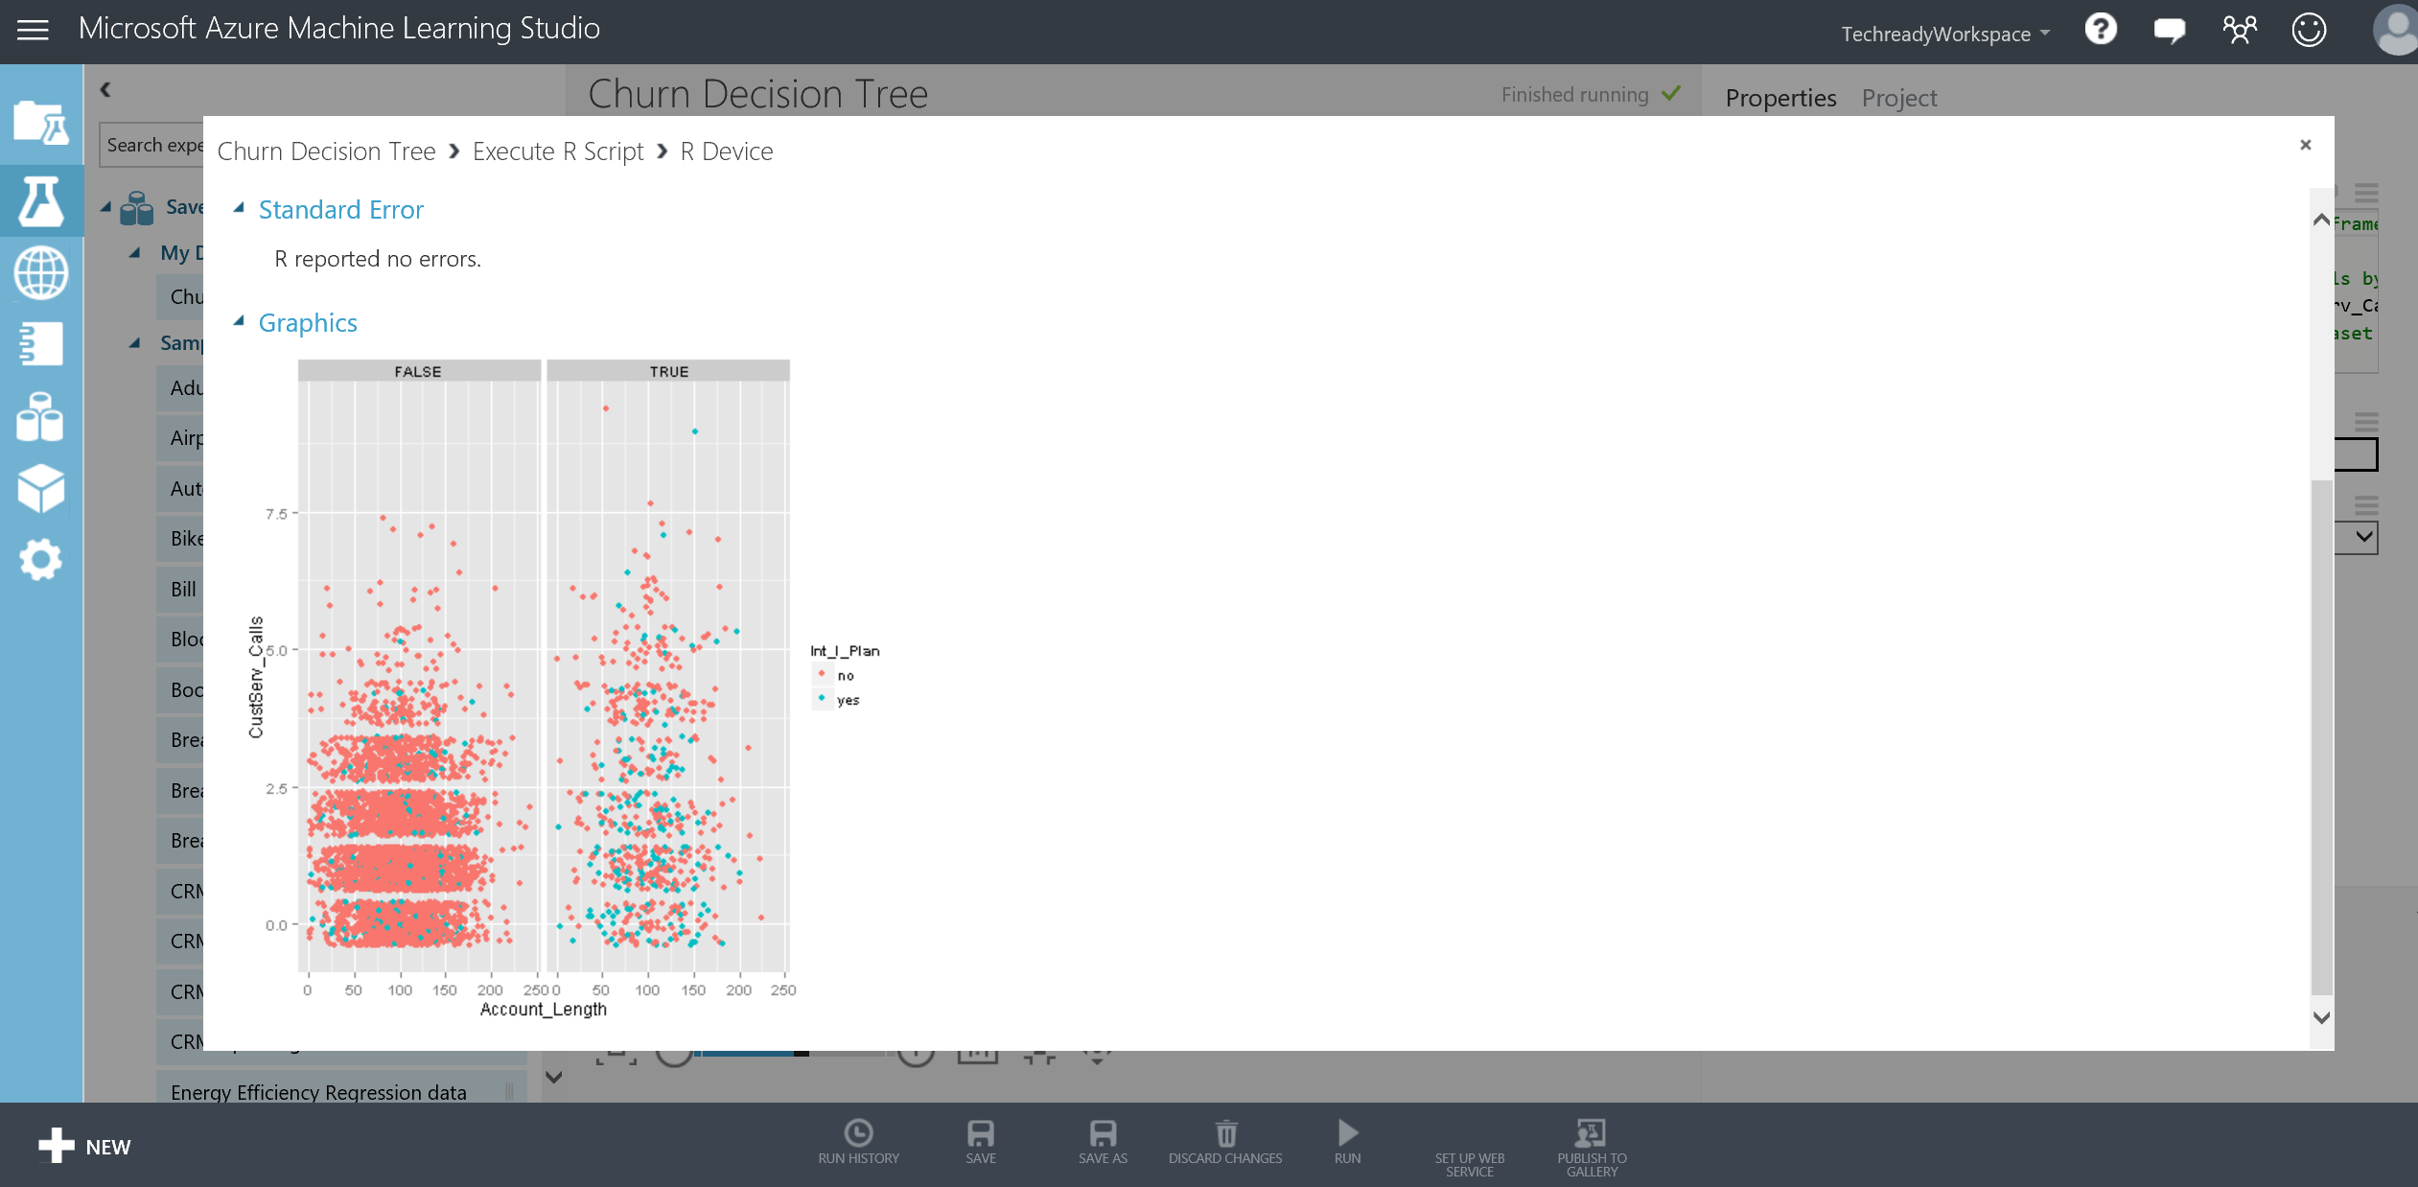

# Creating a Web Service for Binary Classification Model

In this part, you will create a Web service for the Churn experiment that you created before, operationalize and deploy your model to production.

**Key Points**

1. After creating the web service, you will use the test option to verify the RRS (request response service) is operational.
2. Azure ML provides example code snippets in different languages (C#, R etc.) that can be used to call the service from within different custom applications.

**Step-by-step**

This step takes about 15 minutes to complete.

1. Return to the binary classification experiment named Churn, make sure the status of the experiment in the upper right hand corner of the page is **Finished running**. Click on **SET UP WEB SERVICE** button at the bottom of the screen, then select **Predictive Web Service [Recommended].** Your experiment will be named **Training experiment** and a new tab called **Predictive experiment** will automatically be created for you. In the predictive experiment, you will now see a **Web service input** module which defines the input schema of the web service call and a **Web service output** module which defines the output schema. This is an automatic experiment creation as the starting point to setting up your web service. In this new predictive experiment, the model is pre-trained (taken from the training experiment), so that when the web service is called, it will simply score using that trained model. You can find this trained model in the experiment items under **Trained Models** category.

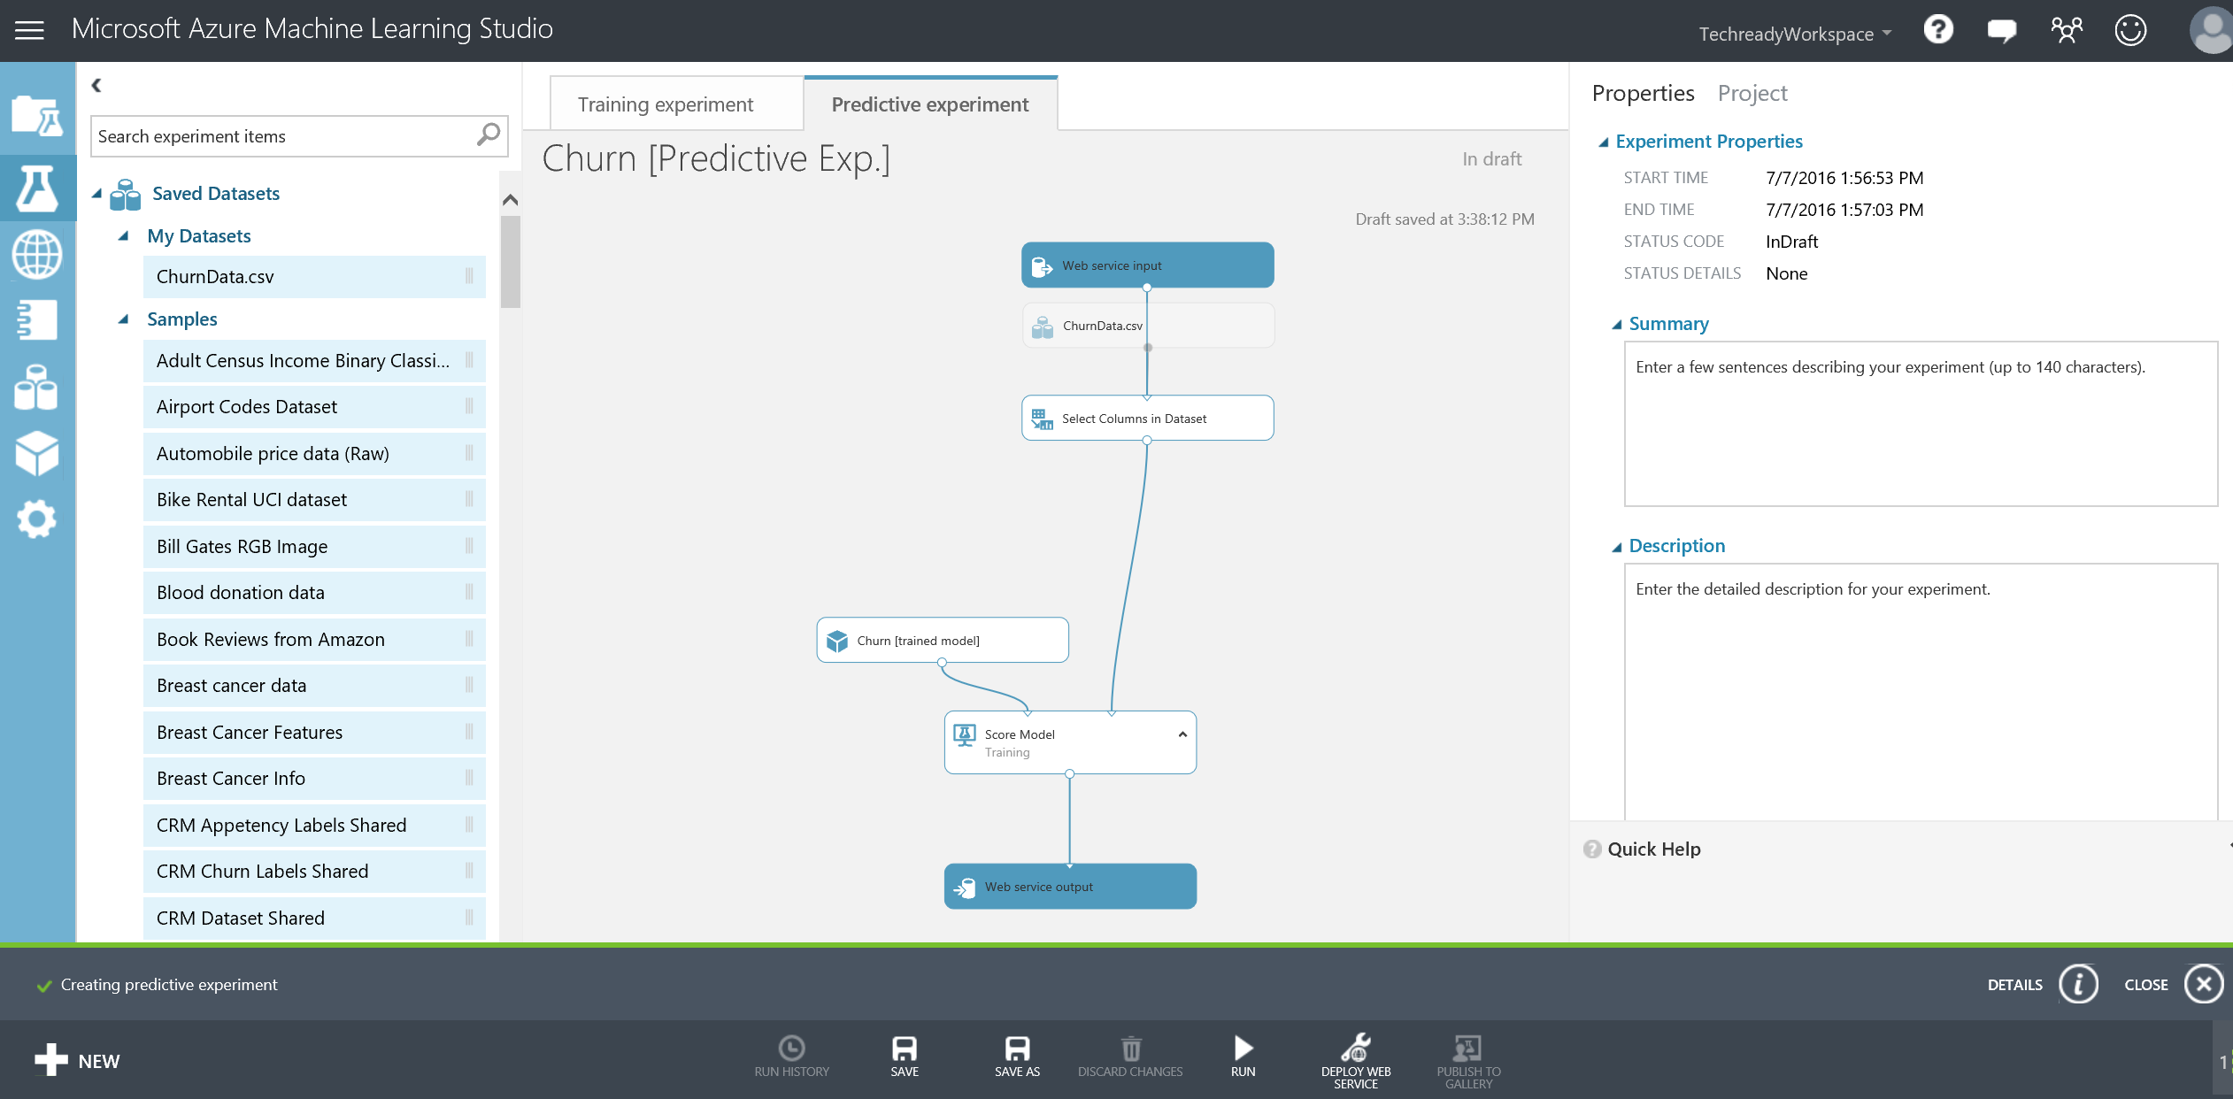

1. Move the connection that goes from the **Web Service Input** to the **Project Columns** to instead go from **Web Service Input** to the right input port of **Score Model.** This changes the web service input to only take the relevant features for the model.

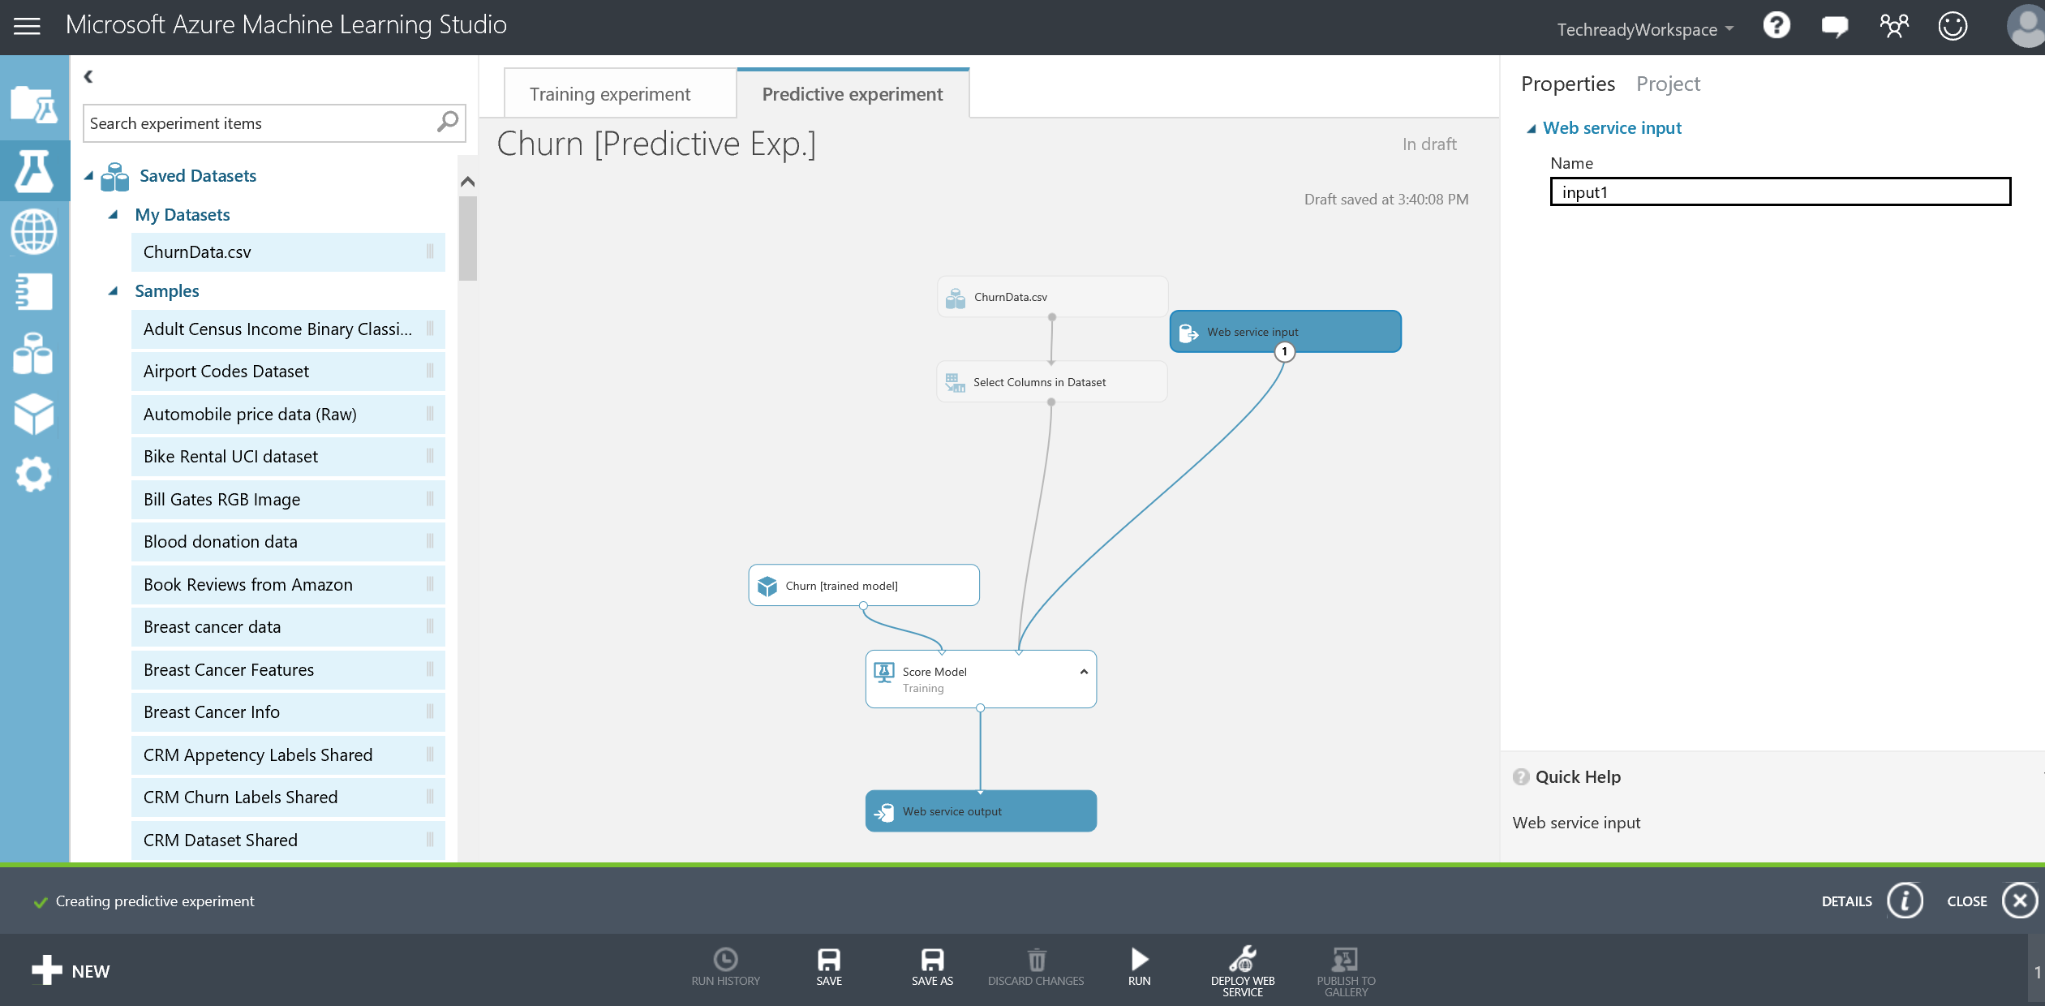

1. **Run** the experiment and once it is finished, click **DEPLOY WEB SERVICE** at the bottom bar. This will take you to the web service dashboard. Observe the **API key** and **REQUEST/RESPONSE** help page links.
2. To test the service, click on the blue **Test** button in the second column of the Default Endpoint table at the bottom of the page. When **Enter data to predict** window pops up, enter the following values: State: NJ, Account_Lenght: 127, Intl_Plan: no, Vmail_plan: no, Vmail_message: 0, Day_mins: 245, Day_calls:91, Eve_mins:217, Eve_calls:92, Night_mins:243, Night_calls: 128, Intl_mins:14, Intl_calls: 6, Custserv_calls: 0, and leave Churn_ unchecked.

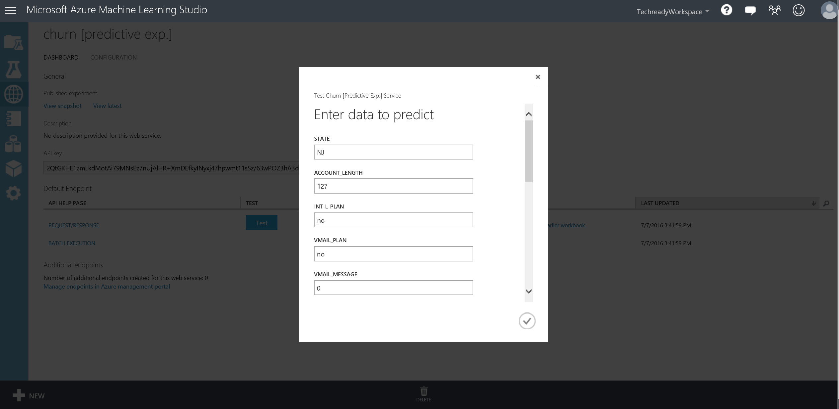

1. Click on the checkmark, then click **DETAILS** at the bottom right corner of the screen. You will see a test return confirmation message with the test returned result as **NJ, 127, no, no, 0, 245, 91, 217, 92, 243, 128, 14, 6, 0, False, False, 0.14724688...**.” The last two values represent the churn model prediction for this customer where the predicted probability for this customer’s likelihood to churn (True) is approximately 14.72%.

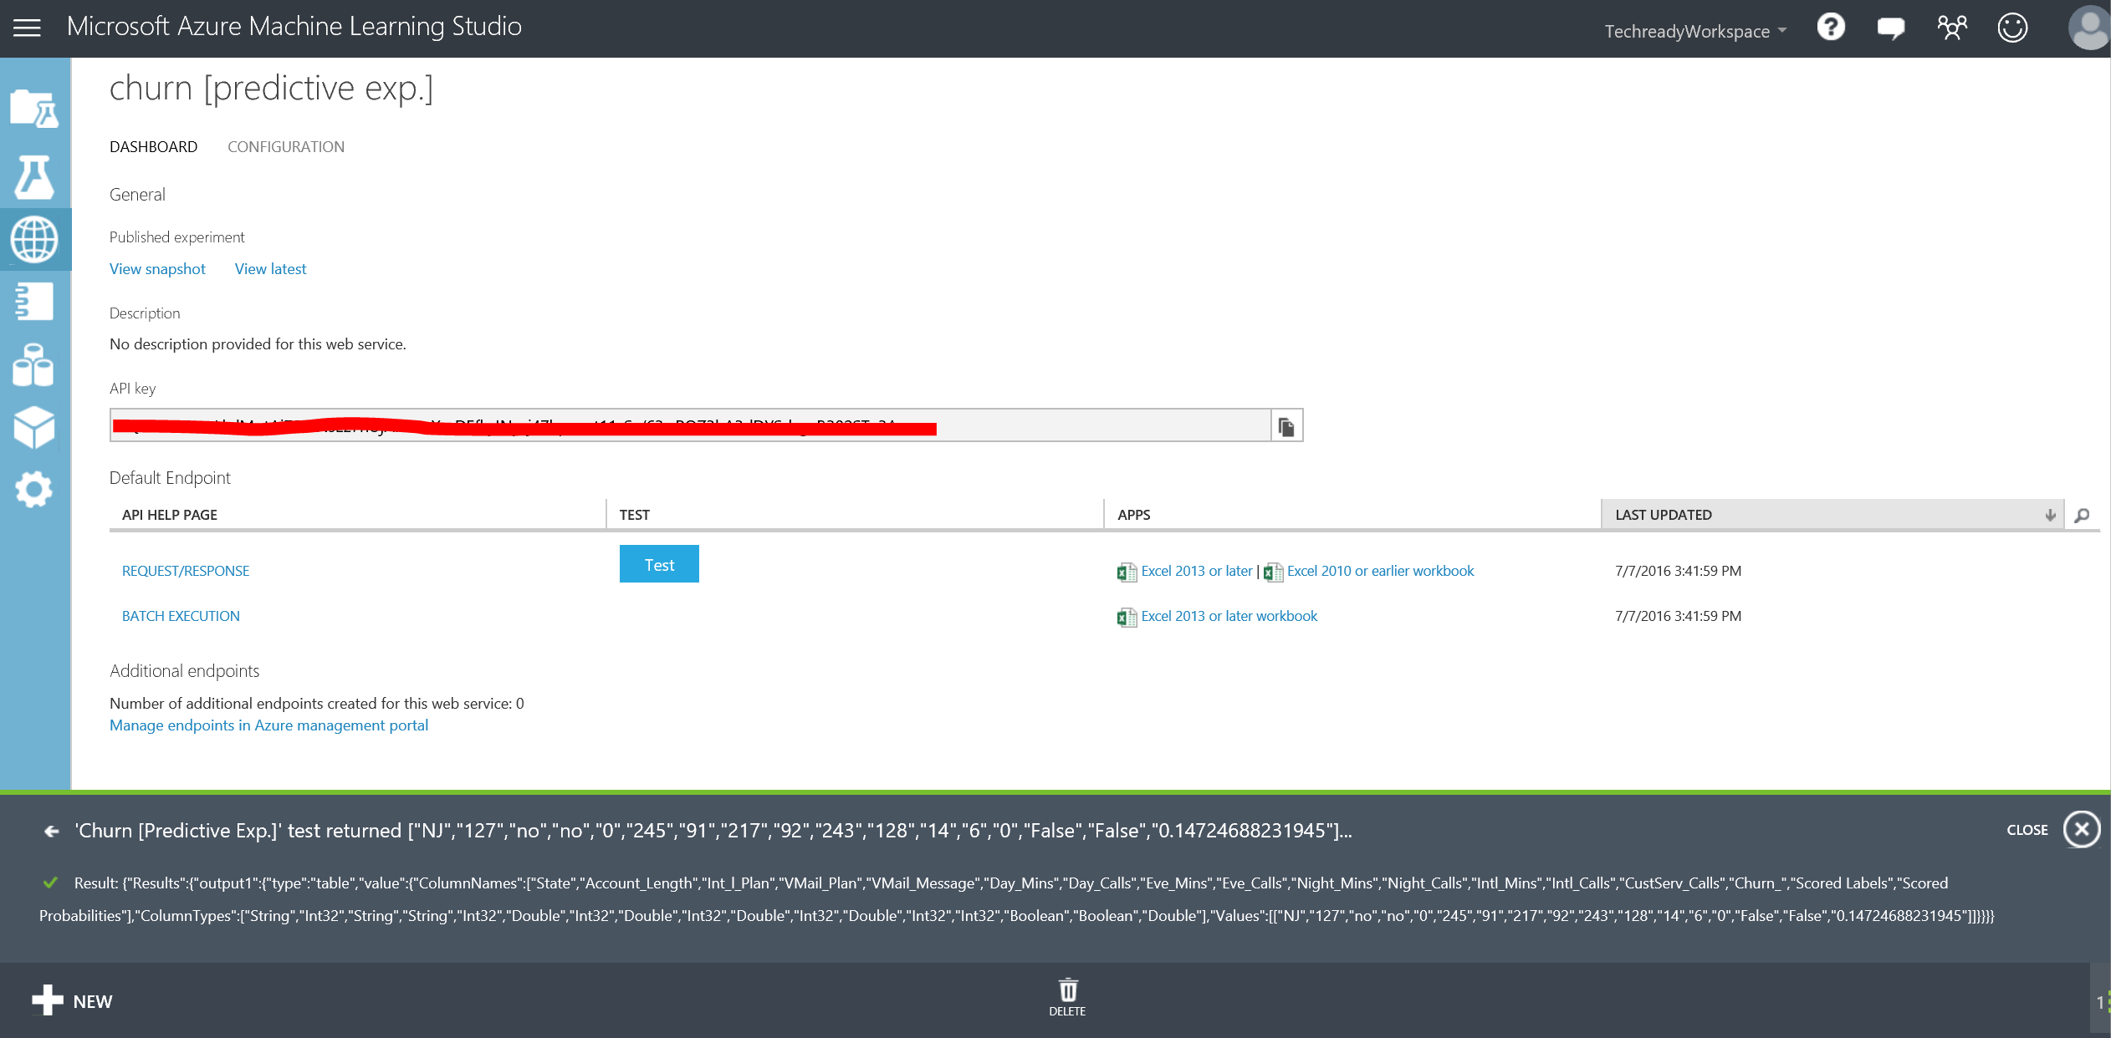

# Azure ML Web service call from Excel

In this exercise, you will use Excel to make a call to the web service you created earlier. For details of how this works, see here: <http://blogs.technet.com/b/machinelearning/archive/2015/09/01/excel-add-in-for-azure-ml.aspx>. This is one example of how you can consume the machine learning model. There are many other ways such as using Azure Data Factory to schedule regular calls to the machine learning model, or connecting the web service to a web site where users can enter values, or calling the machine learning model using Azure Stream Analytics to alert on results.

**Step-by-step**

1. Go back to your browser to the web service dashboard. Click the **REQUEST/RESPONSE** link under the **API HELP PAGE** heading. This will direct you to the **Request Response API Document** for your service. You will find your Web service URI on this page along with Sample Code to call the web service using C#, Python and R when you scroll down to the bottom.
2. Open the file **C:\Lab1\ AzureMLExcelAddIn.xlsx** using Excel. If you are asked to activate Microsoft Office, click cancel, you will still be able to use Excel. Click on **+Add Web Service** in the Excel document and copy/paste the **Request URI** found next to **POST** in the **Request Response API Document** page into the URL spot on the Excel add-in. Copy/paste the API key from the main web service page into the API key of the Excel add-in. Click **Add** to add this web service.

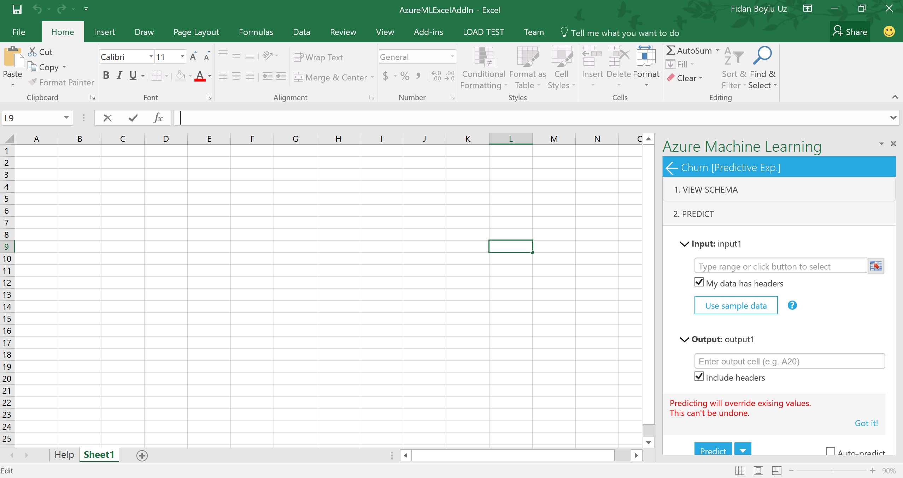

1. Go back to the **Churn Prediction [Predictive Exp.]** experiment and right click the output port of **Set Columns in Dataset** and **Visualize** to see example data that could be fed into the model. Copy/paste a few rows of data from this view to Excel, including the header.

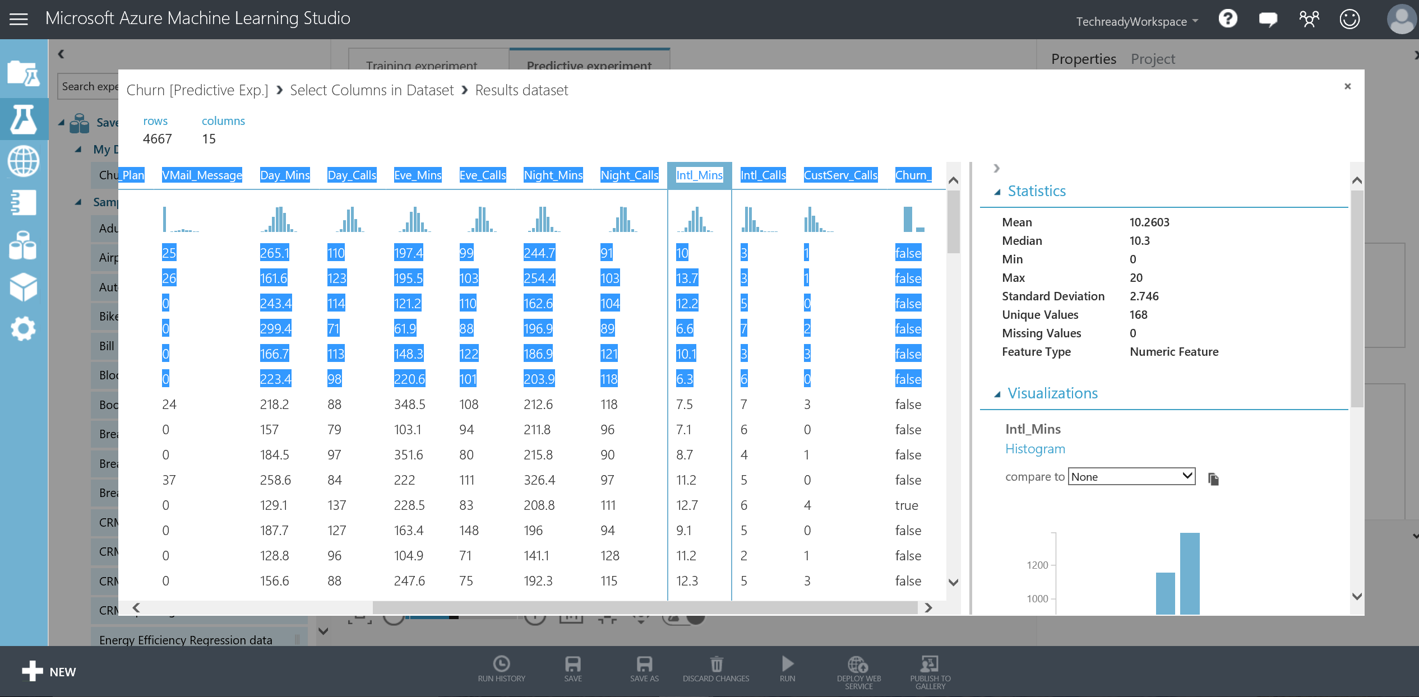

1. Delete rows that don’t have any relevant data (if you copy/pasted the header you will likely need to delete rows 2 and 3). Make sure the data and headers are lined up (if you copy/pasted the header you will likely need to cut/paste the data within Excel to match up with the headers). The final dataset should look like the screenshot below.

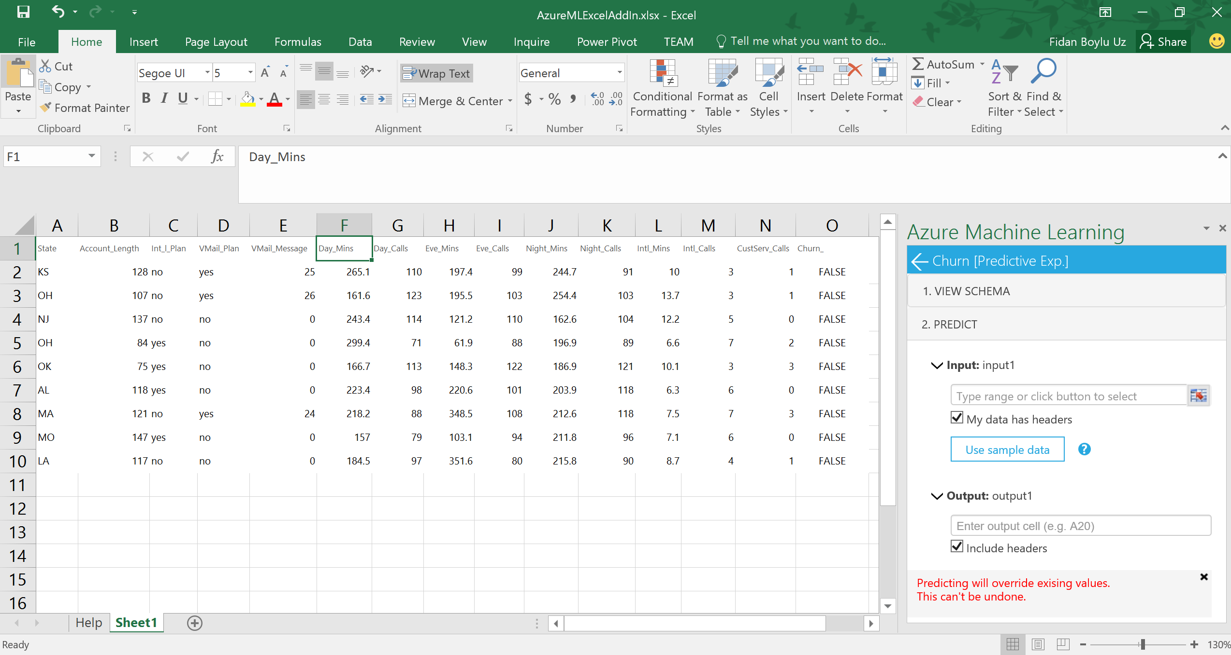

1. Select the range (in the case of above A1:O10) or select it using the button, and make sure **My data has headers** is selected if you copy/pasted the header. Put **P1** as the output cell (make sure your data is copy/pasted starting at cell **A1** in order for this to not override your data and make sure **Include headers** is selected.
2. Next, Click **Predict**. Columns **P** through **AF** will now be populated with results from the web service, with column **AE** representing the predicted value for whether the customer will churn and **AF** representing the associated probability of churn.

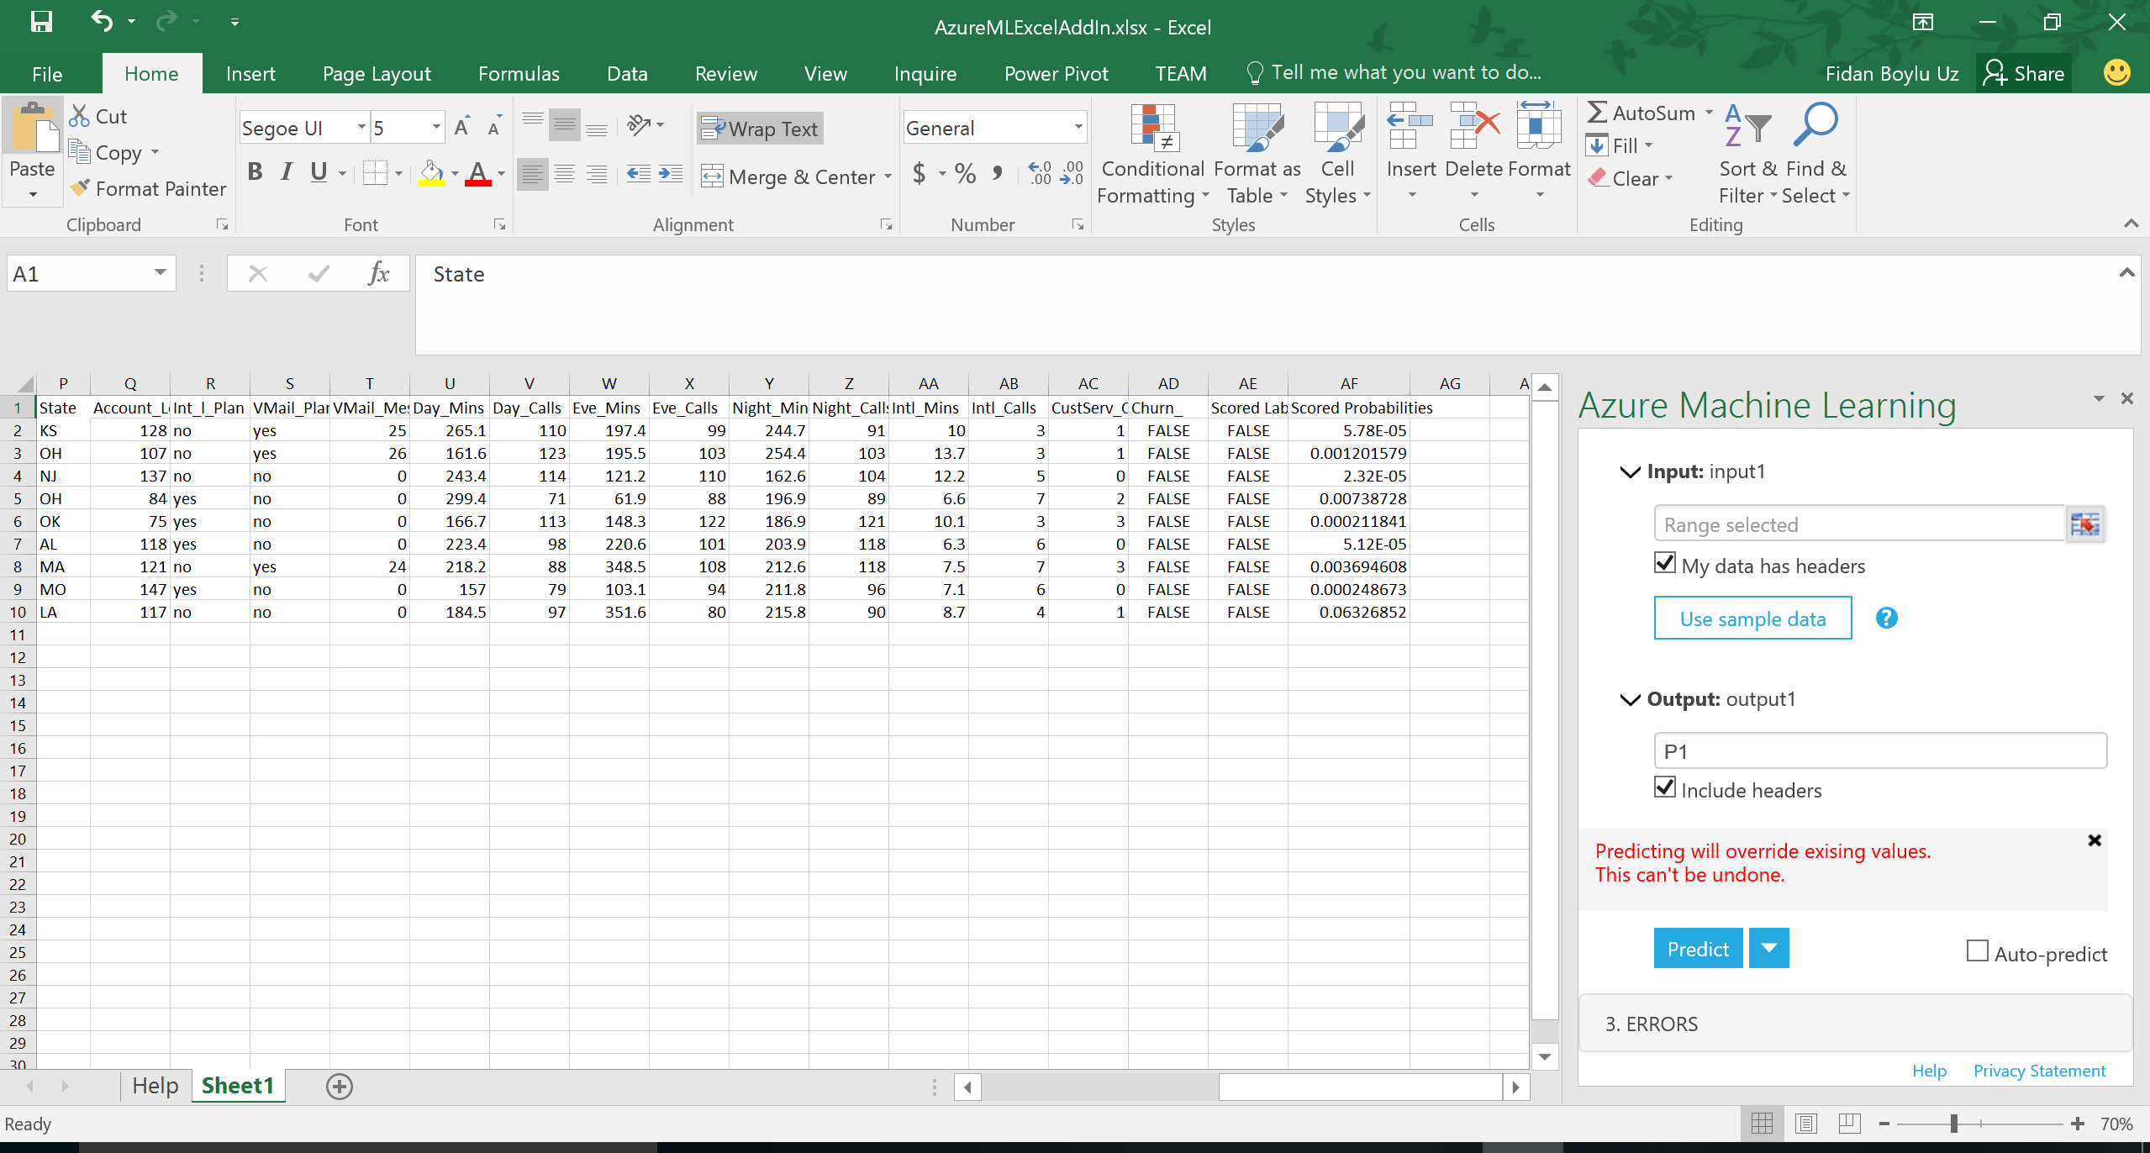

# Optional: Clustering

In this section, you will create a new series of experiments by clustering the Customer Churn data set. Clustering is an unsupervised learning technique that doesn’t require labels in the data in order to apply the algorithm. In the Customer Churn data set, labels are supplied, but we are going to ignore those labels for our current purposes.

The clustering algorithm you will use is called k-means, where k refers to the number of clusters you would like to have. In k-means, each sample in the data set is mapped into an n-dimensional feature space (where n is the number of columns, or features, you are asking the algorithm to consider). Depending on the specific implementation of the algorithm, k initial centroids, or center points of the clusters are established and then an iterative process begins. In each iteration of the process, the centroids are moved so that they are closer (using a distance formula such as Euclidean distance) to the center of a group of n / k nearest points. The iterations continue until either a static state is reached or the maximum number of iterations is reached.

**Key Points**

1. The k-Means clustering algorithm classifies unlabeled data.
2. Be careful to only include significant columns (features) in your clustering model and exclude highly-correlated features. This way, redundant, highly-correlated features will not skew your model.

**Step-by-step**

This step takes about 15 minutes to complete.

1. From literally anywhere in Azure ML Studio, create a new experiment, by clicking on the **+ NEW** button in the lower left corner of the window and then click on **Blank Experiment** box. Rename your experiment by typing **Segmentation** into the title field. In the Search box, search for ChurnData and drag the data set onto the canvas. You will prepare your clustering experiment against this data set.
2. Before clustering, you will first eliminate columns that are not necessary, as in the previous experiment. Search for **Select Columns in Dataset** and drag that module onto the canvas. Connect the **ChurnData** data set to the **Select Columns in Dataset** module.
3. With the **Select Columns in Dataset** module selected, click the **Launch column selector** button in the **Properties** pane and select **BY NAME** tab and by using the arrows, select the following columns **X_dataobs_, State, Account_Length, Int_l_Plan, VMail_Plan, VMail_Message, Day_Mins, Day_Calls, Eve_Mins, Eve_Calls, Night_Mins, Night_Calls, Intl_Mins, Intl_Calls, CustServ_Calls,** and **Churn_** as in the screenshot below. Note that some highly- correlated columns are being excluded, as in the previous experiments. Also note that **X_dataobs_** (the observation number) and **Churn_** (the label) will not be used in the clustering itself, but will be used later for visualization.

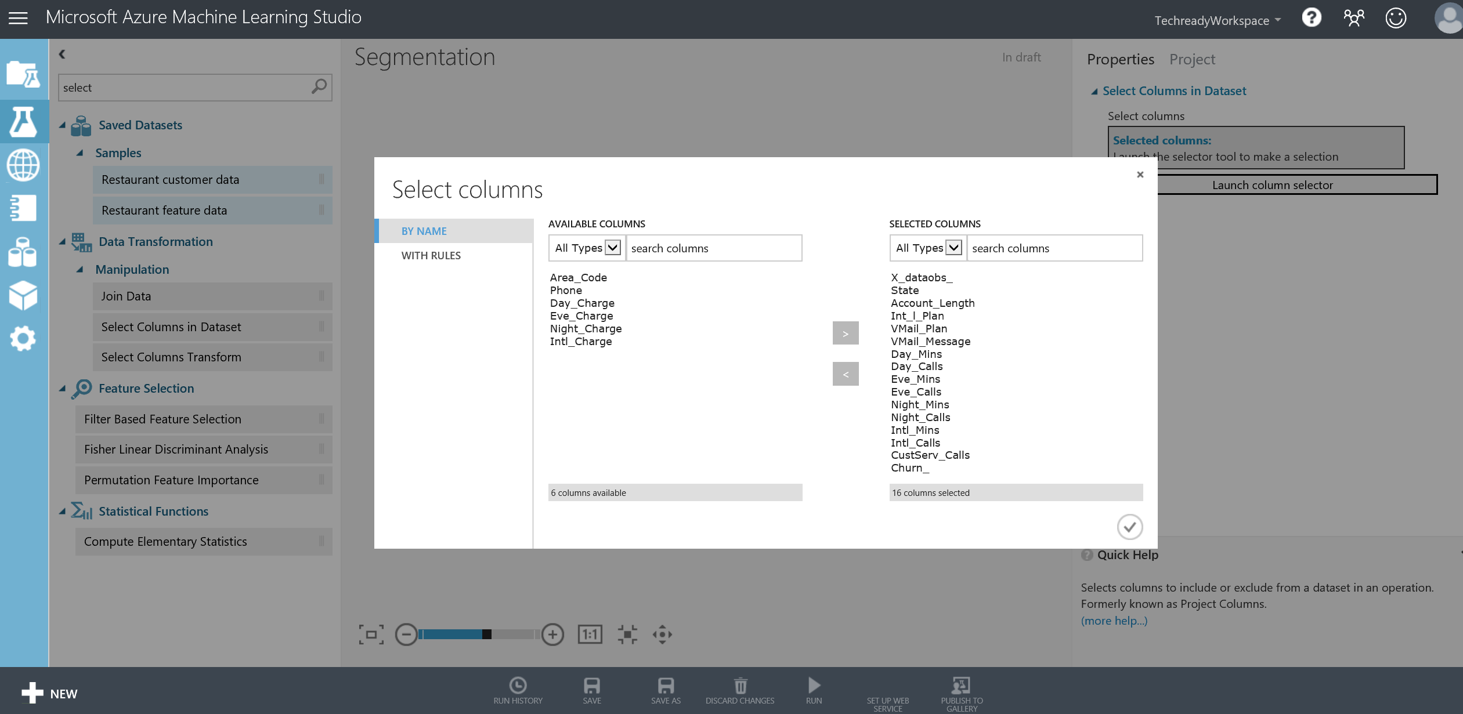

1. Next, use the search box to find the **K-Means Clustering Model** and the **Train Clustering Model** modules and drag them onto your canvas and connect them as shown below. Alternatively, you can use the **Sweep Clustering** module instead, which will allow you to perform a similar task with the **Tune Model Hyperparameters** module you have used earlier for binary classification. Same principles will apply where **Sweep Clustering** module uses a range to run through the clustering algorithm parameters and selects the best ones according to a chosen metric. Here, we will use **Train Clustering Model** module for simplicity.

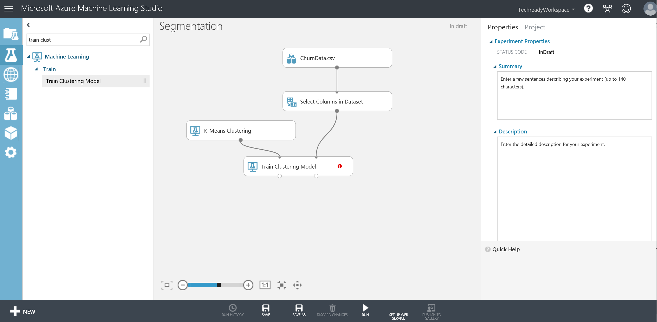

1. Select the **K-Means Clustering** module, go to the **Properties** pane and set the **Number of Centroids** (K) to 4 and leave all the other parameters as defaults.
2. Next, select **Train Clustering Model** module and select the columns that you will include in clustering and the resulting visualization, by pressing the **Launch column selector** button in the **Properties** pane.
3. Select all columns except **X_dataobs_** and the **Churn_** columns that will not be included in the clustering.
4. Use the **Search** box to locate the **Convert to CSV** module and connect its input port to the right output port of **Train Clustering Model** module and **Run** the experiment.
5. Once the experiment has completed, right click on the output node of the Convert to CSV module and select **Download**, as shown below.

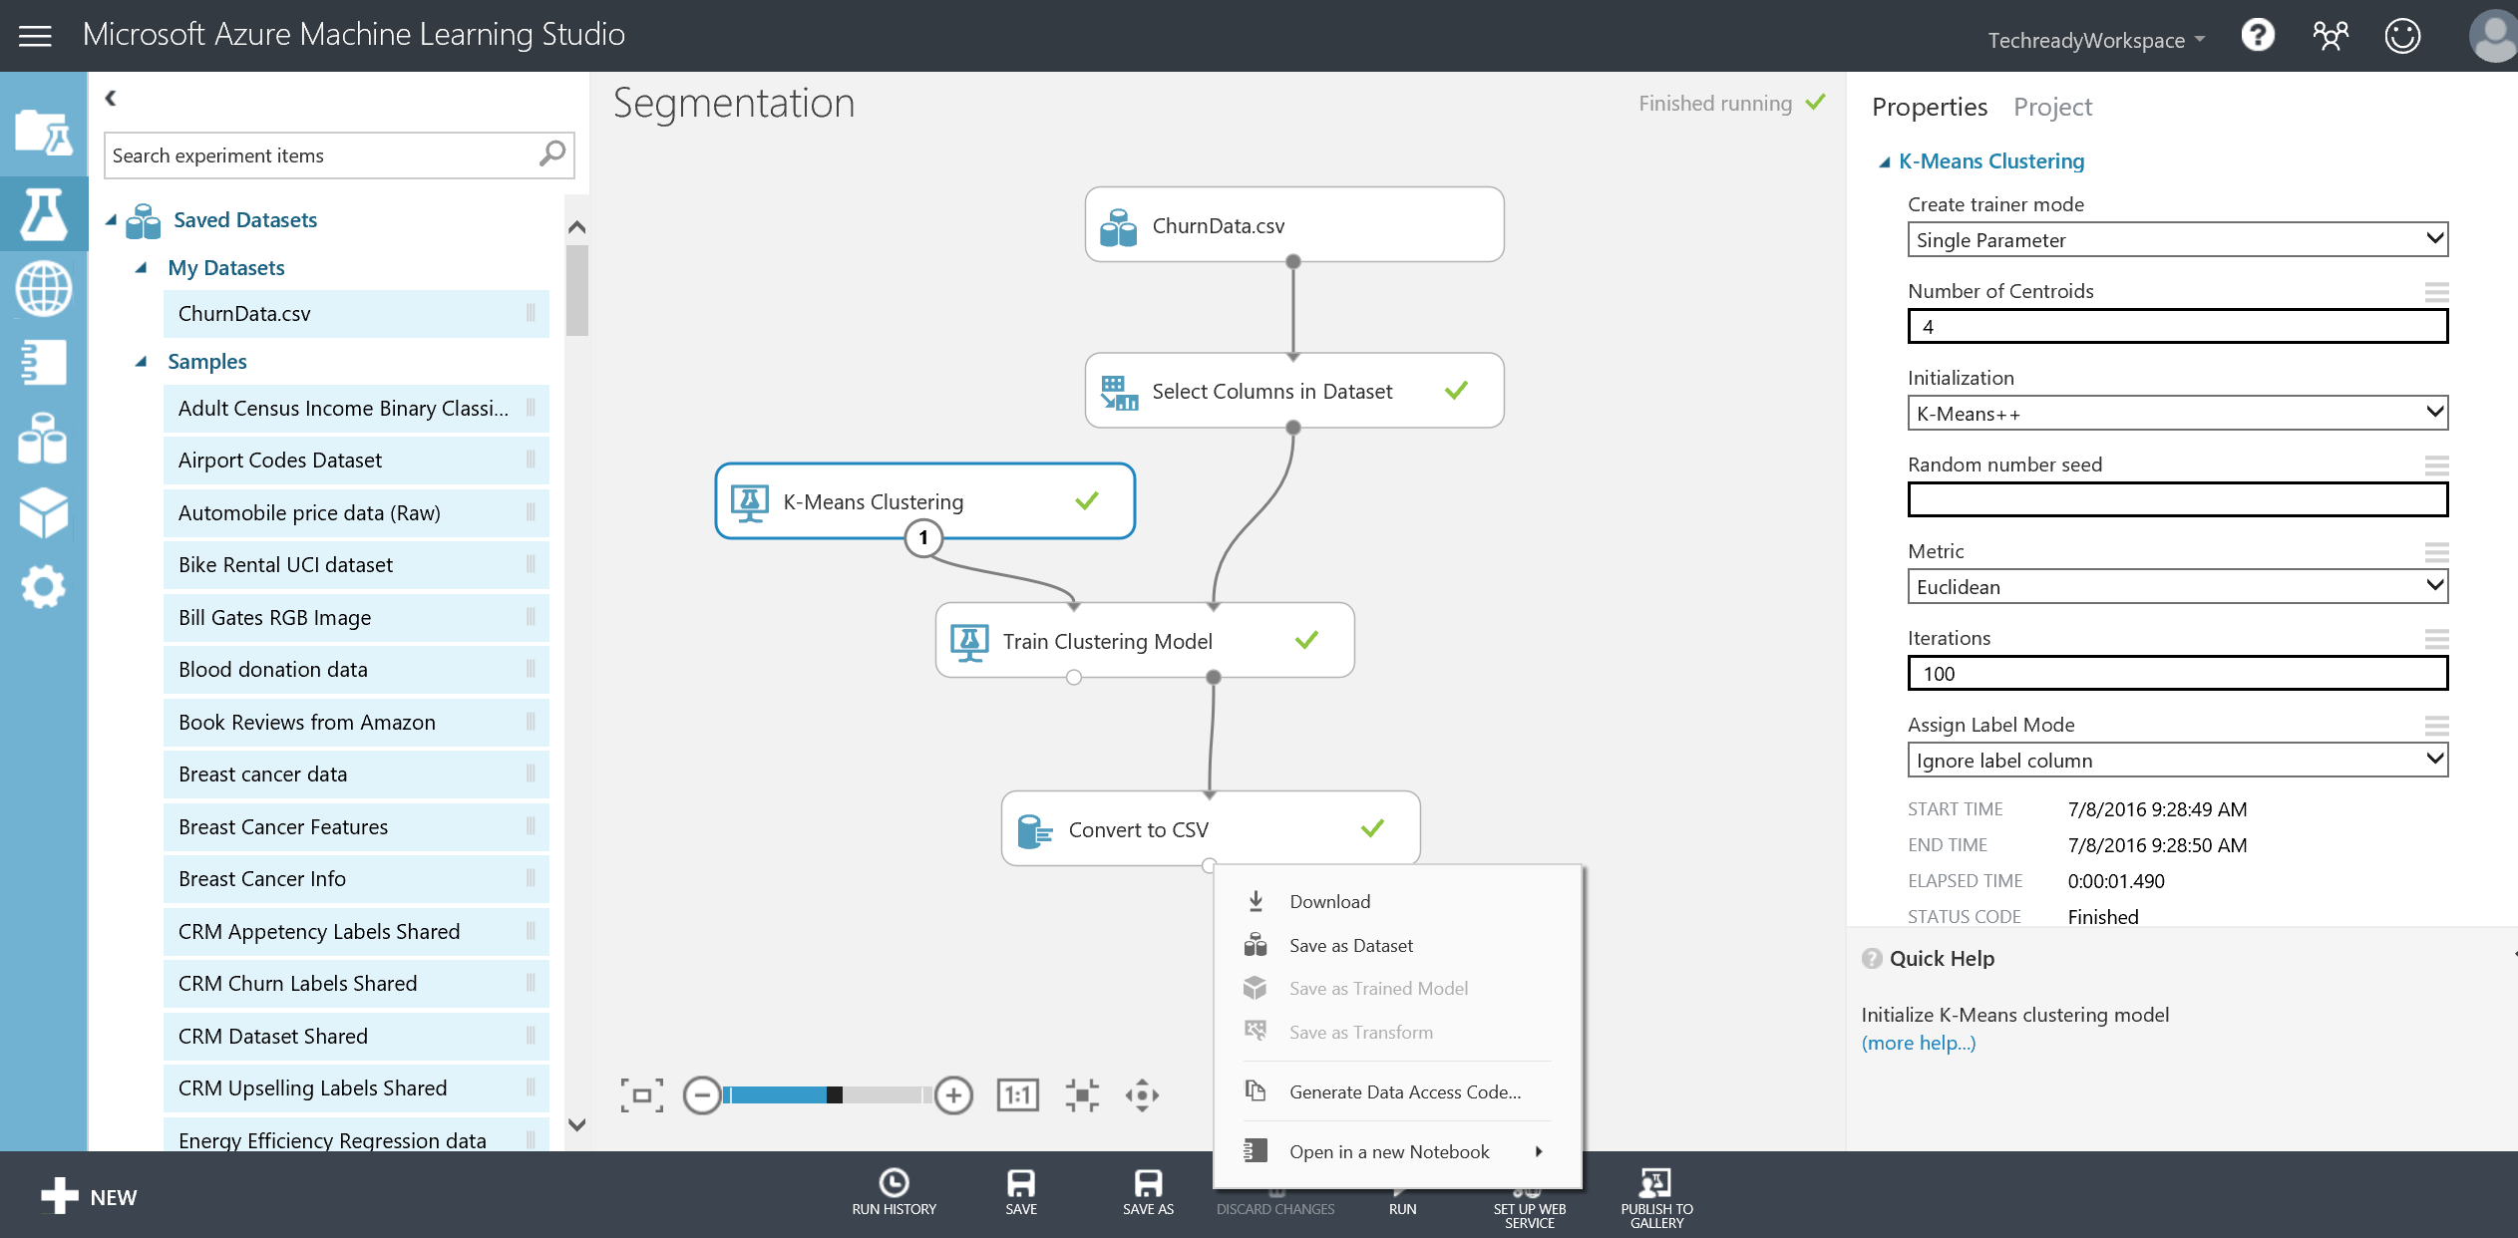

1. The Internet Explorer save dialog will appear. Save the resulting file as **K – Means 4 .csv** where 4 is the number of clusters that you have requested. You will use this file to create Power View visualizations later in the subsequent sections.

# Optional: Jupyter Notebooks

In this section, you will use the Jupyter Notebook service within Azure ML Studio to create an IPython notebook for the clustering problem and also experience how you can integrate your notebook with your Azure Machine Learning workspace. This is a technology preview and its components are subject to change. For more information, please see a complete documentation [here](https://github.com/DinoV/Azure-MachineLearning-ClientLibrary-Python/blob/master/README.md).

**Key Points**

1. It is also possible to use R language with Jupyter Notebooks.
2. Additionally, you can publish datasets from your notebooks to Azure ML studio as well as your models as web services hosted on Azure and consume them from your notebooks.
3. Examples are provided in the pre-built notebook that you will use in this exercise to test execution of python code functionality.

**Step-by-step**

1. In this section, you will use a pre-built notebook called **ChurnClusteringAnalysis.ipynb** that is located in your **C:\Lab1\** folder.
2. Click on **+NEW** at the bottom left of corner or Azure ML studio, then select **Notebook (PREVIEW)** tab, and click on **Python 2** Notebook since the notebook you will use only works with Python 2. Name this new notebook **Churn** and click the checkmark to open it.

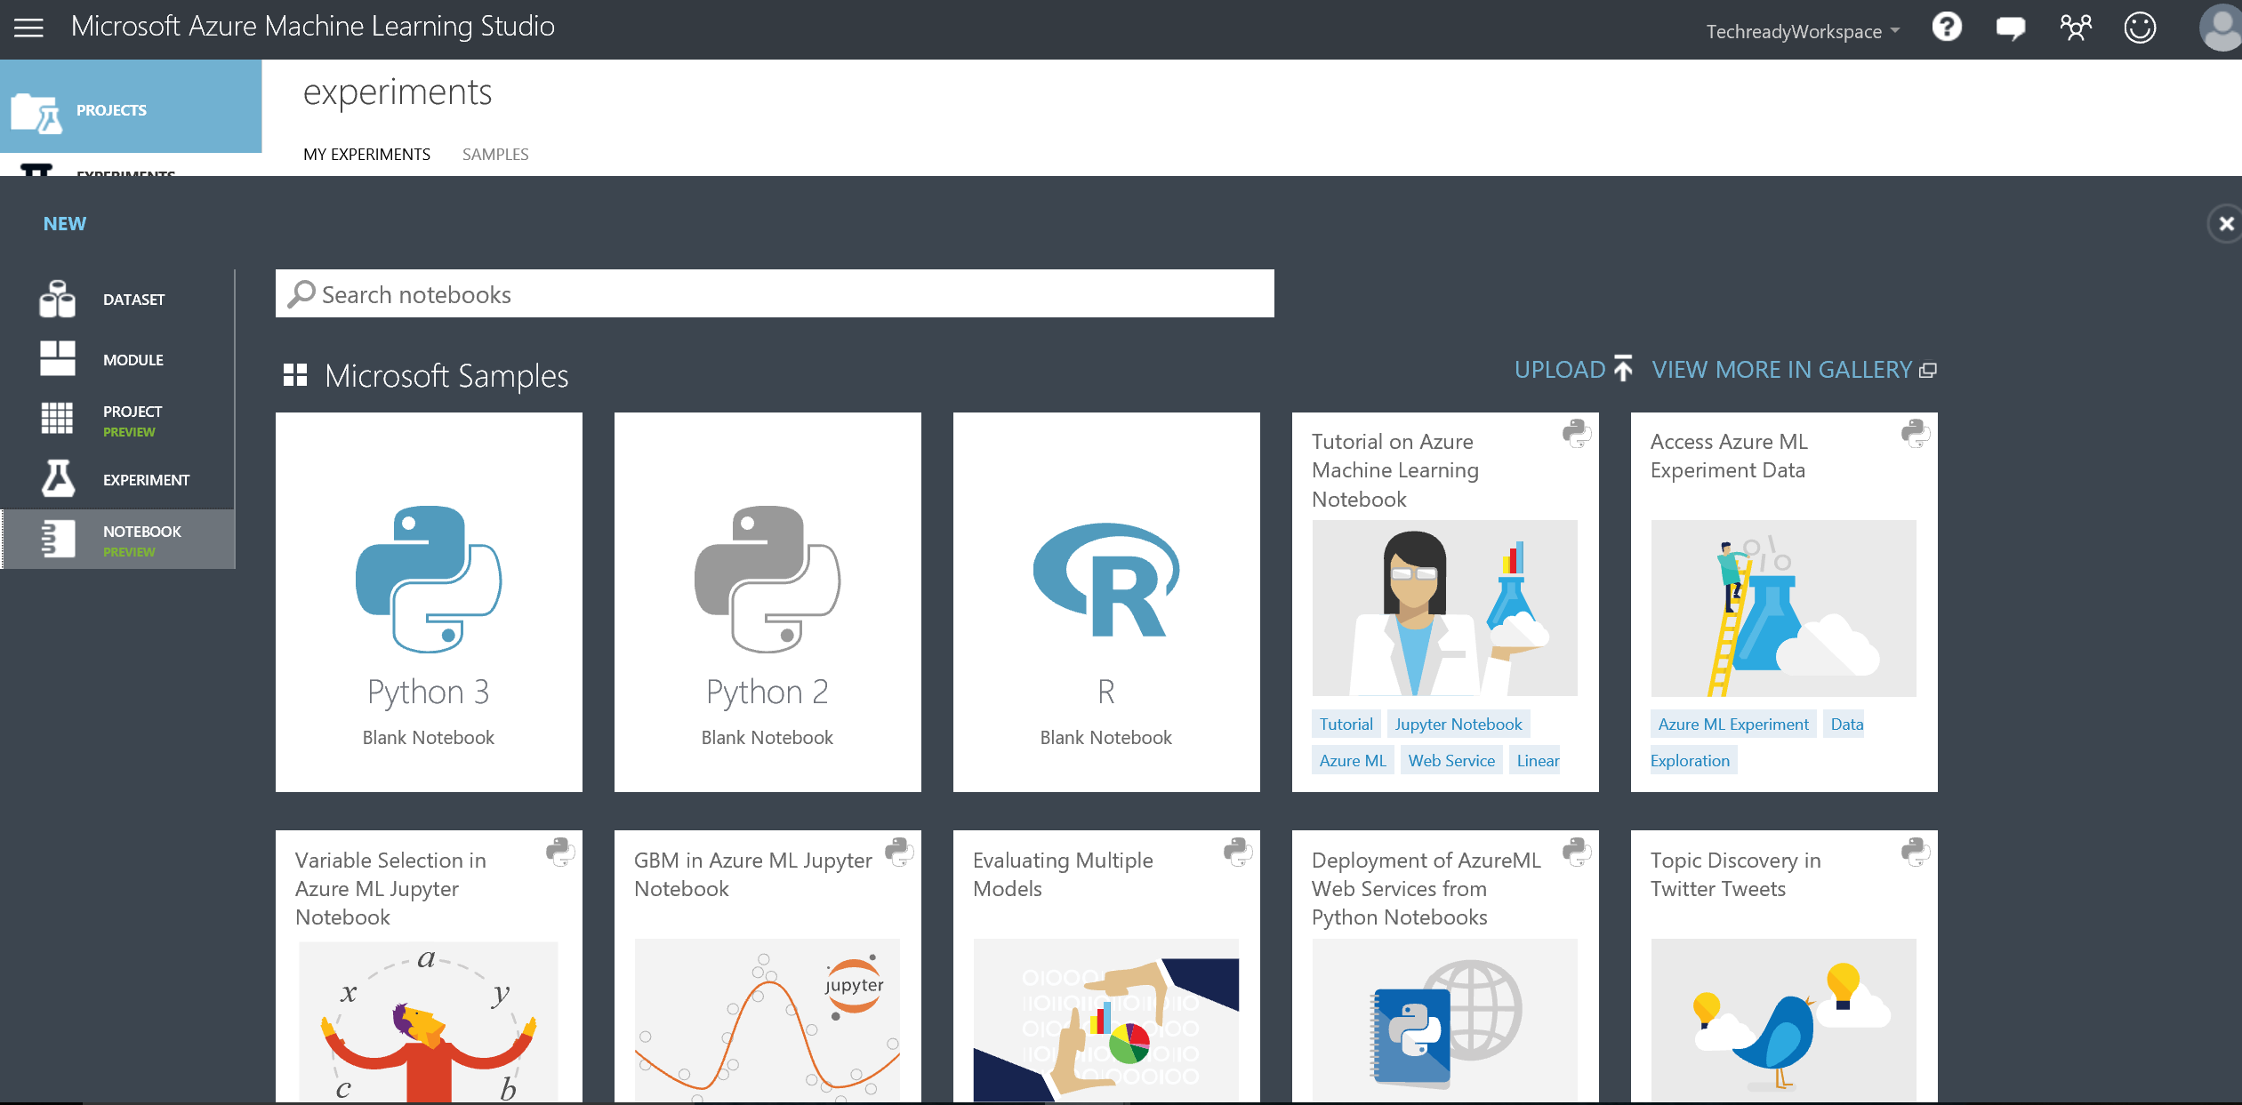

1. A new tab or window will open with a blank IPython Notebook that you can use to begin your analysis using Python language. For the purposes of this lab, you will load a notebook that is pre-built.

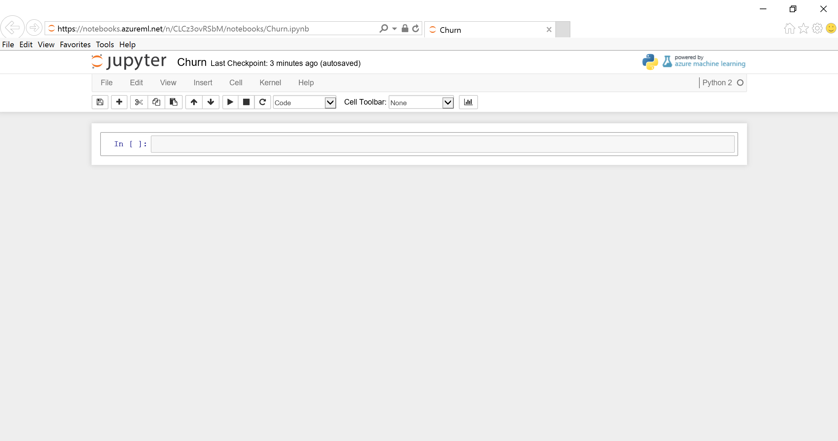

1. Click on **File** then **Open.** Use the **Upload** buttonon the upper rightand browse to **C:\Lab1\ChurnClusteringAnalysis.ipynb** and select **Open**. Then select the blue **Upload** button to upload that notebook to the cloud. When the upload is complete, the blue upload button should no longer appear.

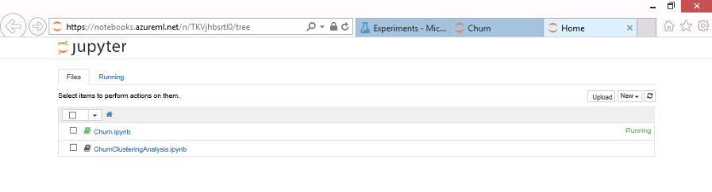

1. Click on **ChurnClusteringAnalysis.ipynb** to open it within Azure Machine Learning Studio.

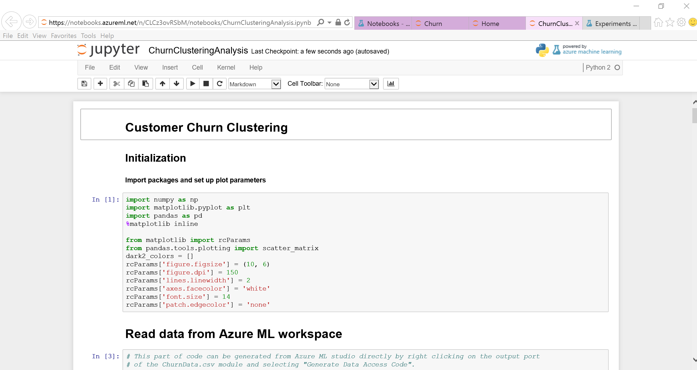

1. In the Read data from Azure ML workspace part in ln [3], you will need to replace the code surrounding workspace id and authorization token. For that, go back to the Azure ML studio and select the **Datasets** tab on the left bar and then select the **ChurnData.csv** dataset, then select the **GENERATE DATA ACCESS CODE** at the bottom.

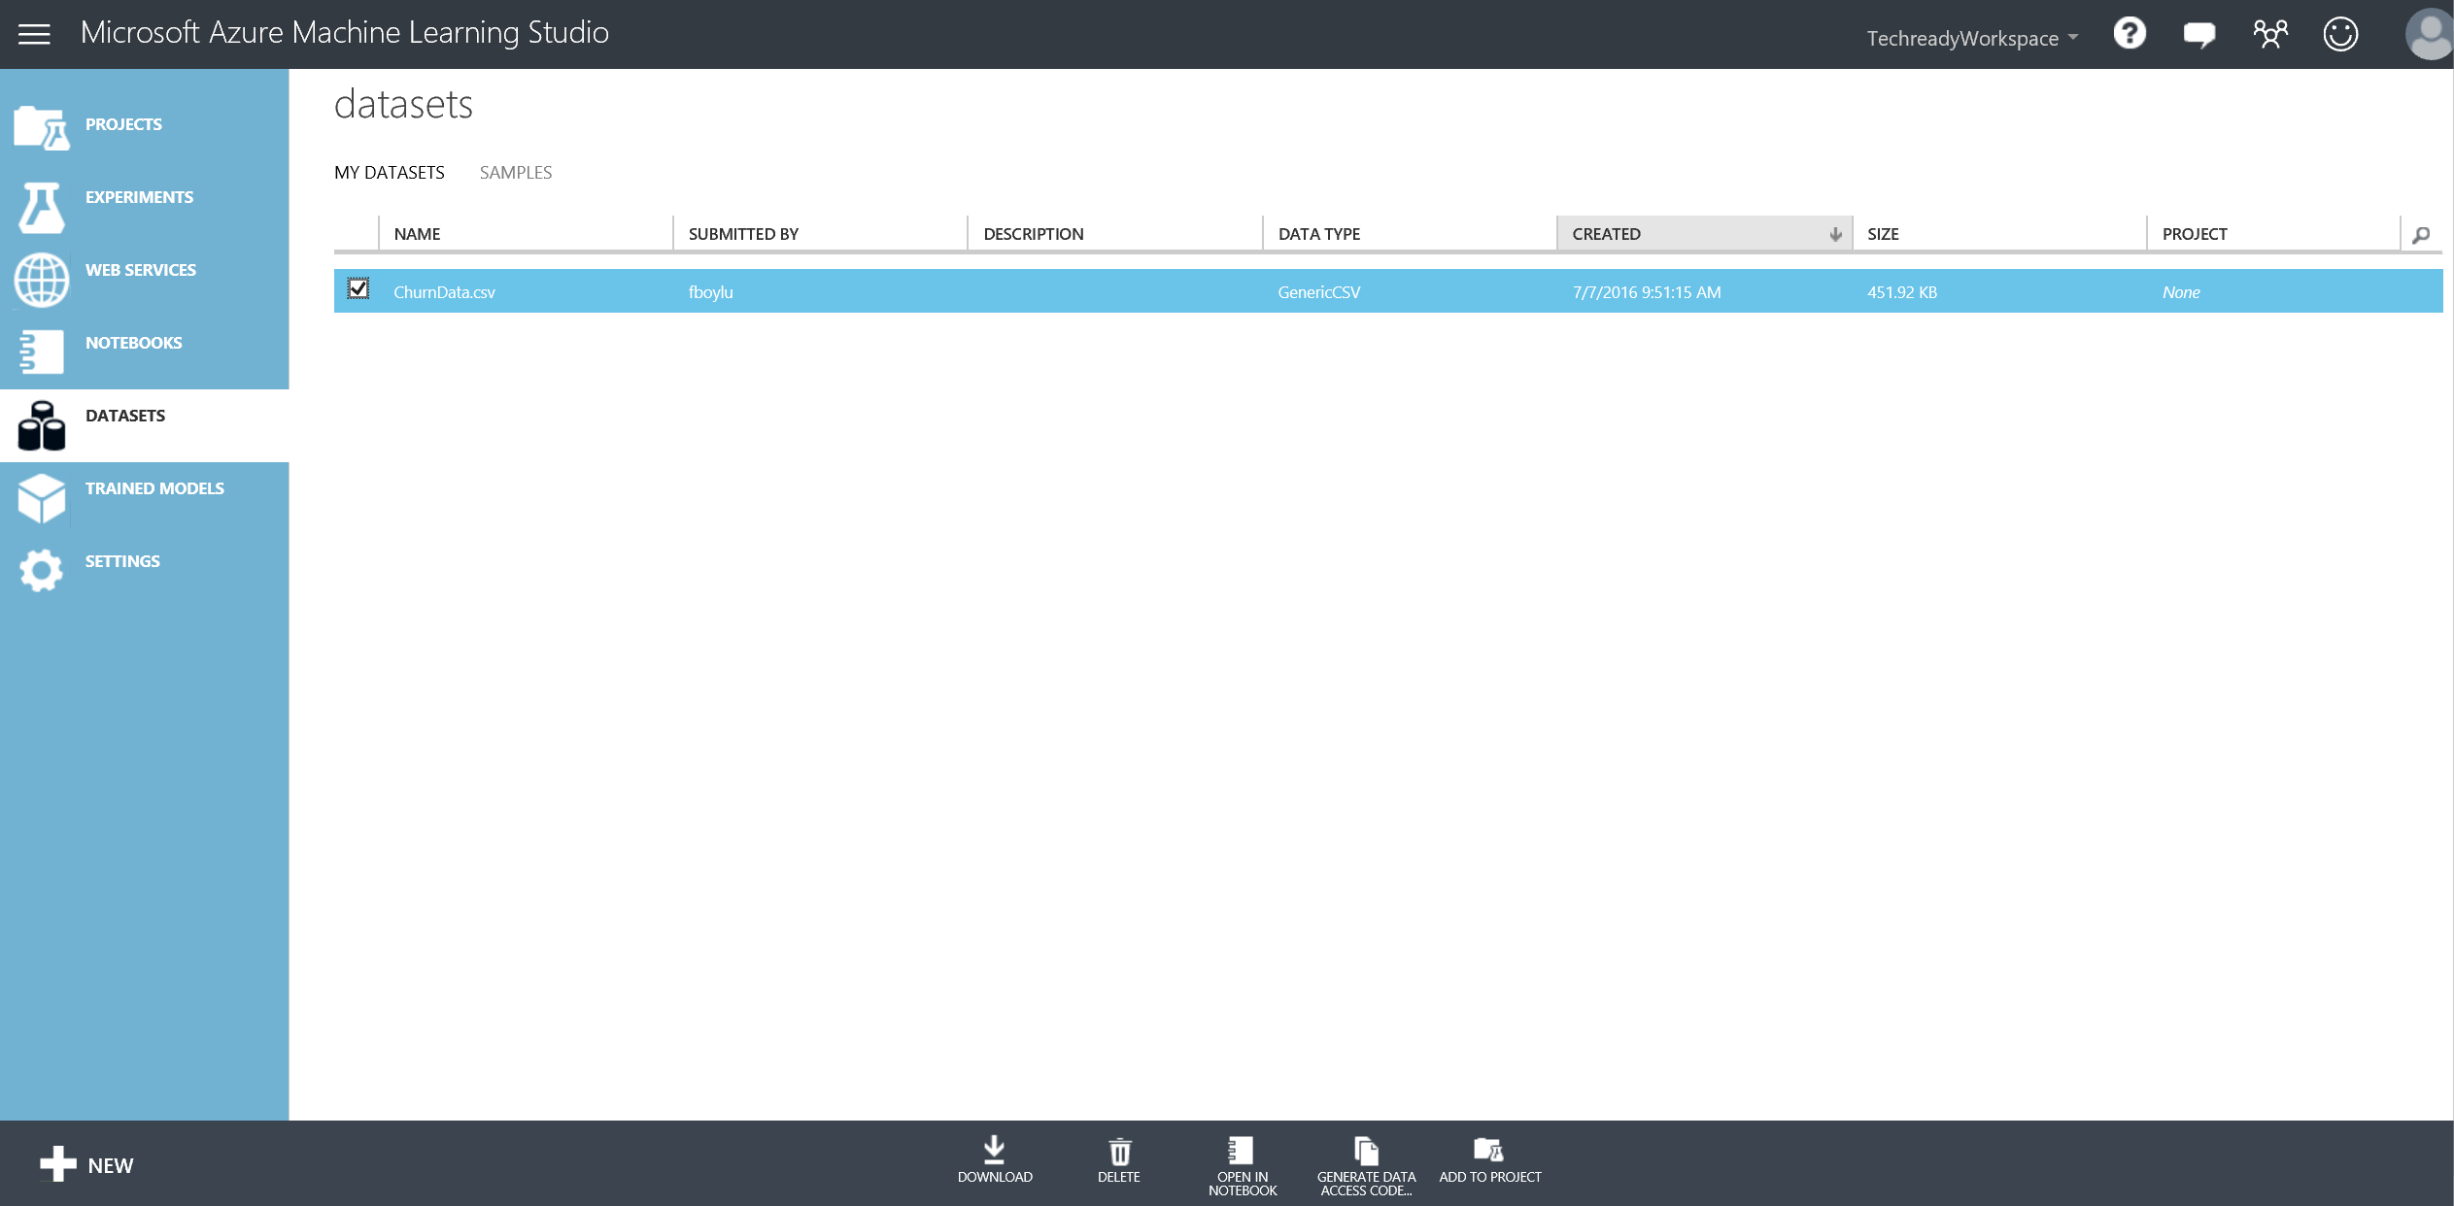

1. Copy the workspace_id and authorization_token from the code snippet and replace relevant sections in ln [3] of the notebook with those.

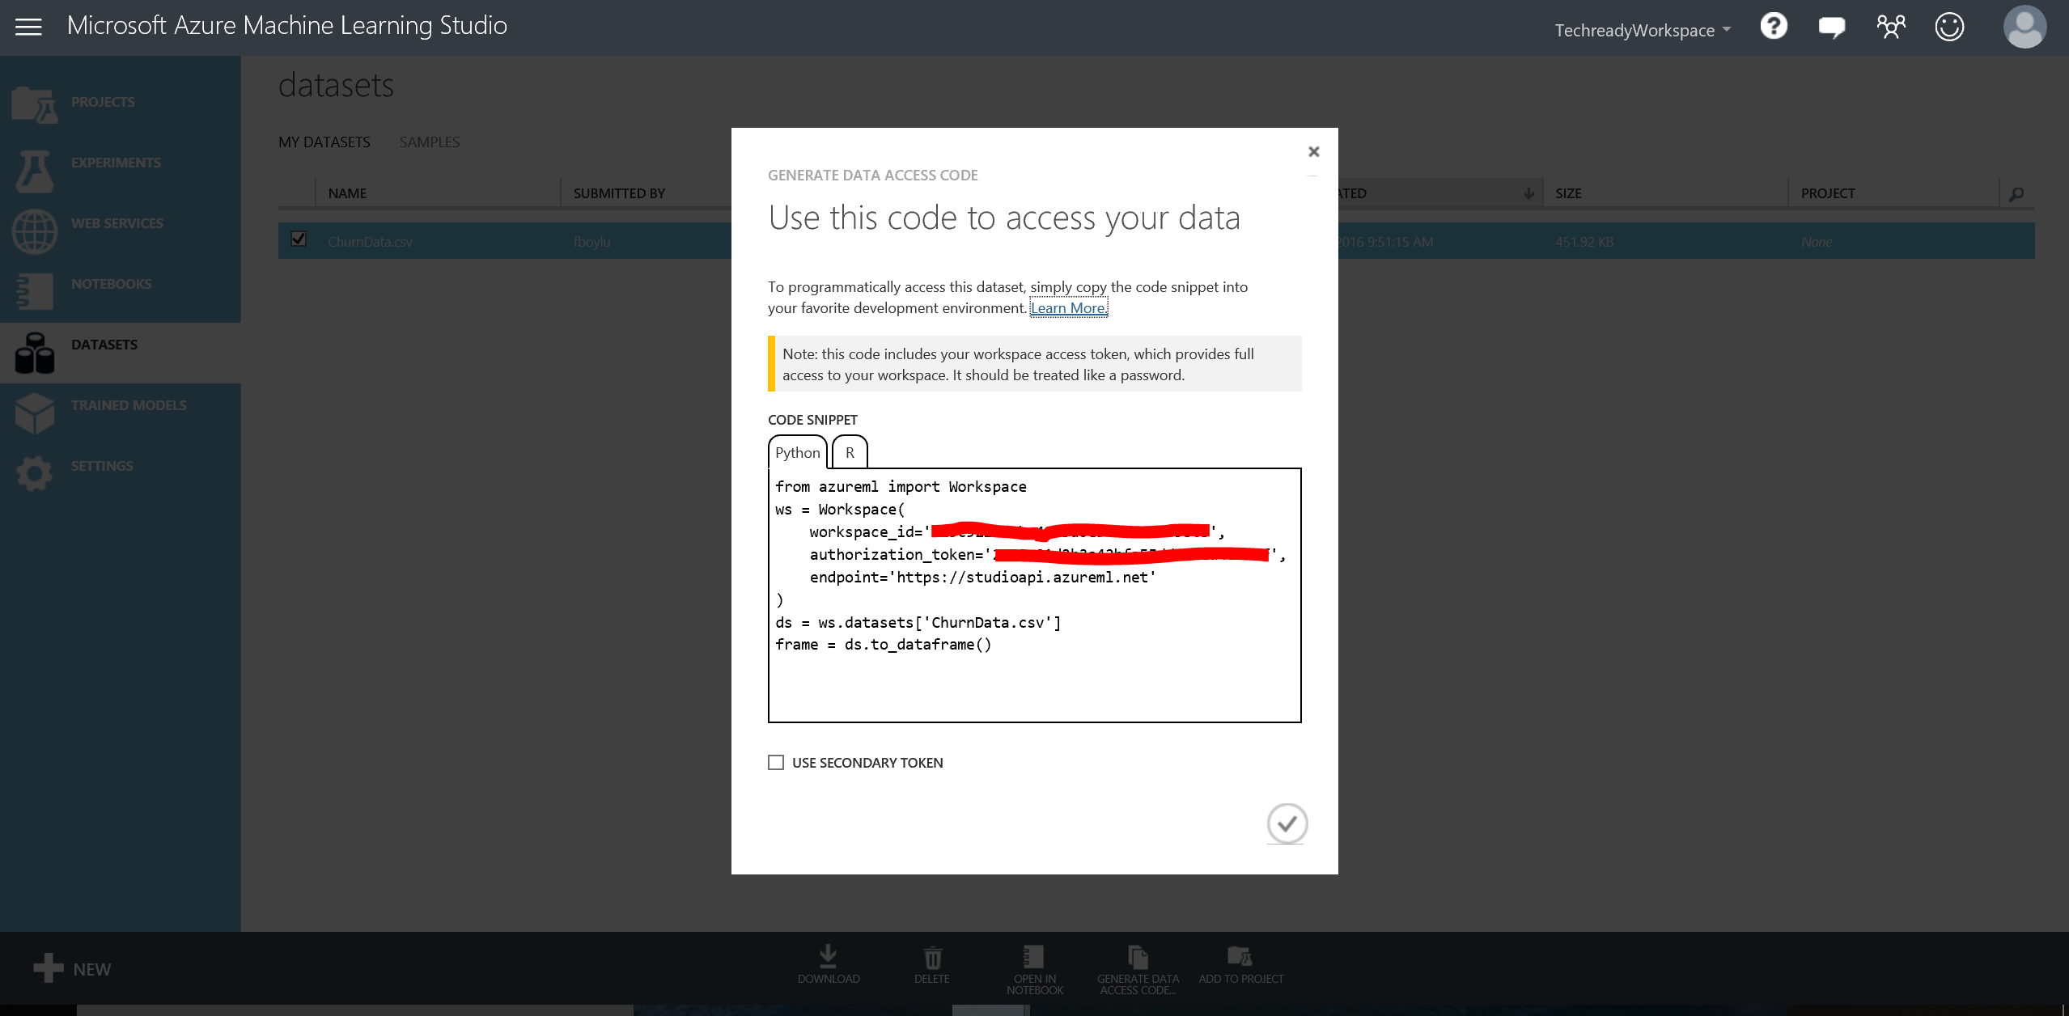

1. Notice that the last line of the code is changed to churnData =ds.to_dataframe().
2. Run the code snippets in each cell starting from the top of the notebook by using **Ctrl + Enter** and feel free to modify or write new code to explore the data if you want.

# Optional: Visualizations for classification using Power View

In this section, you will use Power View for Excel to visualize the scored labels of the classification model you have developed earlier.

**Key Points**

1. Power View and other visualization tools and techniques can be used to visualize the results of the models like the scored datasets by importing the data from Azure SQL database as an example into Power View. For this exercise you will work with a file with already exported data.

**Step-by-step**

This step takes about 20 minutes to complete.

1. Open the file **C:\Lab1\ ChurnDataTestScores – Start.xlsx** using Excel. The tab ChurnDataTestScores has the imported data. This Excel file also has a PowerPivot model. Please spend a few minutes making yourself familiar with the PowerPivot Model, make sure to examine the Measures that were created and also the additional columns. **Note**: If you are not comfortable with PowerPivot and Power View and prefer to analyze the solution for this exercise you can open the file C:\Lab1\ ChurnDataTestScores - Solution.xlsx.
2. Create the Scored churn by State report:
3. Insert a new Power View report and title it **Scored churn by state**.
4. From **Power View Fields** select the following fields: **State** and **Score Labels.**
5. Switch the visualization to Map and change its size for a better visualization. Drag the Scored labels field from the Power View Fields into the Σ SIZE.

In this visualization you can see that people in California is more inclined to change phone carrier than in other states.

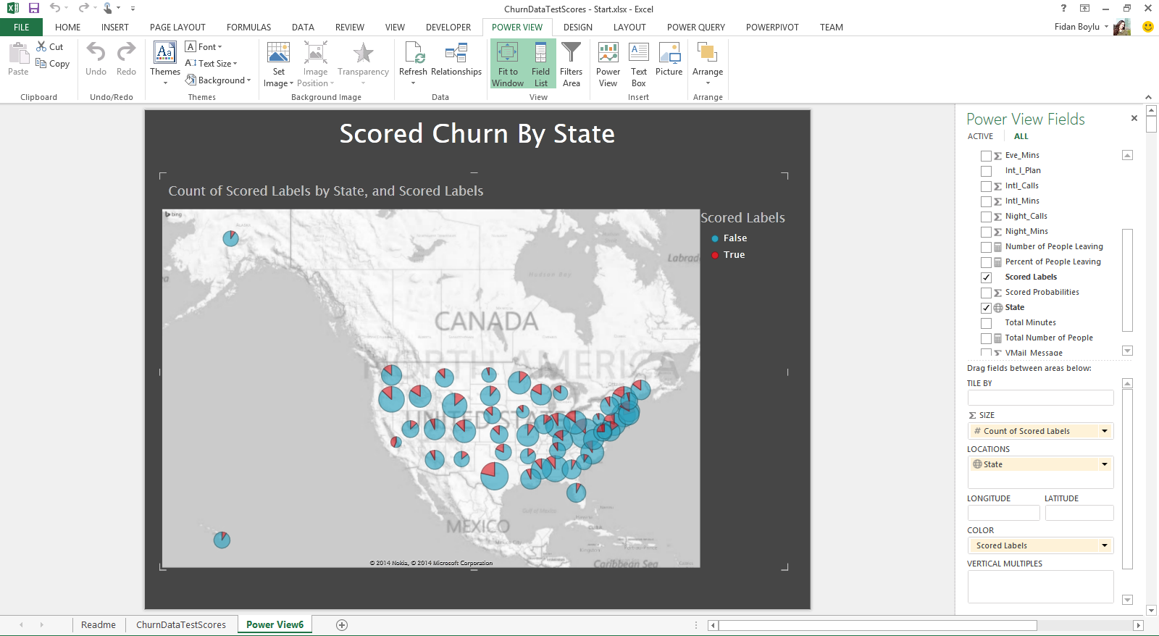

1. Create the Account Longevity and Location Analysis report:
2. Insert a new Power View report and title it **Account Longevity and Location Analysis**.
3. From **Power View Fields** select the following fields: **State** and **Percent of People Leaving.**
4. Switch the visualization to Map and change its size to use half of the screen.
5. Click on the blank part of your report and then, from **Power View Fields** select the following fields: **Account Longevity** and **Percent of People Leaving.**
6. Switch the visualization to Stacked Bar Chart and change its size to use the reaming half of the screen.
7. Select different Account Longevity periods and note the effect it has on the map. You can also try selecting different states and see the effect on the account longevity.

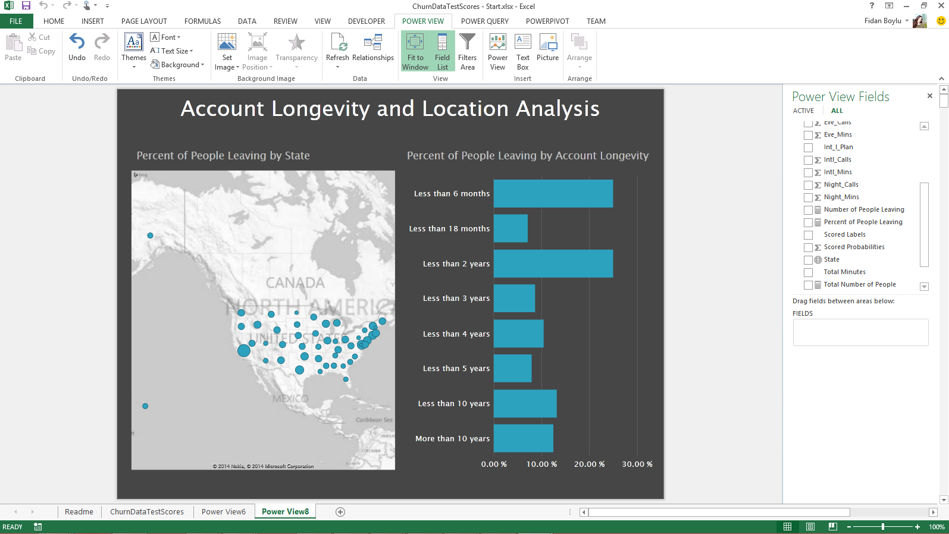

1. Create the Account Details Analysis report:
   1. Insert a new Power View report and title it **Account Details Analysis**.
   2. From **Power View Fields** select the following fields: **Account Longevity** and **Percent of People Leaving.**Switch the visualization to Stacked Bar Chart and change its size to use the top half of the screen.
   3. Click on the blank part of your report and then, from **Power View Fields** select the following fields: **Total Minutes** and **Percent of People Leaving.**
   4. Switch the visualization to Clustered Column Chart and change its size to use the reaming top half of the screen.
   5. Click on the blank part of your report and then, from **Power View Fields** select the following fields: **IntI_Plan** and **Percent of People Leaving.**
   6. Switch the visualization to Stacked Bar Chart and change its size to use the bottom half of the screen.

Note how the possession of the International Plans and use of minutes affect the inclination of people to leave the phone carrier.

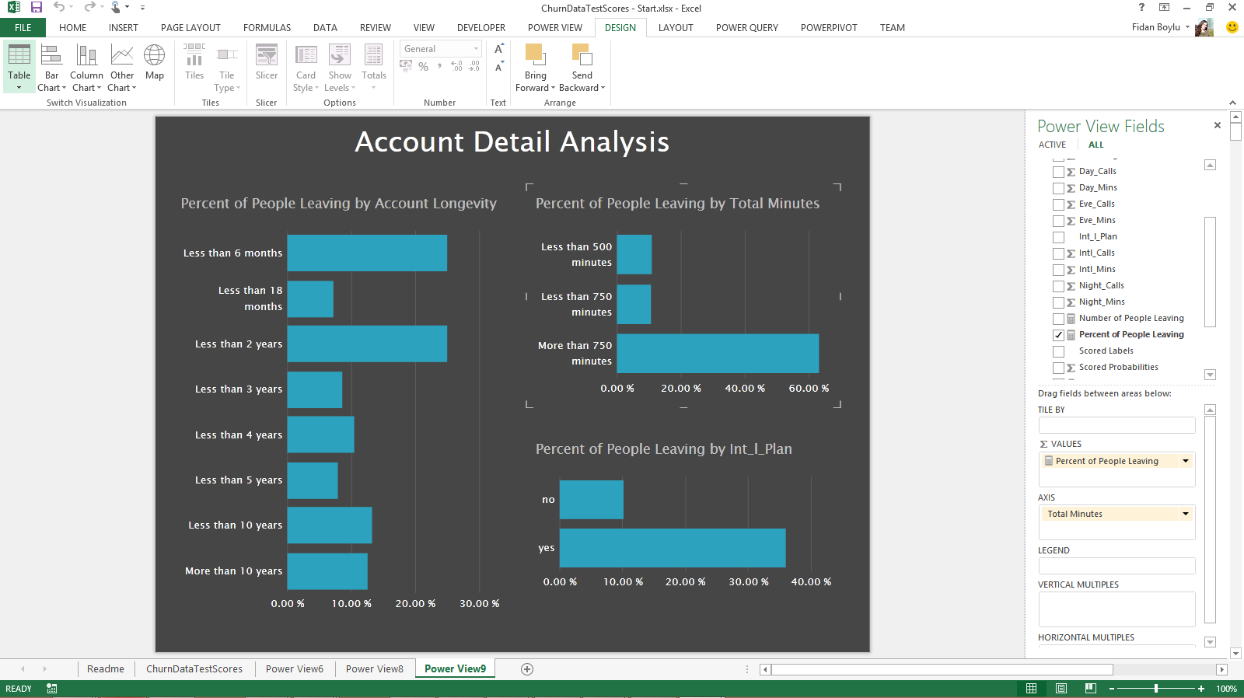

1. As a next step, if you have an O365 account, you can publish your Power View visualizations to a Power BI dashboard by uploading your workbook created above to PowerBI. Alternatively, you can connect to the Azure SQL database from Power BI and prepare your dashboard directly using the ChurnScores table in Churn database.

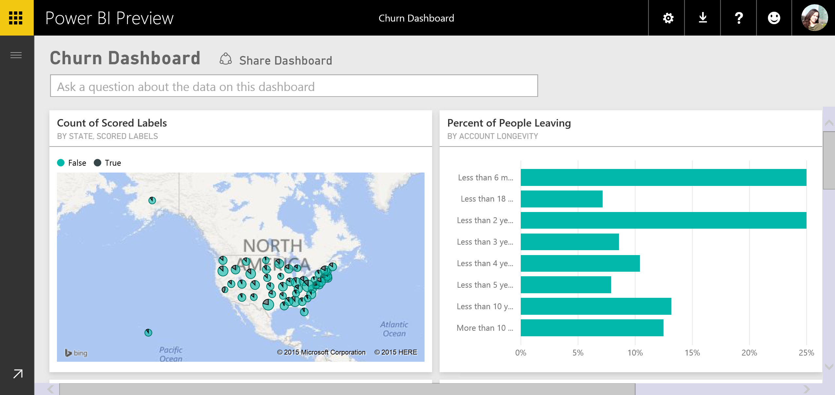

# Optional: Visualizations for clustering using Power View

In this section, you will use Power View for Excel to visualize the cluster assignments. Power View is an easy environment for creating visualizations and interacting with the K-Means data set.

**Key Points**

1. We will create one Power View visualization to include 4 charts which can be used to explore the profiles for each of the clusters created from the K-Means experiment.
2. The charts will profile **Account_Length** against each of the following attributes: **Day_Mins**, **Eve_Mins**, **Intl_Mins**, and **Night_Mins.**
3. This section assumes some hands-on familiarity with Excel and Power View.

**Step-by-step**

This step takes about 15 minutes to complete.

1. From your desktop open the file you downloaded from the K-Means clustering experiment for k = 4 and save as an Excel file **(K-Means 4.xlsx)**. This is necessary in order to use Power View features.
2. Insert a new Power View sheet with the following steps:
   1. On the **K-Means 4** tab, select all the data including header rows;
   2. From the Excel ribbon select the **Insert** tab, and then click on **Power View.**
   3. Change its title to **Account Length By Cluster**
   4. Rename your sheet **Account Length**

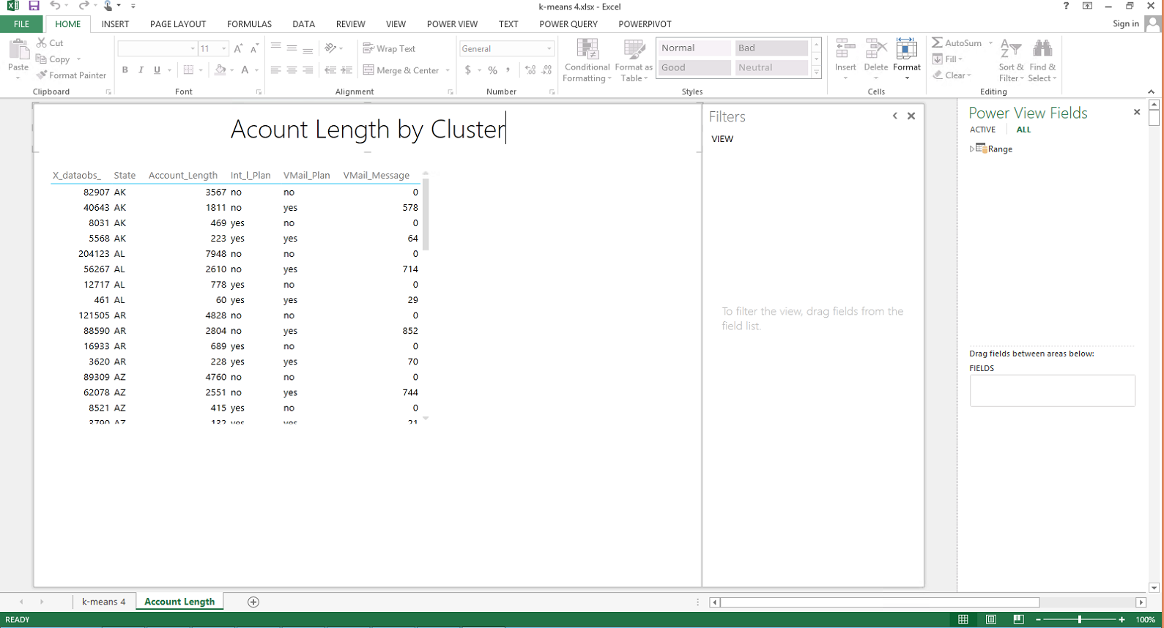

1. Select the existing table and from **Power View Fields** *select* the following fields: **Account_Length, Assignments, Day_Mins** and *de-select* any other fields that may have been selected by default.Modify the fields in the following way:
   1. For **Account_Length** field, click on the drop down and select **Average.**
   2. For **Day_Mins**, click on the drop down and select **Average.**
   3. For **Assignments**, click on the drop down and select **Do not summarize.**

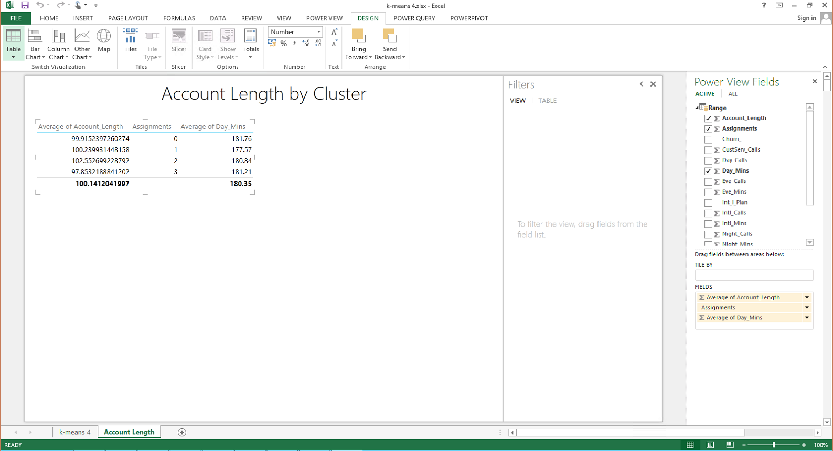

1. Change the visualization from a table to a **Scatter chart** Resize it fit top right corner of the canvas.

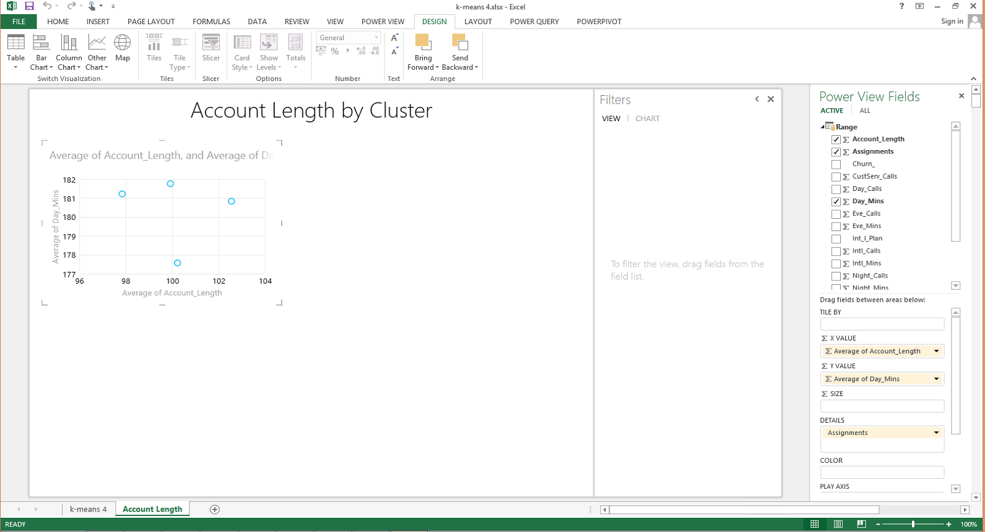

1. Create a legend for the chart by dragging the Power View field **Assignments** into the **COLOR** box. Next, drag the field **Day_Mins** from the Power View fields into the SIZE box. Click on the drop down and select **Average.** Resize your chart and move it to the upper left side of your canvas.

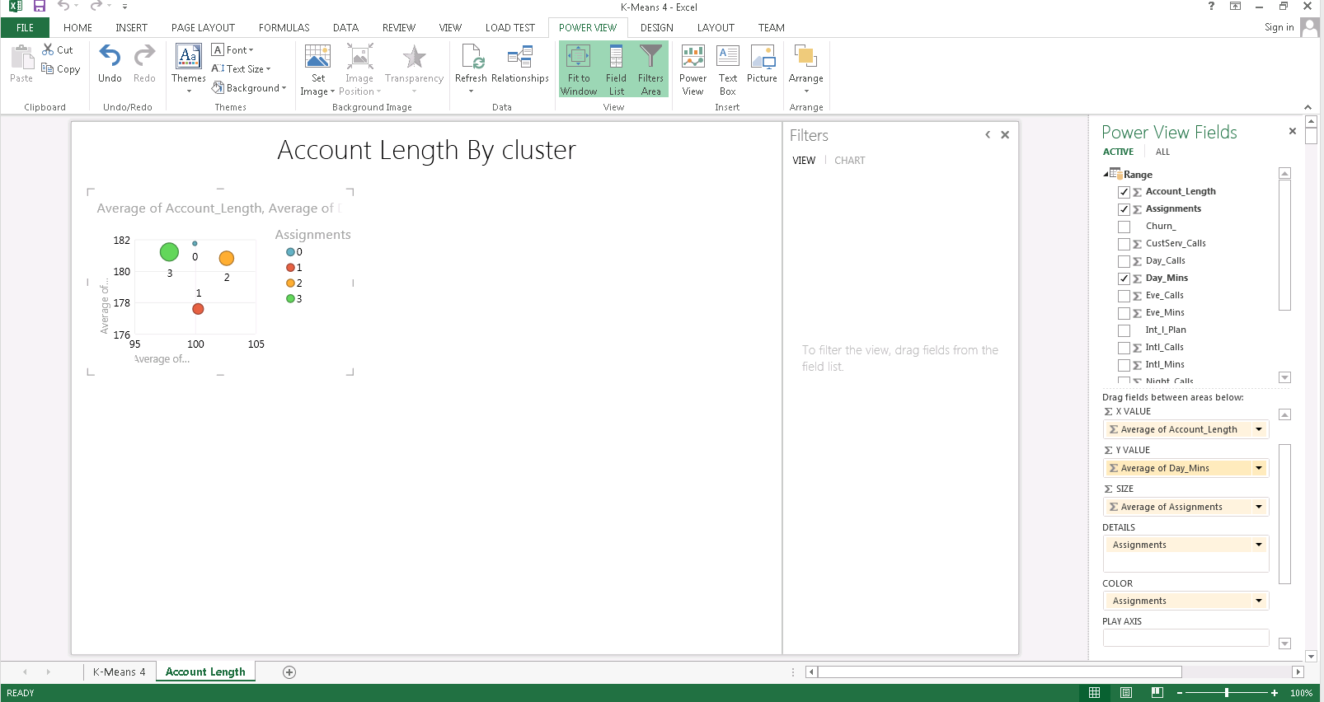

1. Copy and paste the first chart, place it the upper right side of canvas. In this new chart replace **Σ Average of Day_mins** with **Σ Average of Intl_Mins**, on both **Σ Y VALUE** and **Σ SIZE**.

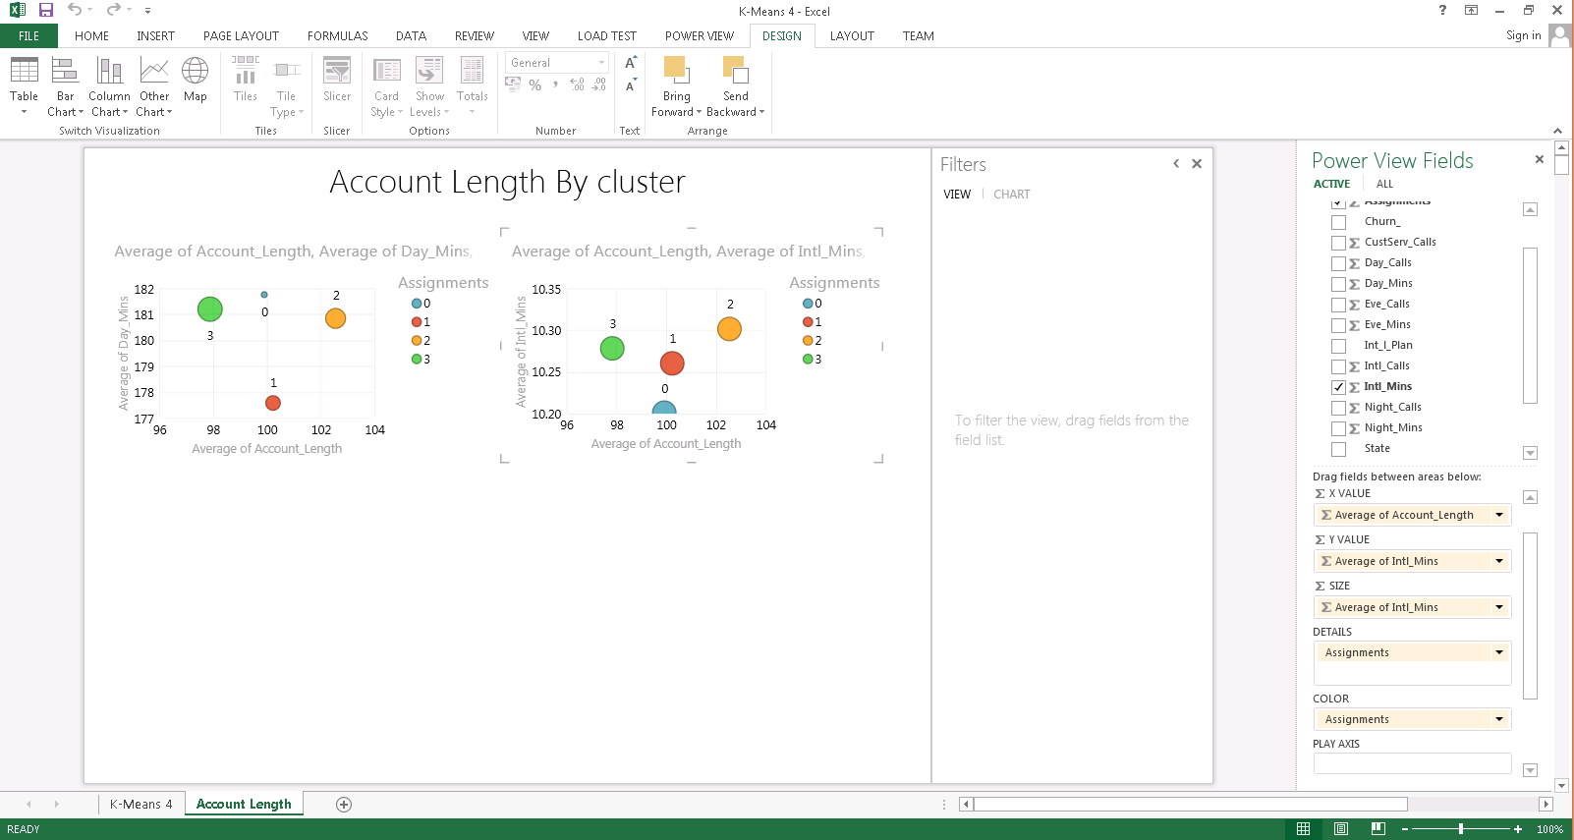

1. Copy and paste the first chart, place it the bottom left side of canvas. In this new chart replace **Σ Average of Day_mins** with **Σ Average of Eve_Mins**, on both **Σ Y VALUE** and **Σ SIZE**.

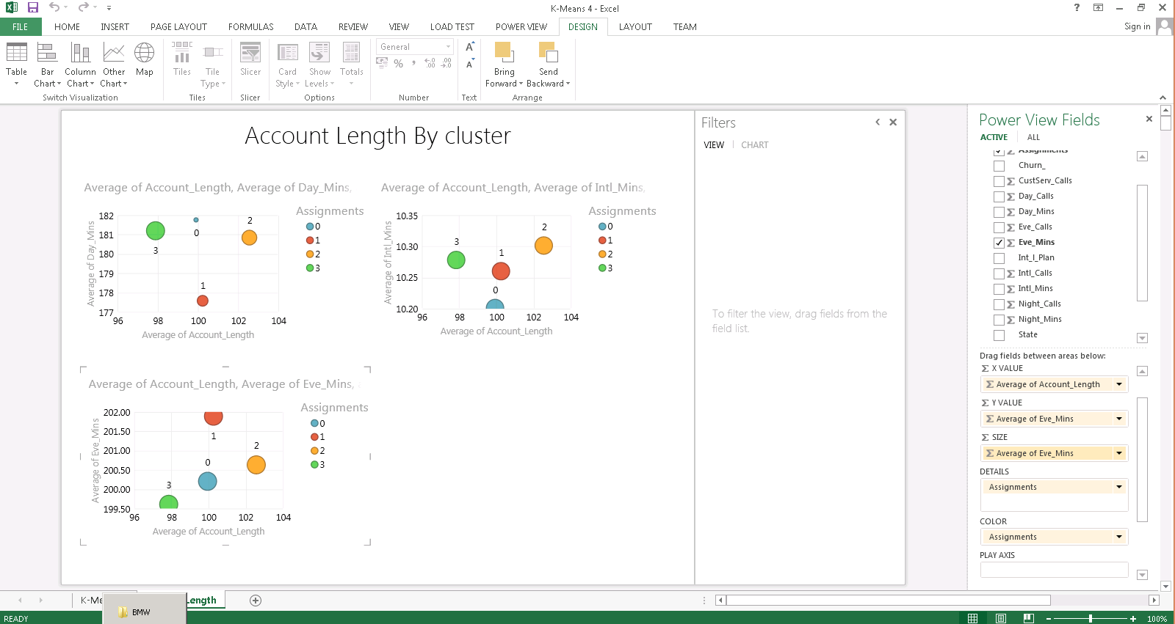

1. Copy and paste the first chart, place it the bottom right side of canvas. In this new chart replace **Σ Average of Day_mins** with **Σ Average of Night_Mins**, on both **Σ Y VALUE** and **Σ SIZE**.
2. Explore the insights and note how each cluster (assignment) is different based on the duration of calls in different periods.

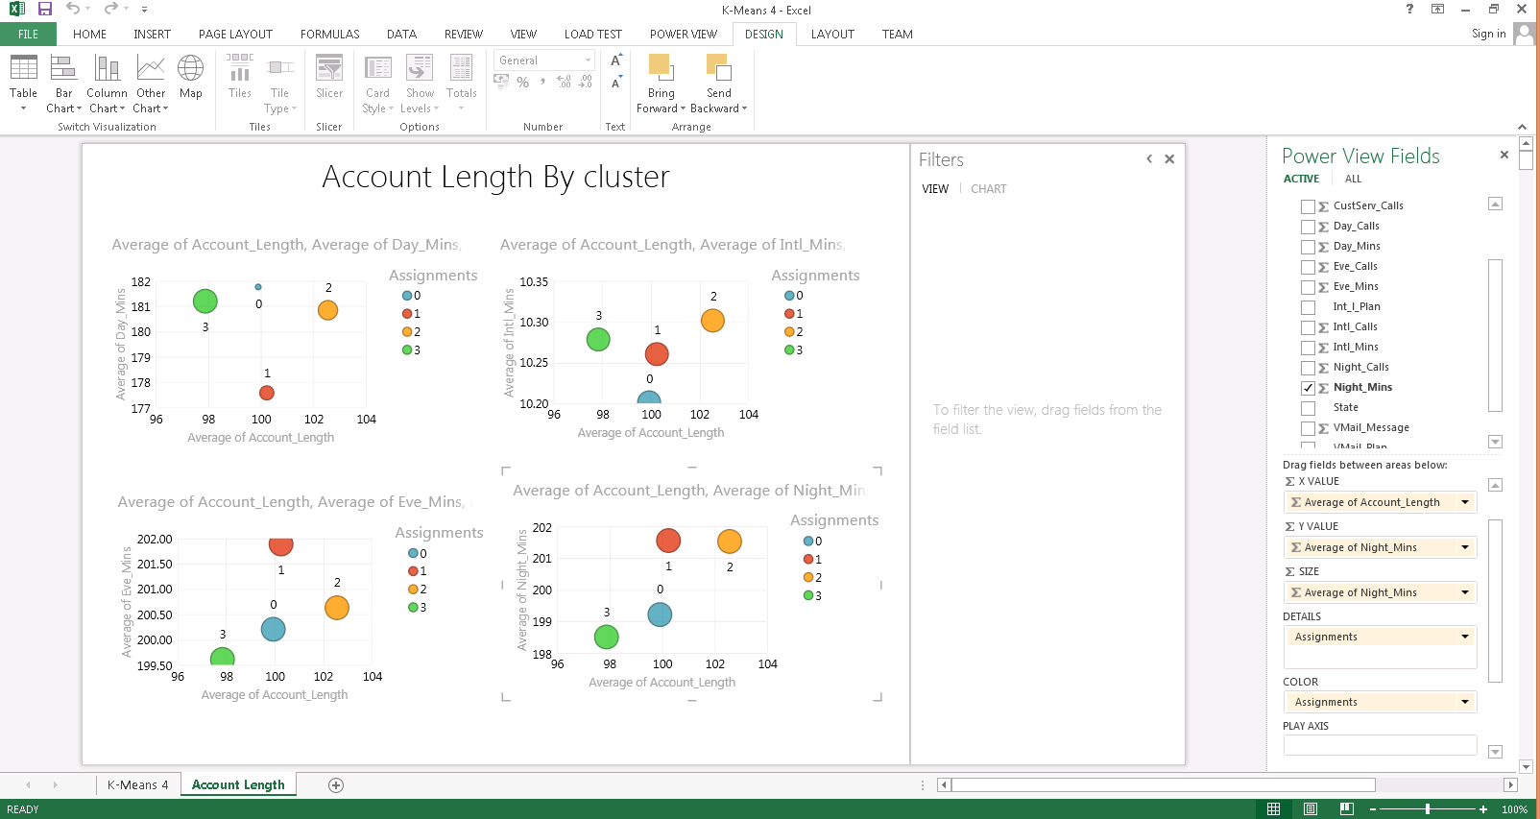

# Optional: Reading Data from Azure SQL Database

In this section, you will read data from an Azure SQL database table into Azure ML studio. You will first run a script to create the database and tables on azure and then copy data into them. After that, you will use the Import Data module to bring data into Azure ML Studio.

**Step-by-step**

1. Open a **Microsoft Azure PowerShell** window as administrator by right clicking the PowerShell Icon on the task bar and selecting **Run as Administrator.**

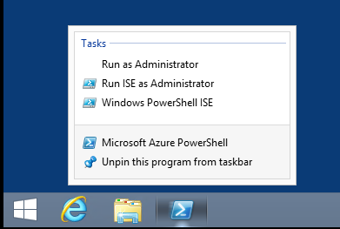

1. Go to the directory C:\Lab1\ChurnDataSQLAzure by typing **cd C:\Lab1\ChurnDataSQLAzure** at the command prompt. Next, execute the necessary script by typing **.\bcpChurn.ps1** at the command prompt. The script will create an Azure SQL database and bulk copy the Churn data. It will also create a database user and a password which will be used to make a connection to database from the Azure ML Studio.

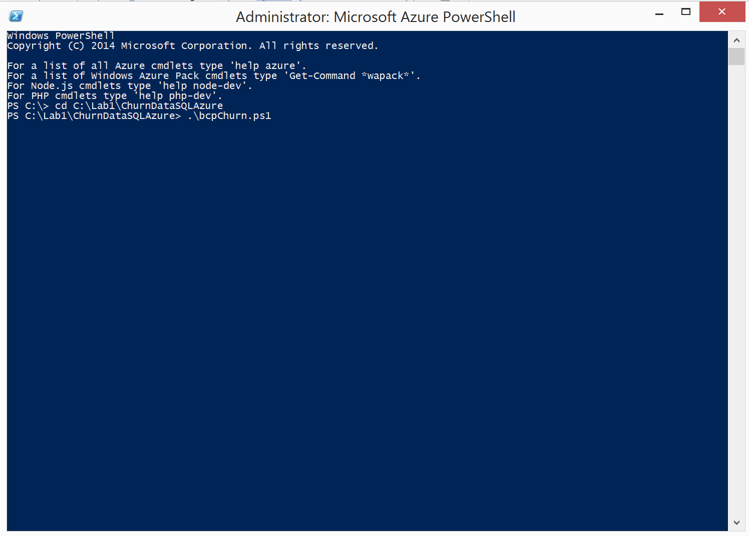

1. Sign into the Microsoft Azure Sign in window and hit Continue. Provide your password in the next window.

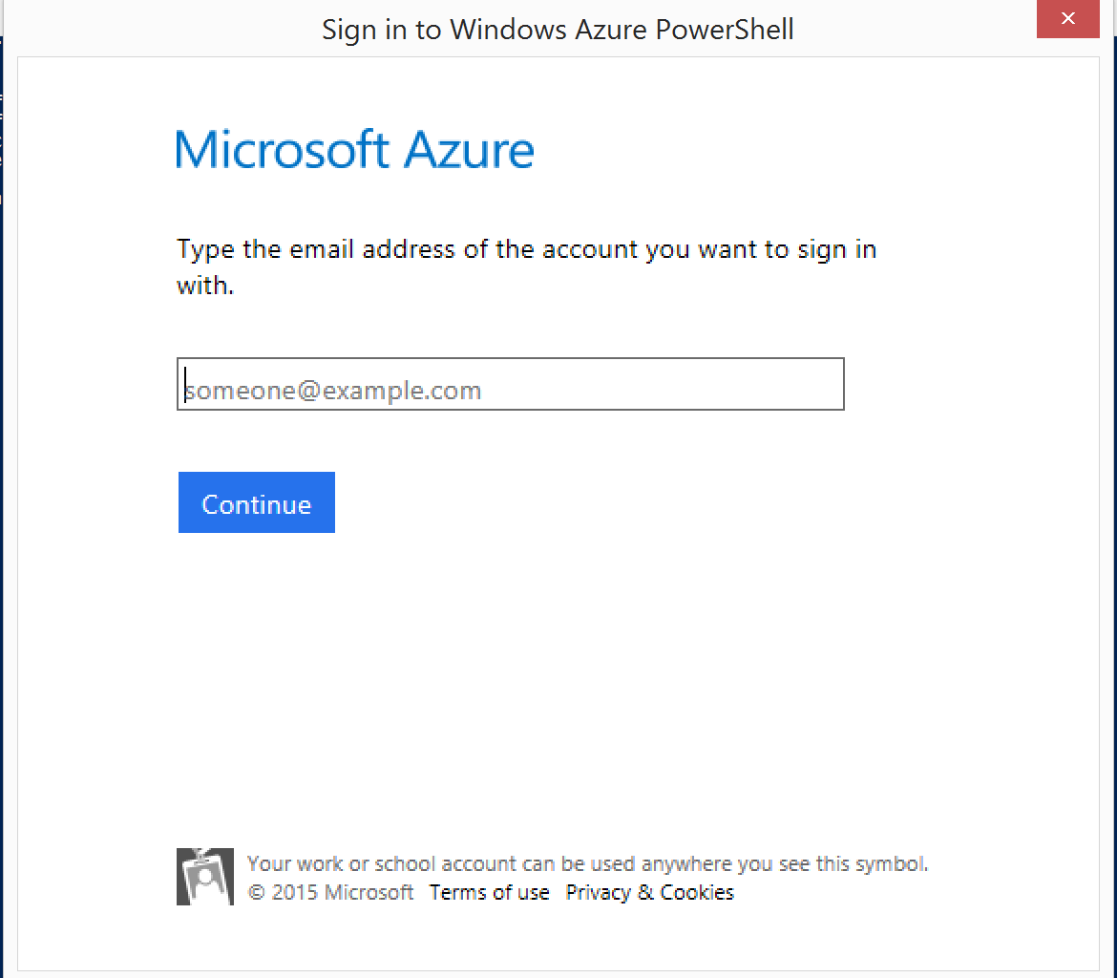

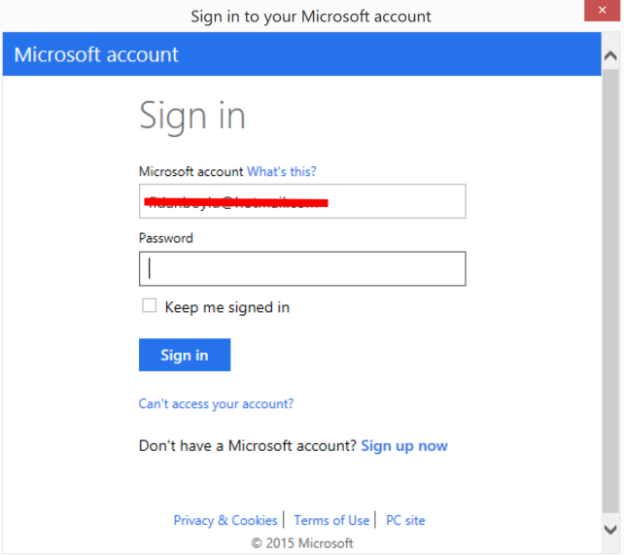

1. If you have multiple Azure subscriptions, you will get warnings and you will need to provide your subscription name at the command prompt. After the script is successfully run, you should see the following output in the PowerShell window.

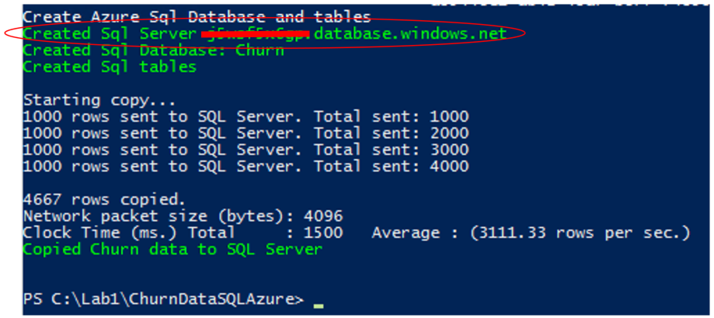

1. Make a note of the SQL Server name in the second line above (masked) which will be different for your subscription and should be taken from your output. You will be using this server name in the next section. You should now be able to see the Churn database created in Azure Management Portal <https://manage.windowsazure.com>. After logging in with your credentials, you should see the Churn database under the menu item SQL DATABASES.

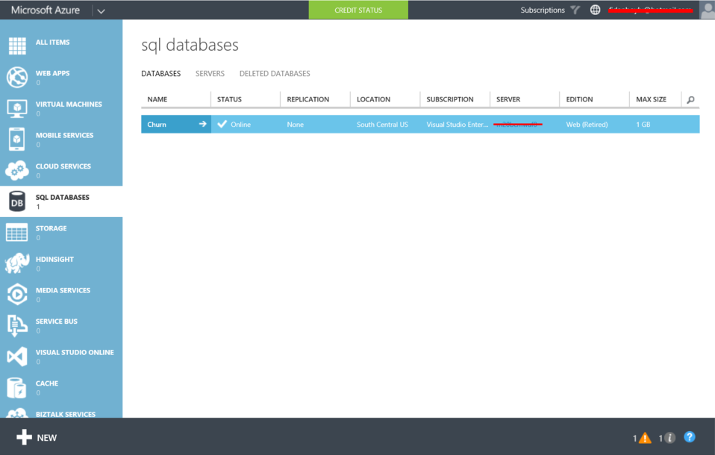

1. Now, you will create a new experiment and read the Churn data from the Azure SQL database into Azure ML studio. Go back to your workspace and select **+New** at the bottom of the page and click on the box called **Blank** **Experiment**. Change the title of the experiment to **Churn from SQL** by deleting the default title (Experiment created on mm/dd/yyyy) **.** Expand the Data Input and Output list in the left navigation pane and drag/drop the **Import Data** moduleto the experiment canvas.

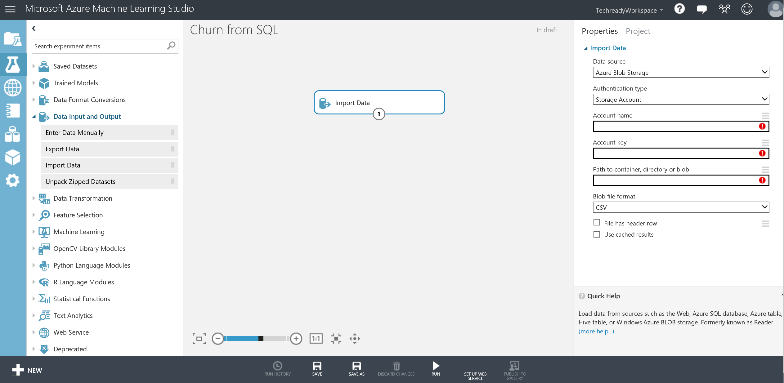

1. Next, under the Properties bar on the right side, select **Azure SQL Database** from the Data source drop down menu. Enter the database server name that you noted from the earlier exercise under the Database server name text box. Alternatively, you can look up the server name from the Azure portal. Type “Churn” for the Database name, “churnuser” for Server user account name and use ”passWord!” for the Server user account password. Check “Accept server certificate (insecure)”. In the Database query box, enter “Select * from ChurnTable” and run the experiment by clicking the **Run** button on the bottom menu bar.

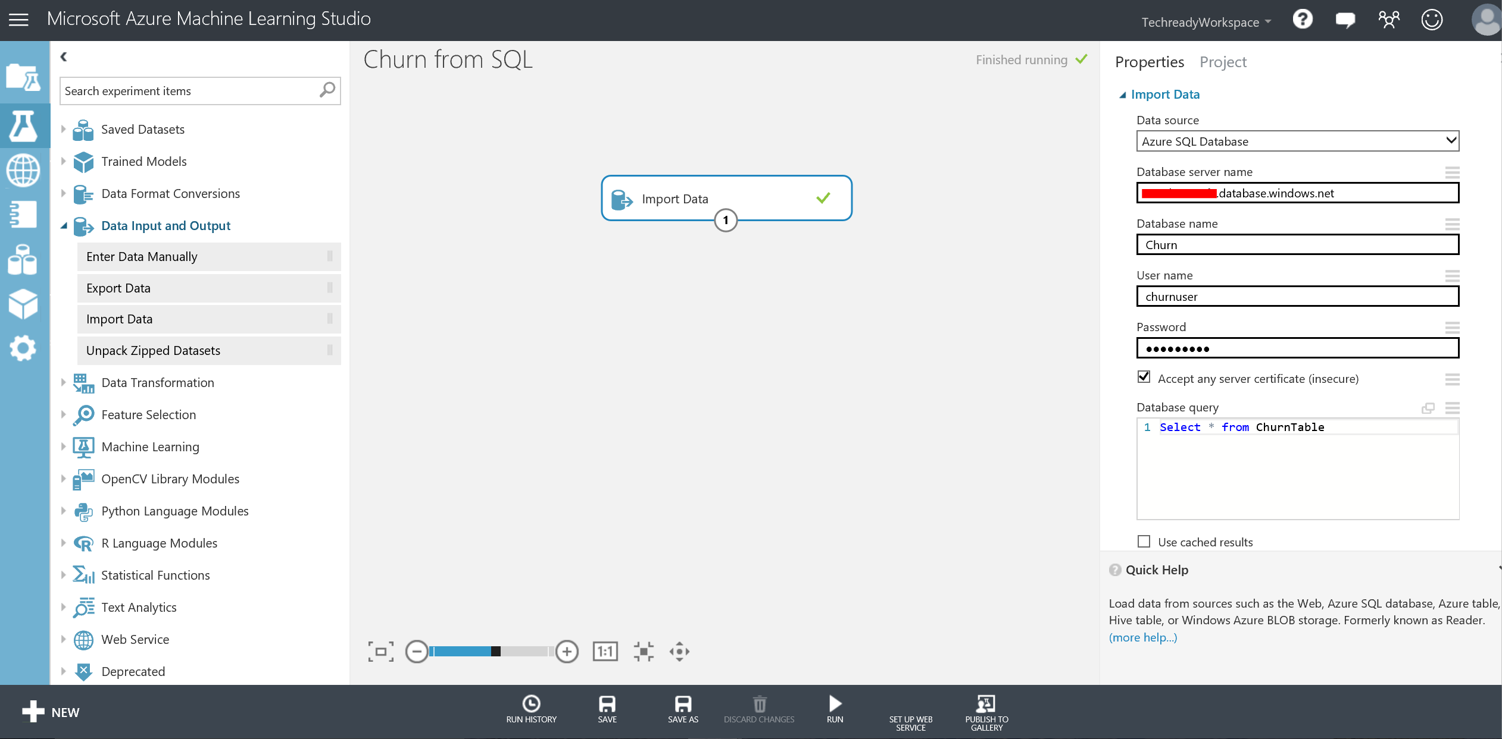

1. When the experiment is finished, you will see a green check mark on the Import Data module. Right click the output port of the Import Data module and then select **Visualize** to visualize the dataset that was ingested from the Azure SQL database. This will take you to a page with general statistics information on the columns of the dataset. Scroll to the right to see more column information and down for first 100 rows of the dataset. Click on the Account_Length column and observe the statistics and visualizations for the column on the right side of the screen. Scroll down for the histogram of the column. Close the page by clicking the close button on the top-right corner.

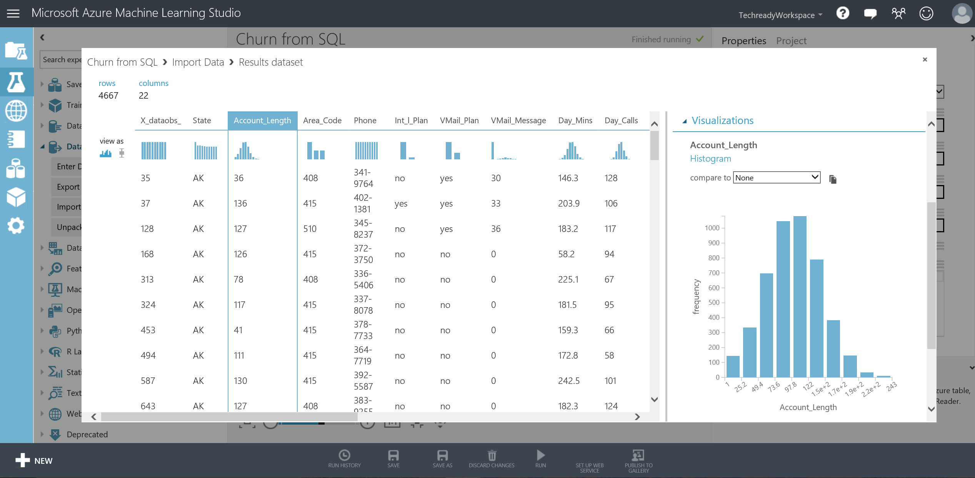

1. Now, right click the output of the Import Data module again and select **Save as Dataset**. Enter “ChurnData” as the name for the new dataset and click the checkmark. You should now have a ChurnData dataset replicated from the Azure SQL database under My Datasets in the left bar.

# Optional: Writing Predictions to Azure SQL Database

In this section, you will use the **Export Data** module to write the scored labels and probabilities of the test set examples into the Azure SQL database created earlier.

**Key Points**

1. Azure ML Studio gives you an option to save datasets to Azure Blob Storage, Azure Table, Azure SQL Database and to a Hive Table using the **Export Data** module.

**Step-by-step**

This step takes about 5 minutes to complete.

1. Go to your **Churn** experiment and save it as **Churn Export to SQL.** In the Search box type **Export Data**, drag and drop the Export Data module in the experiment canvas just below the **Score Model / Testing** module.
2. Connect the **Scored Dataset** port of the **Score Model / Testing** module to the **Dataset** input port of the Export Datamodule.
3. Select the Export Data module and expand the **Properties** pane. Examine the options you have under **Please specify data destination** and select **Azure SQL Database.** Enter the database server name that you noted from the earlier exercises under the Database server name text box. Alternatively, you can look up the server name from the Azure portal. Type “Churn” for the Database name, “churnuser” for Server user account name and use ”passWord!” for the Server user account password. Check “Accept server certificate (insecure)”.
4. In the **Comma separated list of columns to be saved**, type “Churn_, Scored Labels, Scored Probabilities”. Type “ChurnScores” for the Data table name. In the **Comma separated list of datatable columns**, type “Churn_, ScoredLabels, ScoredProbabilities”. Leave **Number of rows written per SQL Azure operation** as default (50) and run the experiment.

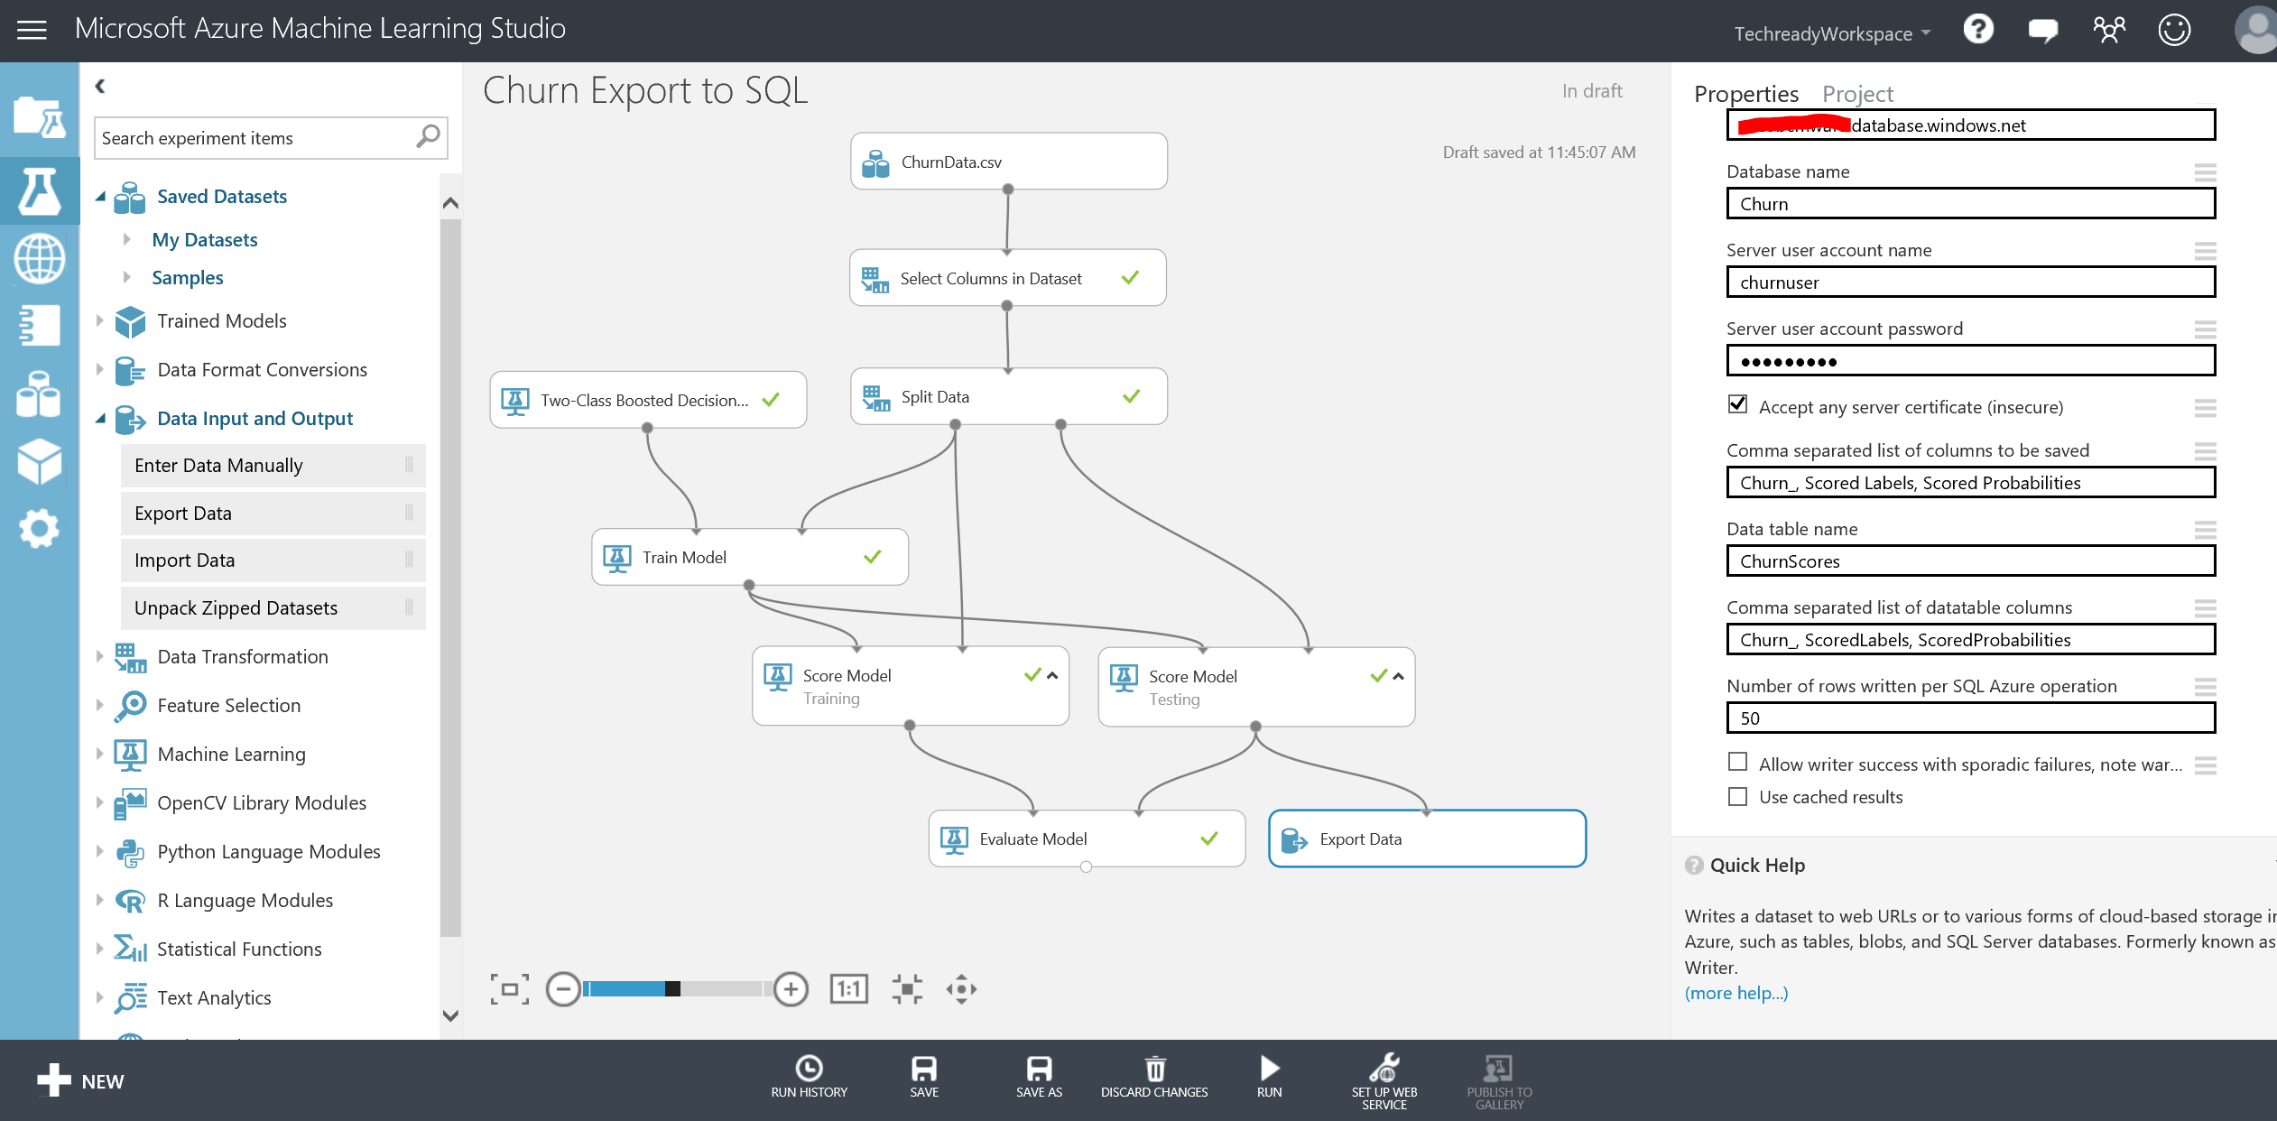

1. Once you see the green check mark on the Export Data module, you can verify your results by connecting to your database through SQL Server Management Studio installed on your lab VM by using the same Azure SQL server name and credentials and by querying the ChurnScores table.

# Optional: Azure ML Web service call from RStudio

In this optional exercise, you will use RStudio to make a call to the web service you created earlier.

**Step-by-step**

1. Go back to your browser to the web service dashboard. Click the **REQUEST/RESPONSE** link under the **API HELP PAGE** heading. This will direct you to the Request Response API Document for your service. You will find your Web service URI on this page along with Sample Code to call the web service using C#, Python and R when you scroll down to the bottom. We will make use of the R sample code in this exercise.

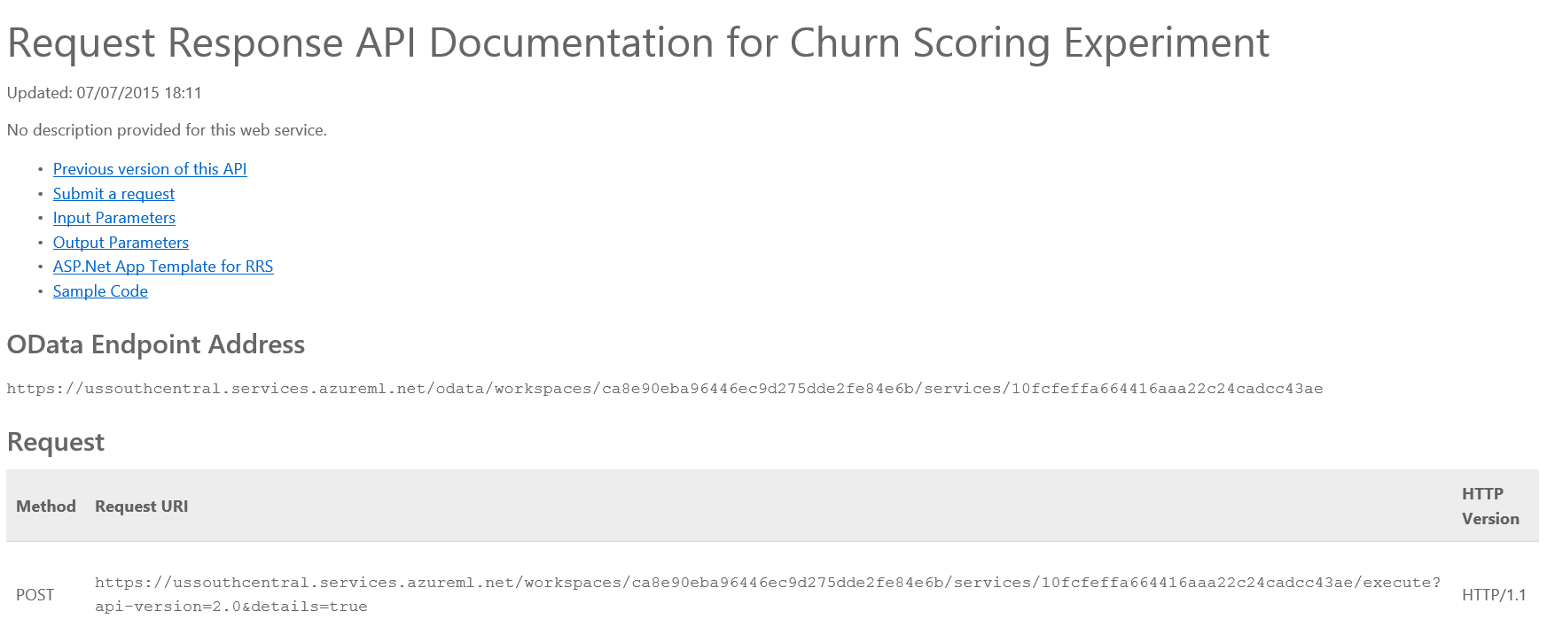

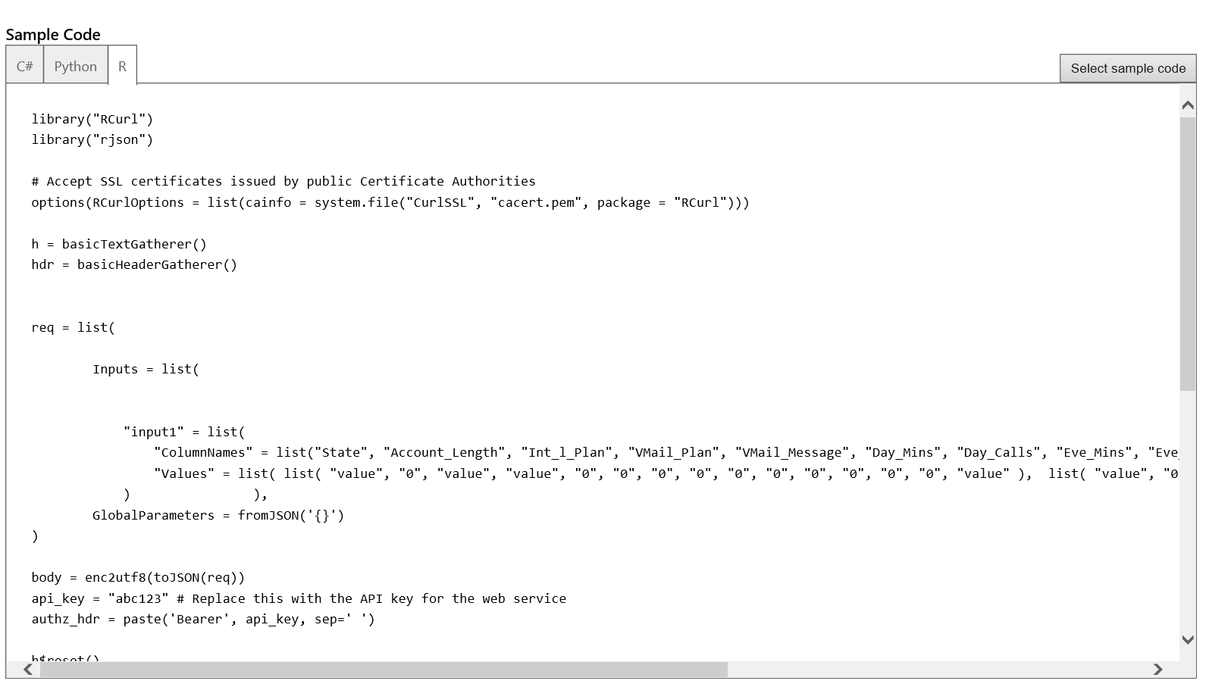

1. Now, on the task bar find **RStudio** and start the program. Under File menu, click Open File and browse to **C:\Lab1\** and open **R_Script_API** file. This will load the sample script to your **RStudio.**

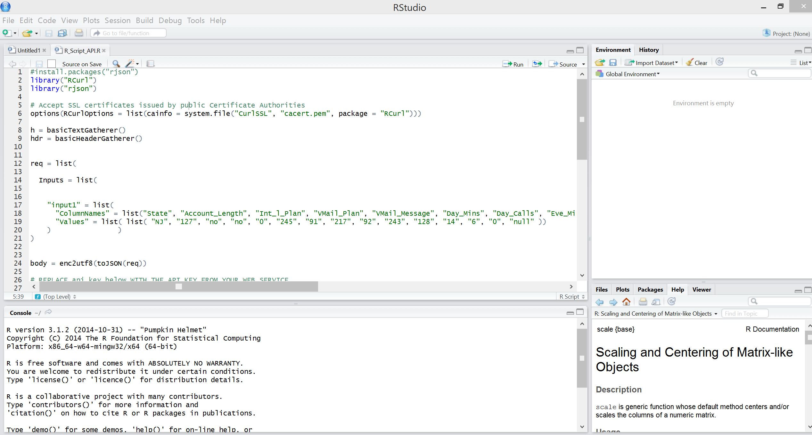

1. Scroll down the script and locate the comments: # REPLACE api_key below WITH THE API KEY FROM YOUR WEB SERVICE and # REPLACE URI BELOW WITH THE URI FROM YOUR WEB SERVICE. Replace the api_key by copying the API key from your we service dashboard under API key column. Also, find your URI on the Request Response documentation page and replace the URI in the script with yours. Observe the inputs list where same input values to test the service from the earlier exercises are provided. Now, select and highlight the whole script and click Run on the upper right corner of the script window. Wait for the script to execute. You can follow progress on the Console window. After script is finished, you should get the following console output:

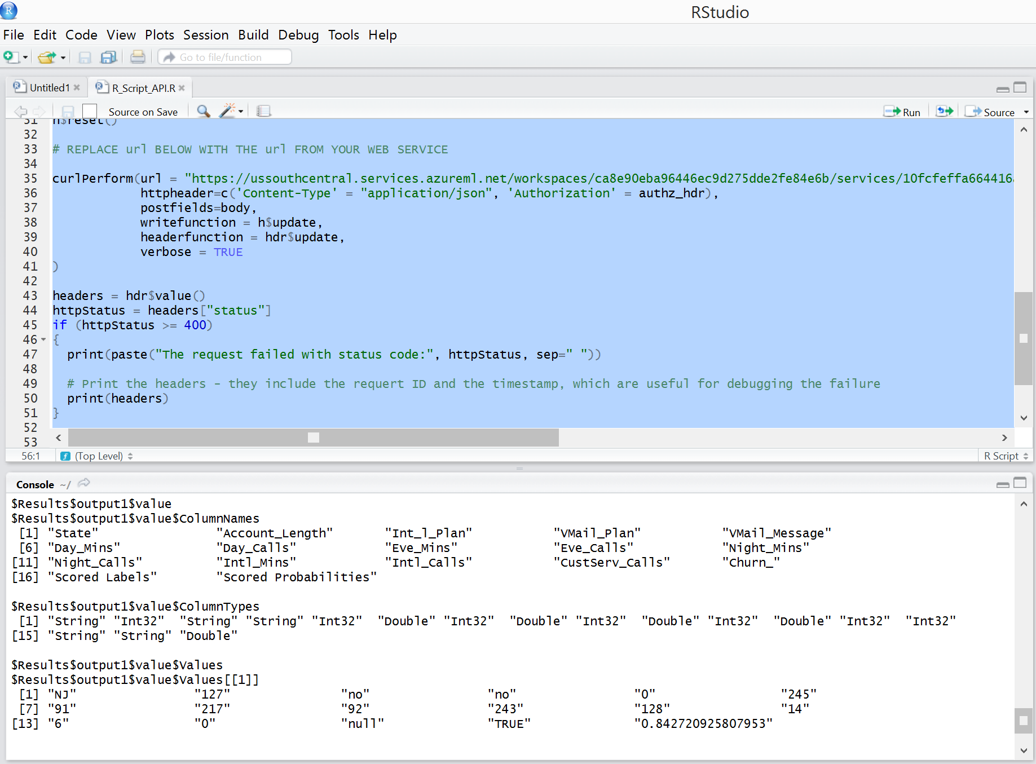

# Optional: Publishing R models as Web services from RStudio

It is also possible to publish your models that are trained in RStudio as web services within Azure ML Studio. In this exercise, you will use a script that trains an R model using the “**gbm”** Rpackage and publishes it as a web service using the “**AzureML”** R package.

**Step-by-step**

1. In **RStudio,** under the File menu, click **Open File** and browse to C:\Lab1\ and open **R_Script_Publish.R**  file. This will load the sample script to your **RStudio.**

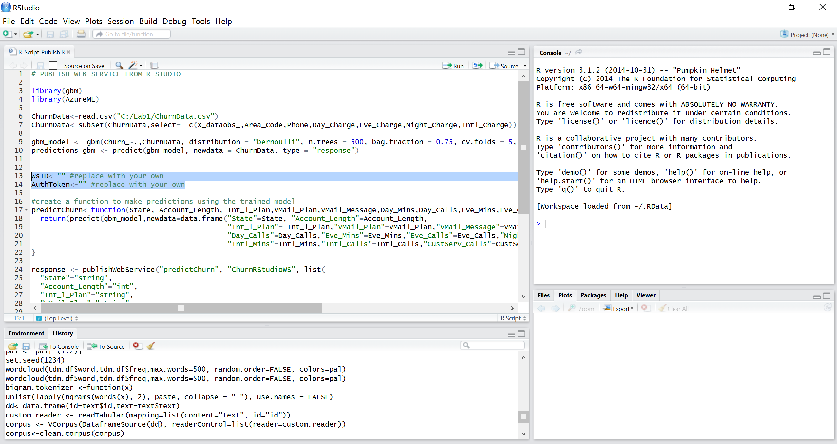

1. You will need to replace the workspaceID and AuthorizationToken parts highlighted in the above screenshot with your own. You can find your workspaceID and AuthorizationToken under the **SETTINGS** tab. Next, **Run** the script file. When finished, you should be able to find your published web service under your **WEB SERVICES** tab in Azure ML.

# Summary

This lab was intended to introduce you to the basic concepts of data science such as binary classification, segmentation, training and testing a model using Azure Machine Learning. Azure SQL Server, Power view, Power BI, Python and R scripting is used for data ingestion and end user visualizations to demonstrate an integrated approach for an end-to-end solution. Finally, a web service is created to operationalize the model and excel and RStudio was used to consume the web service.